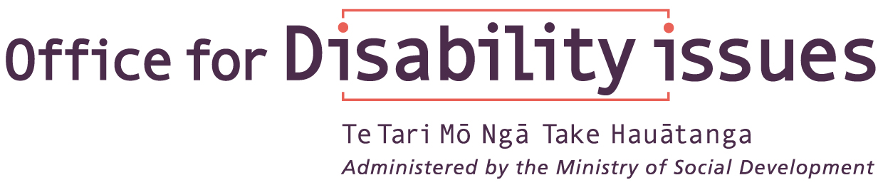

NEW ZEALAND

SIGN LANGUAGE BILL

An easy-to-read explanation

July 2004

INTRODUCTION

This information is a plain language explanation of the New Zealand Sign Language Bill.

While every effort has been taken to make sure the information in this document is correct, this information does not replace or change the New Zealand Sign Language Bill. If you have any specific questions you should refer to a copy of the New Zealand Sign Language Bill.

The New Zealand Sign Language Bill is proposed to come into law in 2005.

You can keep updated on the progress of the New Zealand Sign Language Bill at the Office for Disability Issues website: http://www.odi.govt.nz/about/nzsl.html.

The following information is included in this document:

- What is a Bill?
- What is a “clause”?
- Explanation of the New Zealand Sign Language Bill
Part 1:
Clause 3: The purpose of the New Zealand Sign Language Bill
Clause 4: Some definitions used in the Bill
Part 2:
Clause 6, 7, 8
Clause 9: Principles to guide Government Departments
Clause 10, 11
What Courts and Tribunals can New Zealand Sign Language be used in?
List of government departments

A full copy of the Bill can be found on:

http://www.odi.govt.nz/about/nzsl.html
or
http://www.knowledge-basket.co.nz/gpprint/docs/welcome.html

This easy to read explanation has been produced by IHC Advocacy on request from the Office for Disability Issues.

What is a Bill?

a draft of proposed law presented to Parliament for discussion

What is a clause?

a section of the Bill

NEW ZEALAND SIGN LANGUAGE BILL

PART 1
Clause 3

THE PURPOSE OF THE
NEW ZEALAND SIGN LANGUAGE BILL

To promote and support the use of New Zealand Sign Language by:

a) Making New Zealand Sign Language an official language of New Zealand.

b) Making it a right to use New Zealand Sign Language in legal proceedings.

c) Allowing rules to be made to help make sure interpreters in legal proceedings have the right skills to do the job.

d) Listing principles to guide government departments in the use of New Zealand Sign Language in their services and information.

Clause 4

SOME DEFINITIONS OF WORDS
USED IN THE BILL

Deaf Community means:
Group of people who are deaf and who use New Zealand Sign Language as their first or preferred language

Government Department means:
Government Departments named in The Ombudsmen Act 1975. These are listed at the back of this document.

Legal proceedings mean:
Proceedings before a court or tribunal listed in the back of this document “What Courts and Tribunals can New Zealand Sign Language be used in”. Legal proceedings also include a coroner, a commission of inquiry, or a tribunal or other body with the powers of a commission of inquiry.

Minister means:
The Minister who is responsible for the New Zealand Sign Language Act. The Prime Minister decides this.

New Zealand Sign Language or NZSL mean:
The visual and moving language that is the first or preferred language of the cultural group of people who are Deaf.

NEW ZEALAND SIGN LANGUAGE BILL

PART 2

Clause 6

This clause declares New Zealand Sign Language is to be an official language of New Zealand.

Clause 7

Clause 7 provides that New Zealand Sign Language can be used in legal proceedings.

Clause 8

This clause sets out the effect of New Zealand Sign Language being an official language of New Zealand.

This clause also makes it clear that having New Zealand Sign Language as an official language does not take away the rights of people to use other languages.

Principles to guide
GOVERNMENT DEPARTMENTS

Clause 9

This clause sets out the following principles:

- The Deaf community should be consulted on things that affect their language (New Zealand Sign Language)

- New Zealand Sign Language should be used for the promotion of services and information

- Government information and services should be accessible to Deaf people in different ways, including New Zealand Sign Language

Clause 10

Under this clause Ministers can report on how government departments are doing in the principles set out in clause 9. This report can be included in the Minister’s reports on the New Zealand Disability Strategy.

Clause 11

This clause allows the making of rules (regulations) to help make sure interpreters in legal proceedings have the right skills to do the job.

Rules can also be made for any other matters needed for administration of the Bill, or needed to give the Bill full effect.

WHAT COURTS AND TRIBUNALS CAN
NEW ZEALAND SIGN LANGUAGE
BE USED in?

A. Courts

- The Supreme Court
- The Court of Appeal
- The High Court
- District Courts
- The Employment Court
- Family Courts
- Youth Courts
- The Maori Land Court
- The Maori Appellate Court
- The Environment Court

B. Tribunals

- The Waitangi Tribunal
- The Employment Relations Authority
- The Human Rights Review Tribunal
- The Tenancy Tribunal
- Disputes Tribunals established under the Disputes Tribunals Act 1988

Government Departments

Crown Law Office | Ministry of Health
Department of Child, Youth and Family Services | Ministry of Housing
Department of Conservation | Ministry of Justice
Department of Corrections | Ministry of Maori Development
Department of Internal Affairs | Ministry of Pacific Island Affairs
Department of Labour | Ministry of Research, Science, and Technology
Department of Prime Minister and Cabinet | Ministry of Transport
Education Review Office | Ministry of Women's Affairs
Inland Revenue Department | Ministry of Youth Affairs
Land Information New Zealand | National Library Department
Maori Trust Office | National Provident Fund Department
Ministry of Agriculture and Forestry | New Zealand Customs Service
Ministry for Culture and Heritage | New Zealand Defence Force
Ministry of Defence | Office of State Services Commission
Ministry of Economic Development | Parliamentary Counsel Office
Ministry of Education | Serious Fraud Office
Ministry for Environment | Ministry of Social Development
Ministry of Fisheries | Statistics New Zealand
Ministry of Foreign Affairs and Trade | Treasury

