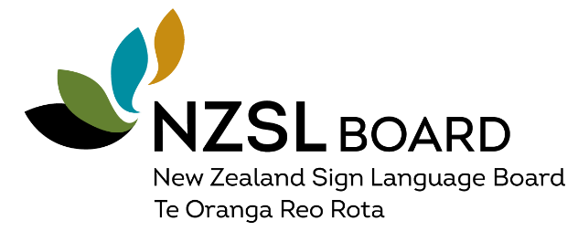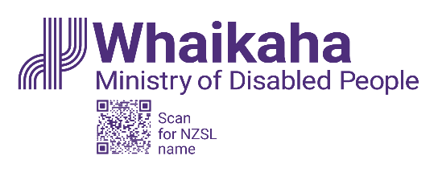

New Zealand Sign Language Strategy 2026–2036

Action Plan: May 2026–June 2027

Contents
Minister’s Foreword 3
NZSL Board Chair’s Foreword 4
Executive Summary 6
Our Vision 7
What We Will Deliver: May 2026 – June 2027 8
1. Acquisition and Learning 8
2. Evidence and Data 9
3. Deaf and NZSL Workforce 9
4. Public Sector 10
5. Celebrating NZSL 12
Governance, Monitoring & Future Planning 12
What Success Looks Like by June 2027: 13

Minister’s Foreword
I am delighted to be releasing the first action plan for the New Zealand Sign Language (NZSL) Strategy 2026-2036.
The new strategy is ambitious. It aims to address the many issues faced by NZSL users, particularly the Deaf community, when learning and using NZSL. This is a first step in a decade to affirm the status of NZSL as an official language and a taonga for Deaf people.
It is apt this action plan is being launched during the 20-year anniversary of NZSL of being made an official language by the New Zealand Sign Language Act 2006.
I am pleased to see practical steps to remove the barriers Deaf people face in accessing health, education, justice and emergency information and public services.
I look forward to the public sector leading with NZSL language plans and to progress being made for Deaf learners, so we address gaps in education.
I congratulate the NZSL Board on this important work and look forward to hearing about their progress.

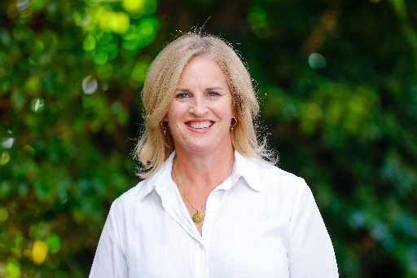
Hon. Louise Upston
Minister for Disability Issues

NZSL Board Chair’s Foreword
The NZSL Strategy 2026-2036 reflects the voices, priorities and aspirations of the Aotearoa New Zealand Deaf and NZSL communities. This action plan is the start of bringing the strategy to life.

Progress relies on government agencies, organisations, educators, the Deaf community, and NZSL users working together.

We look forward to the public sector actively planning for NZSL. This will be a cultural shift that makes a major improvement to the lives of Deaf people and NZSL users.

A strong Deaf and NZSL workforce is essential to supporting Deaf communities and the acquisition, promotion, and maintenance of NZSL. The NZSL Board will start a work programme that focuses on supporting the development of workforce skills and capacity, with a focus on addressing widely recognised issues. A comprehensive workforce strategy will also be developed as well as continuing to progress NZSL interpreter standards.

The board will be checking progress, so we learn from what is working – and what is not. This is the start of a journey for our vison of everyone being aware of, using and accepting NZSL – ‘everyone, everywhere, every day.’

Catherine Greenwood
Chair
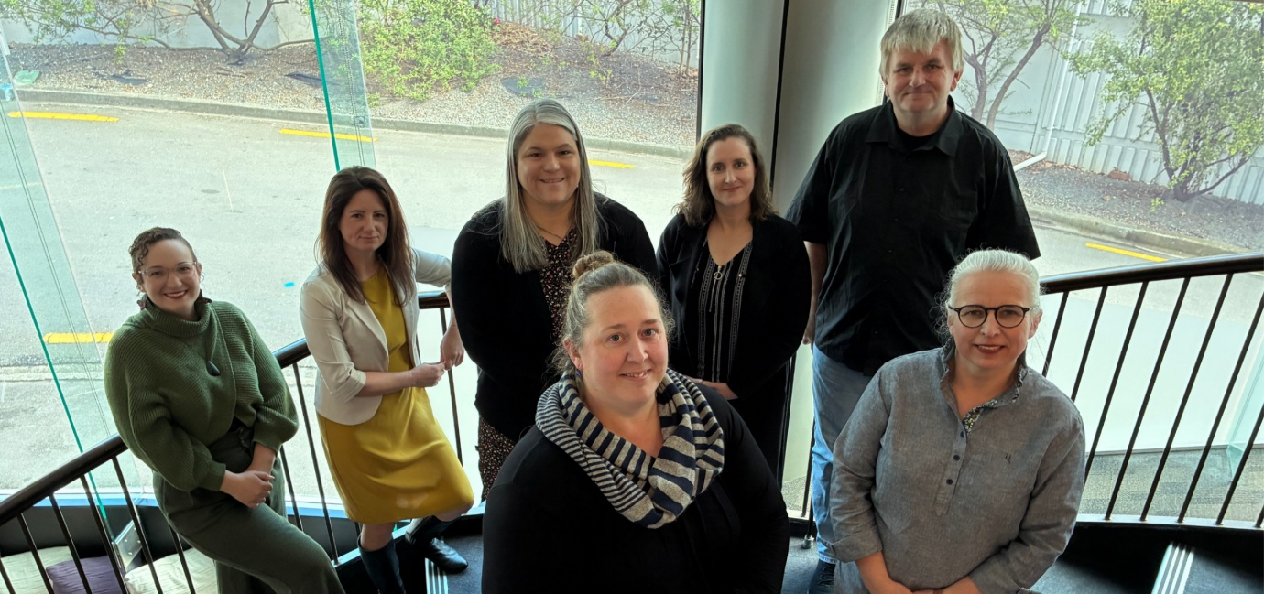

NZSL Board: Back row from left: Erica Dawson, Jaime Brown, Catherine Greenwood, Sarah Mason and Kim Robinson. Front row, Joanne Becker and Monica Leach.

Executive Summary
A collective commitment to NZSL – everyone, everywhere, every day.
New Zealand Sign Language (NZSL) is an official language of New Zealand and a taonga essential to communication, belonging, and identity for Deaf people, Turi Māori, Deafblind people, and other NZSL users.
Despite the progress of recent years, NZSL users still face major barriers accessing healthcare, education, the justice system, emergency information, and wider public services. The NZSL Strategy 2026–2036 sets the long-term direction for change.
This Action Plan (May 2026–June 2027) sets out the first steps we will take to activate this decade of transformation. This Plan outlines the actions government agencies, Deaf and NZSL communities, organisations, and the public will take over the next 14 months to strengthen NZSL across Aotearoa. These actions are practical, measurable, and grounded in partnership with communities.

Our Vision
New Zealand Sign Language – everyone, everywhere, every day.
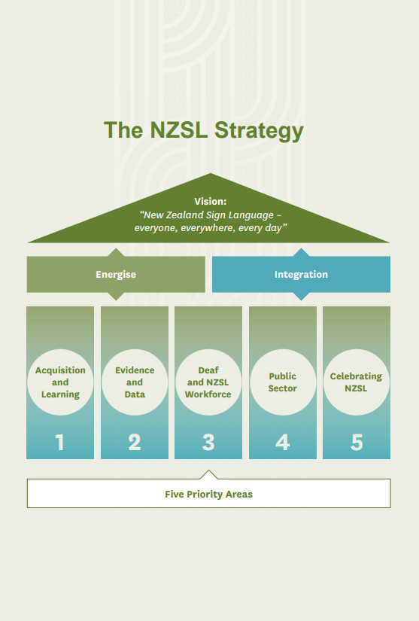
Figure 1 The NZSL Strategy as a house.

What We Will Deliver: May 2026 – June 2027
The Action Plan focuses on early and tangible actions that create momentum for the Strategy.

Acquisition and Learning
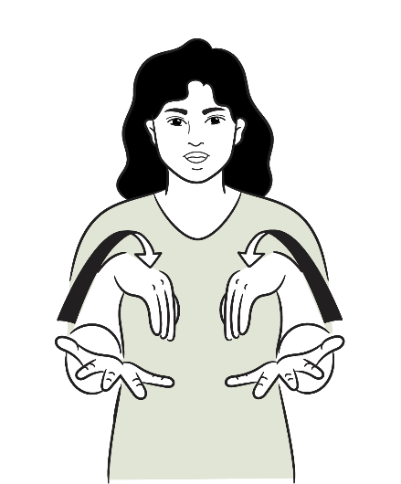
These first actions are aimed at establishing a shared understanding across the education system and support longer term reform to improve NZSL outcomes for Deaf children and NZSL users.

Host a Deaf Education Futures Forum

A Deaf Education strategic hui will bring together education stakeholders, Deaf leaders, parent groups, and government agencies to strengthen pathways for Deaf learners, improve system responsiveness, and address capability gaps in Deaf education.

Evidence and Data
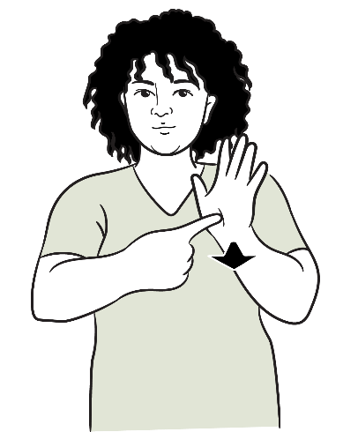

Support Stats NZ to improve data infrastructure for NZSL
Whaikaha will work with Stats NZ to improve data infrastructure relevant to NZSL users, enabling the development of an NZSL indicators framework and strengthening monitoring of access, usage, and outcomes.

Deaf and NZSL Workforce
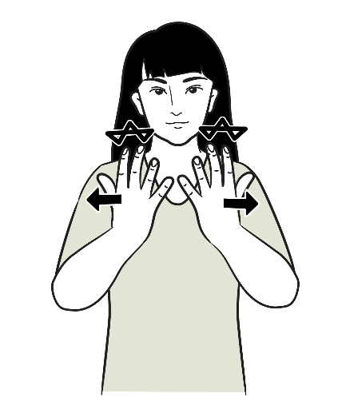

Host a National NZSL Workforce Development Forum
The forum will identify system-wide NZSL workforce needs, including teachers who work with deaf children, NZSL teachers, and interpreters, and develop collaborative actions across agencies and providers to strengthen workforce sustainability.

Develop an Interpreter Workforce Strategy
A comprehensive strategy will be developed to support:
- NZSL interpreters
- trilingual interpreters (NZSL–te reo Māori–English)
- tactile sign language interpreters (for Deafblind).
This will include identifying capability pathways, training needs, and system improvements.

NZSL Interpreter Standards
Whaikaha will support the development of NZSL interpreter standards. NZSL interpreting is an unregulated profession and NZSL interpreter standards are needed to ensure Deaf people consistently receive safe, accurate and culturally appropriate interpreting services that uphold their rights, build trust, and enable full and equitable access to public services and civic life.

Public Sector
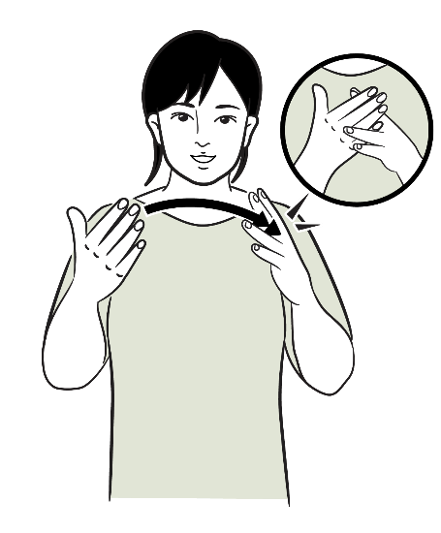

NZSL Capability Plans developed and supported
To improve how public services respond to Deaf people and NZSL users, Whaikaha will support several public service departments to develop NZSL Capability Plans. These plans are about building awareness, skills, and systems so NZSL is considered early and consistently.
NZSL Capability Plans will outline practical steps agencies will take to improve access to information and services for NZSL users and to strengthen their ongoing capability to use and support NZSL as an official language.
To support transparency and shared accountability, public service agencies will also be expected to include information about NZSL access and usage in their annual reporting. This will help build a clearer picture of how NZSL is being used across government over time and support learning and improvement.

Support targeted engagement across government
The NZSL Board will work with key agencies to accelerate progress, including:
- Public Service Commission: ensuring Leadership Development Centre programmes are available with NZSL interpreters
- Ministry of Education: developing a detailed Action Plan for NZSL in schools
- Ministry of Health: developing an Action Plan for NZSL use in health settings
- Stats NZ: improving data infrastructure for NZSL users.

New Zealand Sign Language & Artificial Intelligence Forum
A national forum will explore opportunities and risks relating to NZSL and AI, and support ethical, Deaf-led and innovative use of technology, including informing how government funds NZSL-related AI projects appropriately.

Celebrating NZSL



20th Anniversary of the NZSL Act (2026)
Deaf clubs across New Zealand will lead NZSL Board-funded celebrations to mark the 20th anniversary of NZSL.

Action Plan Launched
The May 2026–June 2027 Action Plan will be publicly launched, increasing visibility and enabling coordinated action.

Governance, Monitoring & Future Planning

Annual Report on NZSL Strategy Progress and Impact
An annual report will be delivered to track progress, identify gaps, and maintain transparency.

Action Plan for July 2027 – June 2030 Developed
Work will begin on developing the next Action Plan, ensuring continuity and momentum beyond June 2027.

What Success Looks Like by June 2027:
- NZSL workforce needs identified, with agreed collaborative actions
- Government Departments progressing NZSL Capability Plans
- Public service agencies including material about NZSL use and service availability within their annual reports
- Education and health system improvements underway
- A draft indicator framework developed
- Increased visibility of NZSL
- Annual Strategy reporting setting clear baselines and accountability
- A clear forward pathway established through the development of the next Action Plan.
These early steps will build the foundation for achieving the NZSL Strategy vision of everyone, everywhere, every day by 2036.

