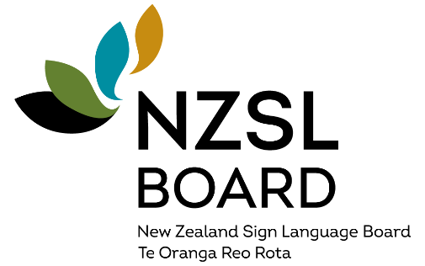

New 10-year strategy to increase use of New Zealand Sign Language
A new 10-year strategy setting out how Aotearoa New Zealand can work together to strengthen and increase the use of New Zealand Sign Language (NZSL), has been launched by the NZSL Board.
The strategy New Zealand Sign Language – everyone, everywhere, every day reflects the Board’s ambitions for a strong and vibrant language that is recognised and embraced as living language by all New Zealanders.
“We want NZSL to be a language that supports and improves the lives of Deaf people, Turi Māori (Māori Deaf people) and NZSL users,” says NZSL Board Chair Catherine Greenwood.
The strategy takes a new approach by both supporting NZSL users to learn and use the language, and by ensuring non-NZSL users understand its importance and embrace its use.
The strategy’s five priority areas include supporting deaf and NZSL-using children and their families to learn and use NZSL and ensuring there is a skilled workforce to sustain that support.
Government departments will be required to develop capability plans to support the use of NZSL. These will include providing more information and services in NZSL and giving staff the opportunity to learn both the language and about Deaf culture.
“Given the ambition of the strategy, we have extended its life from 5 to 10 years so we can make progress on long-standing issues,” says Greenwood.
“NZSL is more than just an official language of New Zealand. It is vital for connection and inclusion and is used by many Deaf, Turi Māori, and NZSL using people.”
An initial action plan will be developed to coincide with the 20-year celebration of NZSL as an official language in April next year.
During the 2025/26 financial year, more than $650,000 will be invested in community initiatives, and almost $250,000 has been allocated in grants to maintain and promote the use of NZSL.
“We encourage all New Zealanders to incorporate NZSL into their daily life, in the same way kupu Māori have become part of everyday language,” says Greenwood.
Information about the strategy is available in Alternate Formats – NZSL, Easy Read, large print, audio and Braille on the NZSL Board website.
https://www.nzsl.govt.nz/strategy/nzsl-strategy-2026-2036
Short url: https://shorturl.at/RDffj
End of: Media Release, NZSL Board | New 10-year strategy to increase use of New Zealand Sign Language
This Large Print document is adapted by Blind Citizens NZ from the standard document provided by Whaikaha | Ministry of Disabled People

