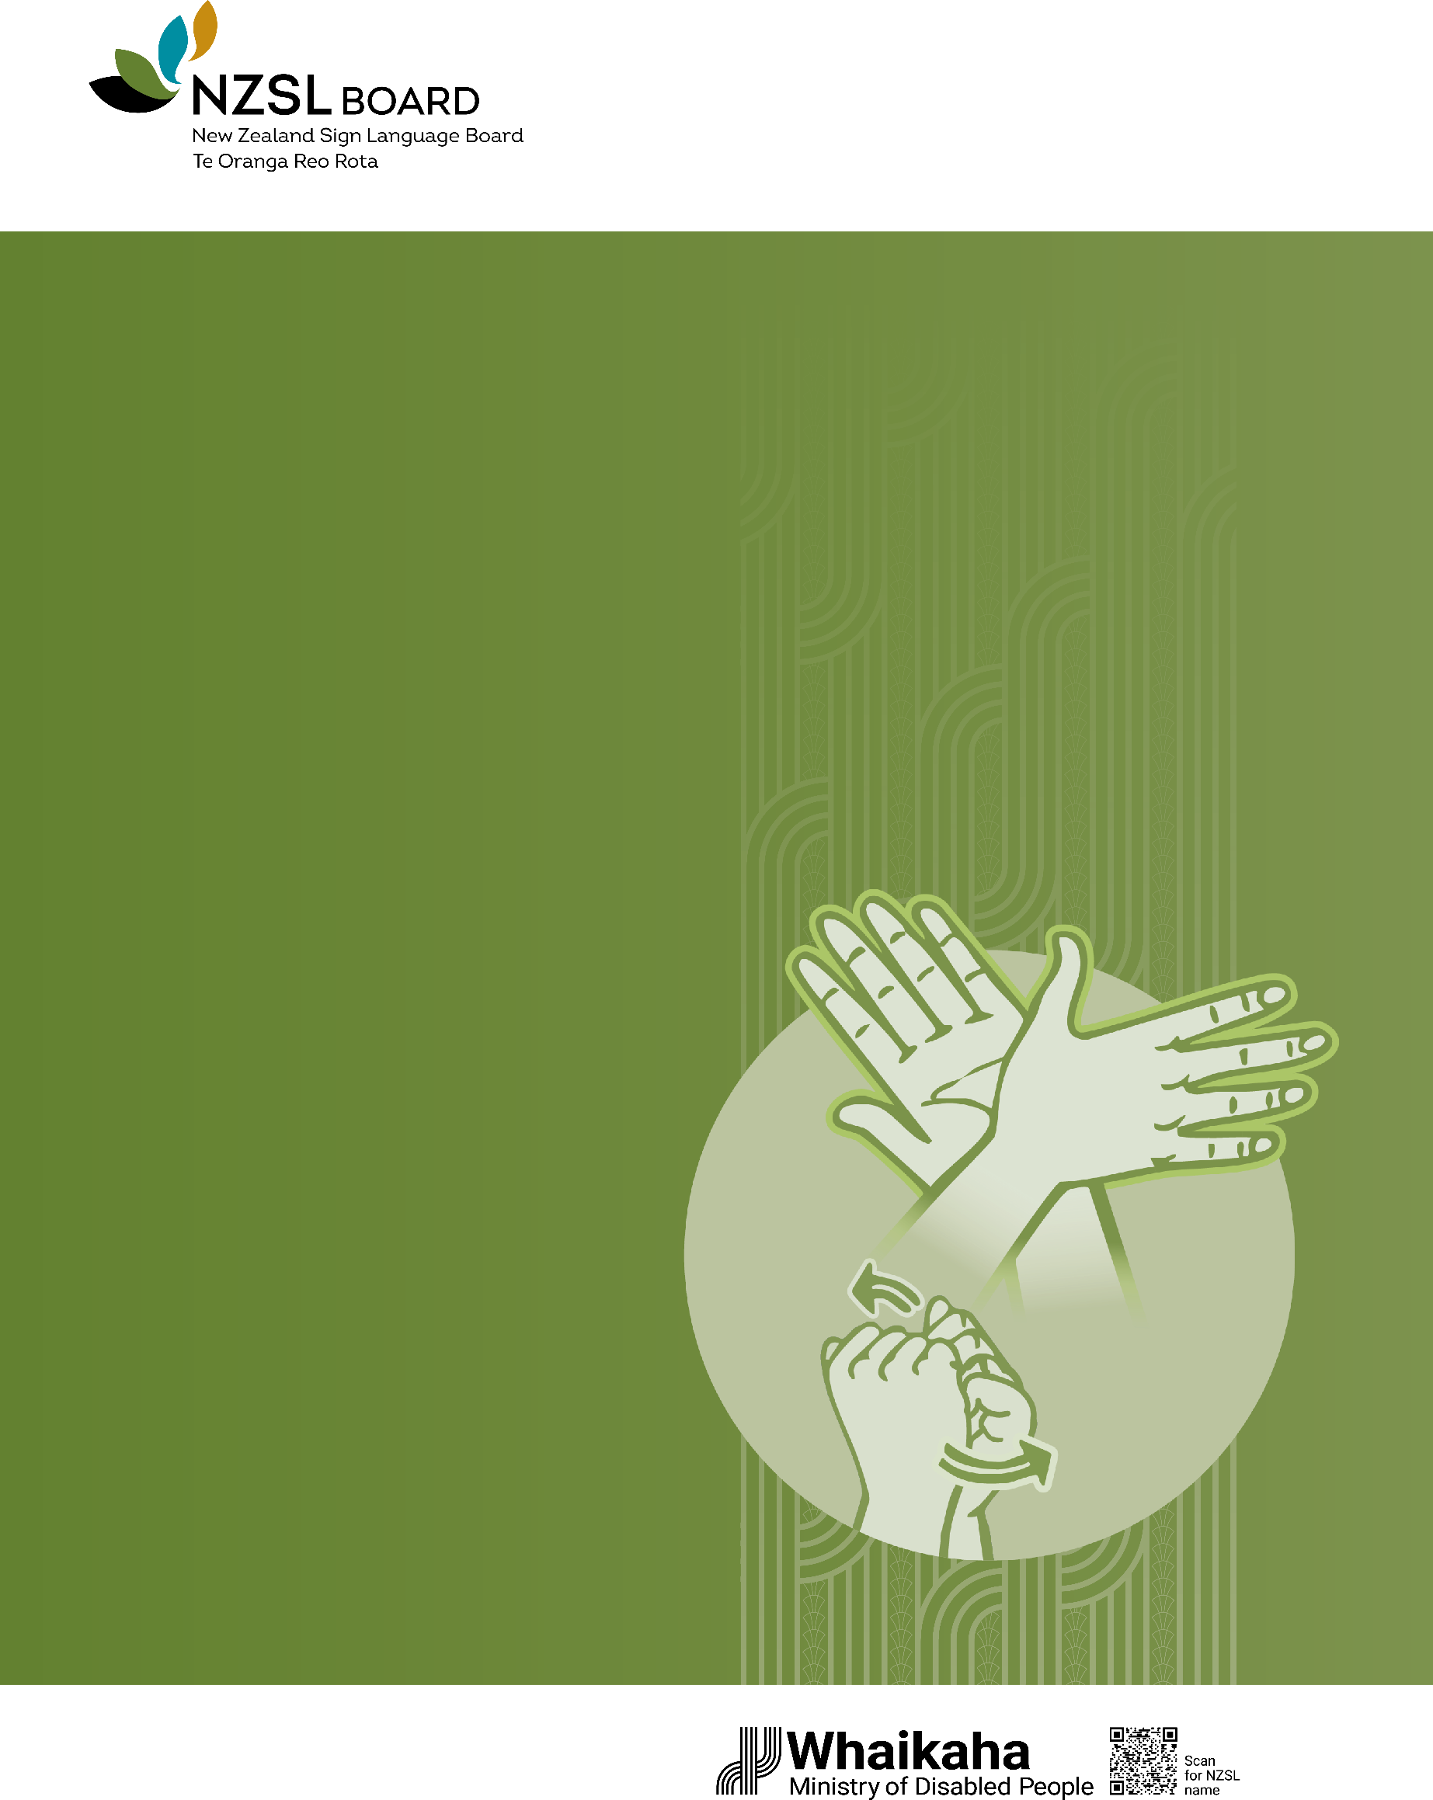

New Zealand Sign Language Strategy
New Zealand Sign Language
– everyone, everywhere, every day
2026–2036

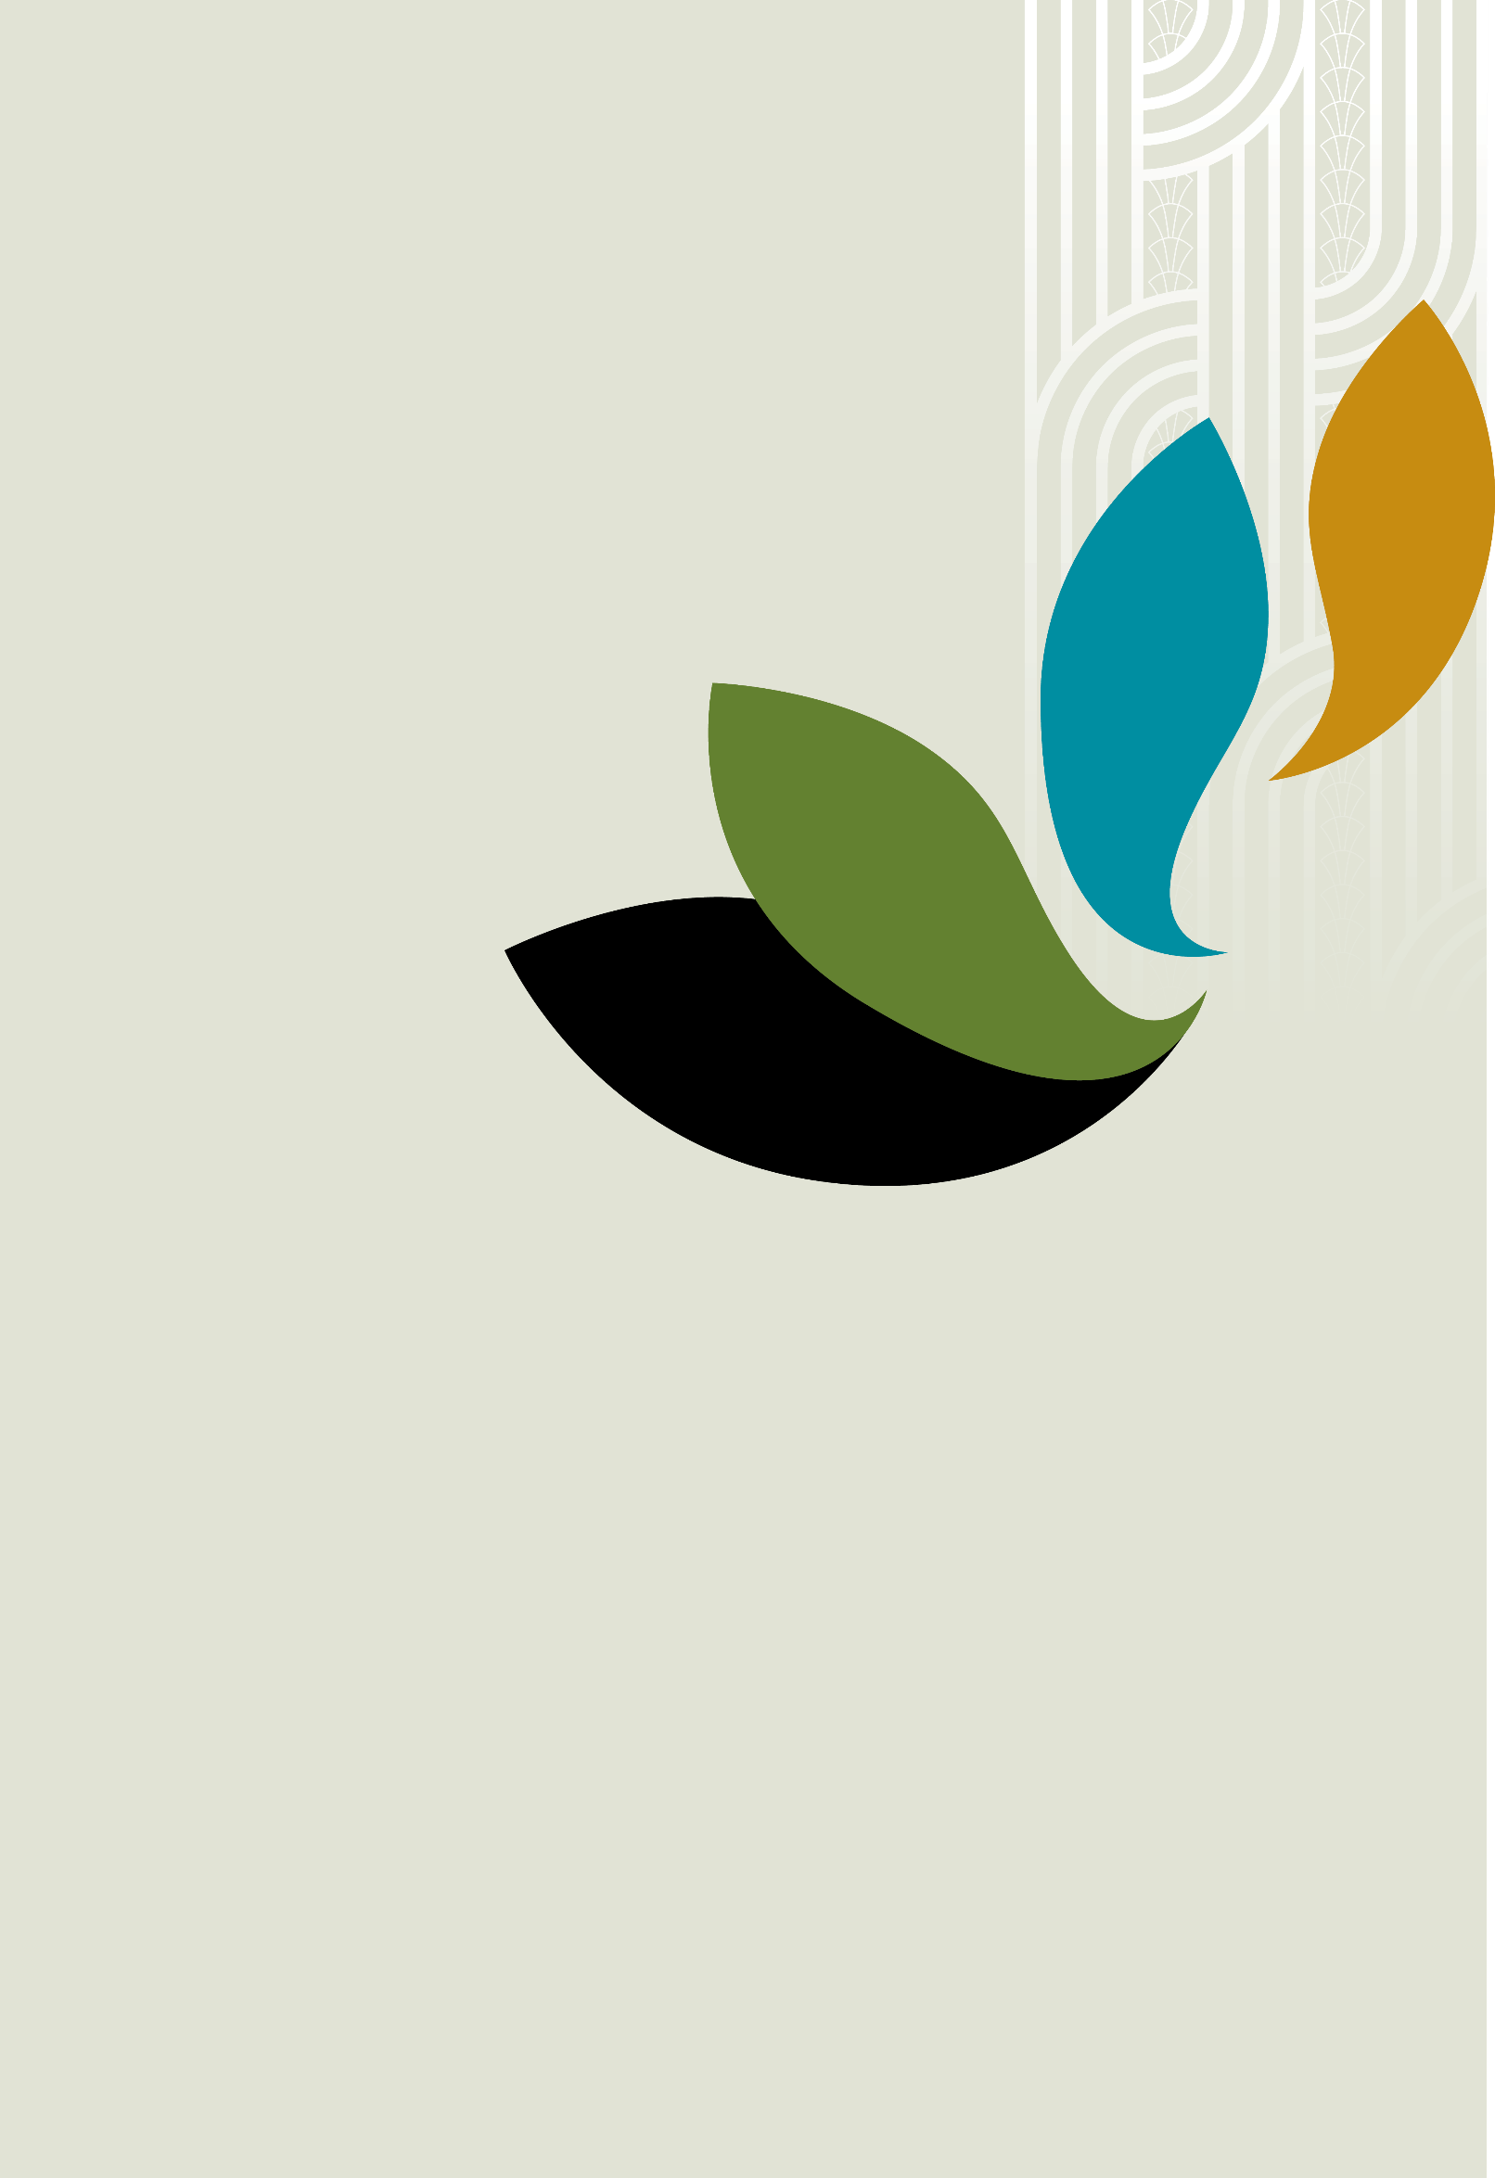
QR (Quick response codes)
QR codes are designed to be read using the camera in
a smartphone or tablet and make it easier to link to the
NZSL version and alternate formats of each section.
For most devices, open your camera application and point it
at the QR code. To work, the system requires you to be
connected to the internet.
You can also access the NZSL version and alternate
formats at www.nzsl.govt.nz/nzsl-strategy-2026-2036
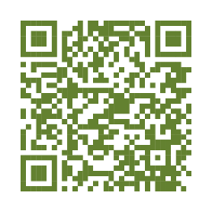

Acknowledgments
The New Zealand Sign Language Board and the Ministry of Disabled People – Whaikaha acknowledge and thank everyone who provided input to develop
this strategy.

This work is licensed under the Creative Commons Attribution 4.0.
In essence, you are free to copy, distribute and adapt the work, as long as you attribute the work to the Crown and abide by the other licence terms.
To view a copy of this licence, visit: CC BY 4.0 Legal Code | Attribution 4.0 International | Creative Commons.
Please note that no departmental or governmental emblem, logo or coat of arms may be used in any way which infringes any provision of the Flags, Emblems, and Names Protection Act 1981. Attribution to the Crown should be in written form and not by reproduction of any such emblem, logo, or coat of arms.
Published November 2025
ISSN (Print) 978-1-991429-00-1
ISSN (Online) 978-1-991429-01-8

Contents
Minister’s Foreword 4
NZSL Board Chair’s Foreword 5
Te Rōpū Kaitiaki kupu whakataki / Foreword 6
Executive Summary 8
New Zealand Sign Language (NZSL) is an official language of New Zealand 8
This strategy has a goal of everyone being aware of, using and accepting NZSL 8
Building NZSL use will improve outcomes for all New Zealanders 9
Everyone has a role to play to achieve real change 9
This strategy is about NZSL and the people who use NZSL 10
NZSL is a dynamic, visual language 10
NZSL access, use and human rights 10
Why is NZSL essential? 10
Outcomes for Deaf people in New Zealand 12
NZSL is also used by other people in New Zealand 13
Refreshing the NZSL Strategy 14
The first NZSL strategy responded to concerns NZSL was a language at risk –
and it is still at risk 15
NZSL users cannot always access services and information using NZSL 15
Ensuring NZSL is recognised and embraced by all New Zealanders 16
The NZSL Strategy 17
The NZSL Strategy is based around two strategic approaches 18
Five priority areas sit under the two approaches 21
Acquisition and Learning 23
Evidence and Data 24
Deaf and NZSL workforce 25
Public Sector 26
Celebrating NZSL 28
Implementing the refreshed NZSL Strategy 29
Developing action plans to deliver on the strategy 30
Reporting on progress 30
Measuring change 31
Knowing whether the strategy is making a difference 31


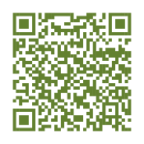

Minister’s Foreword
I am very pleased to release the New Zealand Sign Language (NZSL) Strategy 2026–2036. The strategy is ambitious and seeks to address the issues faced by NZSL users, particularly the Deaf community, when learning and using NZSL.
I have spoken of the importance of NZSL many times. I also recognise that NZSL users, primarily Deaf people, have struggled to access public services or community events using NZSL. This ongoing struggle reflects the importance of having a strategy that guides the work needed across government and across community organisations, to ensure that NZSL is and can be used by everyone, everywhere, every day.
I want to thank the NZSL Board for its work in developing this strategy, and for its continued work in advocating for the maintenance and promotion of NZSL. I also want to acknowledge and thank all of the individuals, communities, and organisations, who participated in the consultation – your views have helped to shape this strategy.
It is important that all of us – government agencies, community organisations, businesses, communities, hapū and iwi, families and whānau – whether we are Deaf, hard of hearing, or hearing – continue to be involved in supporting, strengthening, and promoting NZSL in New Zealand.
While New Zealand has come a long way in promoting NZSL, there is still much more work to do. This strategy reflects both the need, and the ambition, for change to occur so that this nation reflects NZSL – everyone, everywhere, every day.
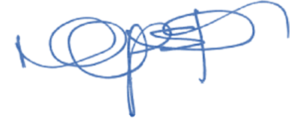
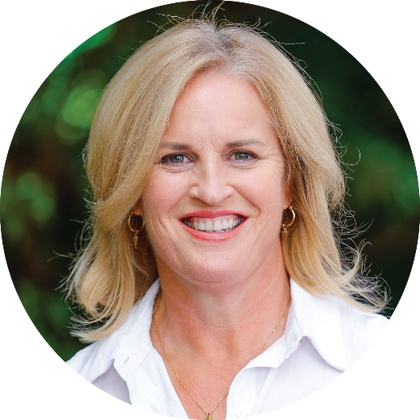
Hon Louise Upston
Minister for Disability Issues

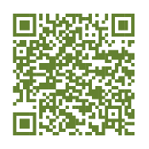

NZSL Board Chair’s Foreword
It gives me great pleasure to release this NZSL Strategy. This strategy reflects the Board’s ambitions for NZSL. We want NZSL to be a strong and vibrant language that is recognised and embraced by all New Zealanders.
We want NZSL to be a living language that supports and improves the lives of Deaf people, Turi Māori, and hard of hearing people. We also want NZSL to enrich and enhance the lives of non-speaking people who use NZSL.
This strategy is the culmination of research and information collected through engagement with the Deaf community over recent years. It also reflects the insights generously shared by Te Taura Whiri i te Reo Māori – the Māori Language Commission on its experiences growing the use of te reo Māori. Most of all, this strategy reflects you, your participation in research over the last few years, and your input and insights during the public consultation. Thank you. With your continued support, the Board can lift the understanding, acceptance, and value of NZSL in New Zealand so that it is truly valued and recognised as the taonga that it is.

Finally, I want to acknowledge current and recent past members of the Board for their work in developing the strategy. I also want to acknowledge current and recent past members of Te Rōpū Kaitiaki for their support and advice to the Board.
Catherine Greenwood
Chair, NZSL Board

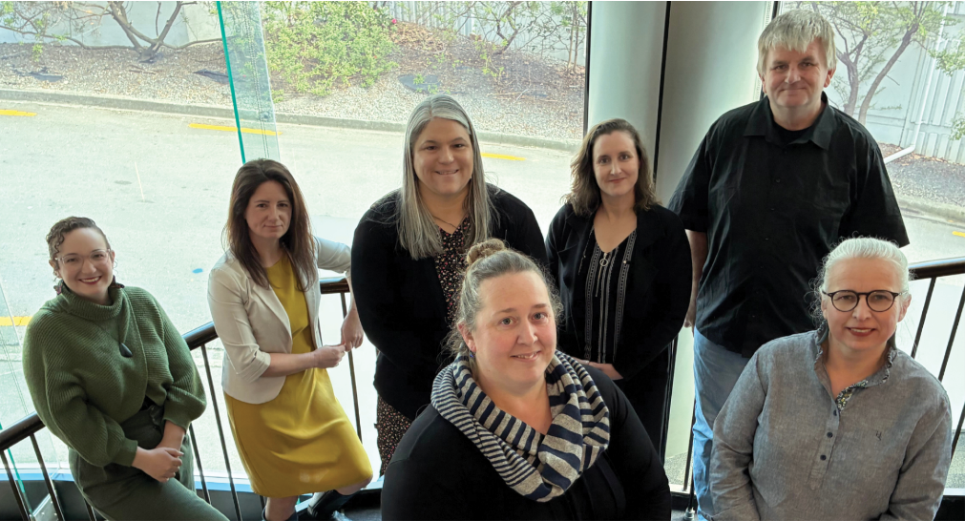 | Members of the  NZSL Board  Front (L-R) Joanne Beckers, Monica Leach.  Back row (L-R): Erica Dawson, Jaime Brown, Catherine Greenwood, Sarah Mason, Kim Robinson.  Absent: Rosita Rapihana

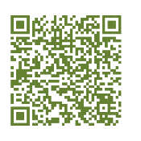

Te Rōpū Kaitiaki kupu
whakataki / Foreword

Mihimihi / Welcome
E ngā mana, e ngā reo rotarota, e ngā Turi Māori me ō koutou whānau whānui, tēnā koutou katoa! E ngā mate kua whetūrangitia, haere, haere, haere atu rā.
We acknowledge all Turi Māori across Aotearoa. We honour those who have passed away and now live in the stars. We farewell you. Tihei mauri ora! Your memory lives on as we continue your good work.

Kupu whakataki / Foreword
Te Rōpū Kaitiaki, the Māori Advisory Group to the NZSL Board, offers cultural guidance rooted in Mahi Rangatira – Leading Together. We base our decisions on what is best for our mokopuna, aiming to improve access to education, health, and te ao Māori, including more trilingual interpreters (people skilled in te reo Māori, NZSL and English).
It is vital that our community – especially rangatahi and mokopuna – can connect
with te ao Māori through NZSL. Turi Māori leadership provides strong role models to support this identity.
We are proud the strategy reflects Turi Māori aspirations, and we look forward to shaping better outcomes with the NZSL Board, in kotahitanga.
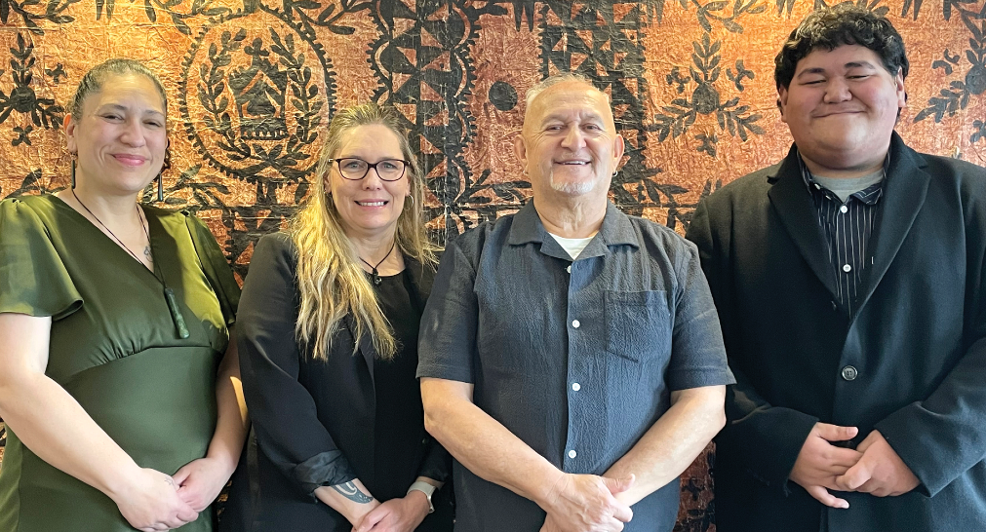 | Members of Te  Rōpū Kaitiaki  From left to right: Stevie Aiono, Rāhera Turner, Haamiora Sam Te Maari, Brooklyn West.  Absent: Mita Moses

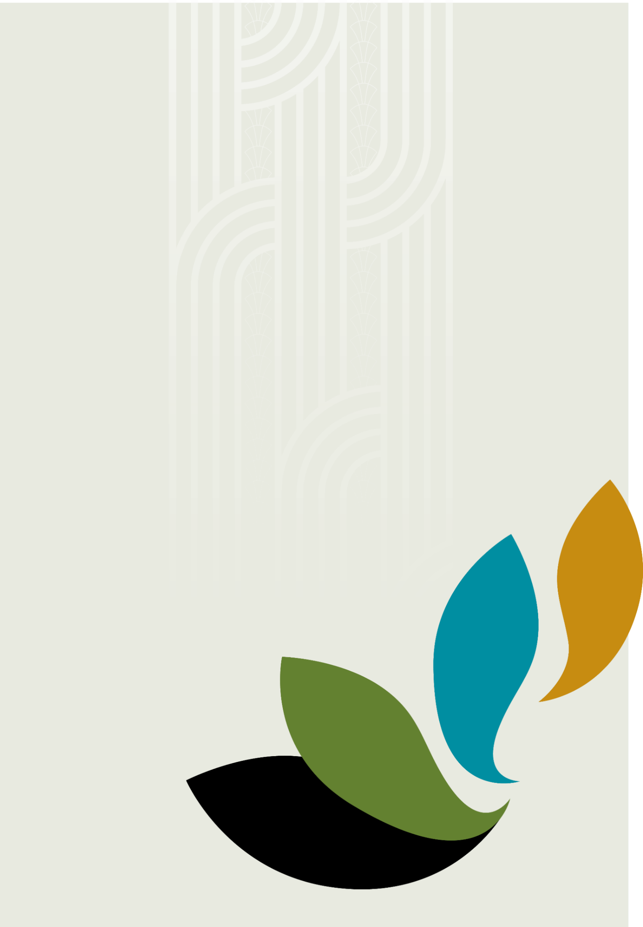
Ka mutu, kia whai ora,
kia whai hua, kia whai kaha
– Haumi ē, hui ē, tāiki ē!
We will embrace and grow these qualities to live well, thrive
and find strength.
United we are stronger.


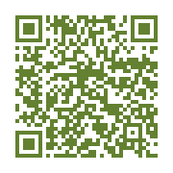

Executive Summary

New Zealand Sign Language (NZSL) is an official language of New Zealand
NZSL is more than just an official language; it is about communication. Without language and communication, people do not have connection and inclusion.
NZSL is the language used by many Deaf and hard of hearing people living in
New Zealand. It can also be the preferred language of non-speaking people, and people who use signed rather than spoken language.
For some people in New Zealand, NZSL will be their only language.
This strategy outlines the changes needed to ensure that Deaf people and NZSL users can learn, access, and use NZSL. Learning and using NZSL is important if
Deaf people and NZSL users are to have equal opportunities in areas like health, education, and employment. It is also important for supporting Deaf people to foster Deaf identity.

This strategy has a goal of everyone being aware of, using and accepting NZSL
The vision for this strategy is “New Zealand Sign Language - everyone, everywhere, every day”.
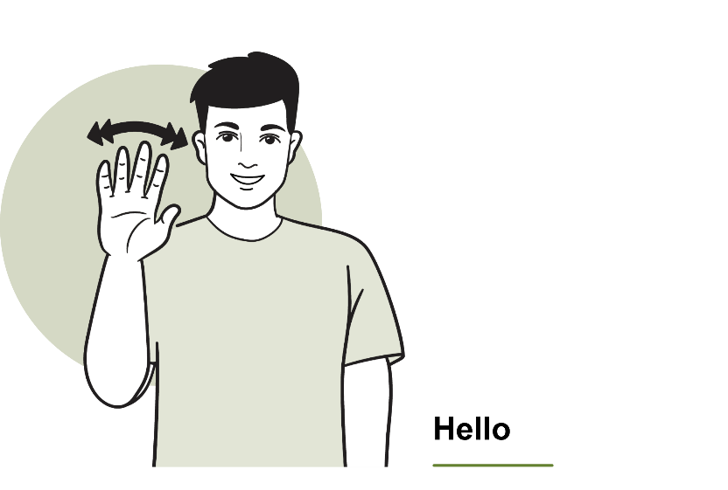
The aim is for all hearing New Zealanders to be able to incorporate NZSL phrases into everyday language in the same way many New Zealanders have adopted kupu
Māori, such as ‘kia ora’. This is not intended to reduce or weaken the importance
of Deaf people and NZSL users being able to access education, services, and information using NZSL, but rather recognises that to strengthen NZSL, everybody needs to be aware of, using or accepting NZSL. This could include learning tactile variations of NZSL.
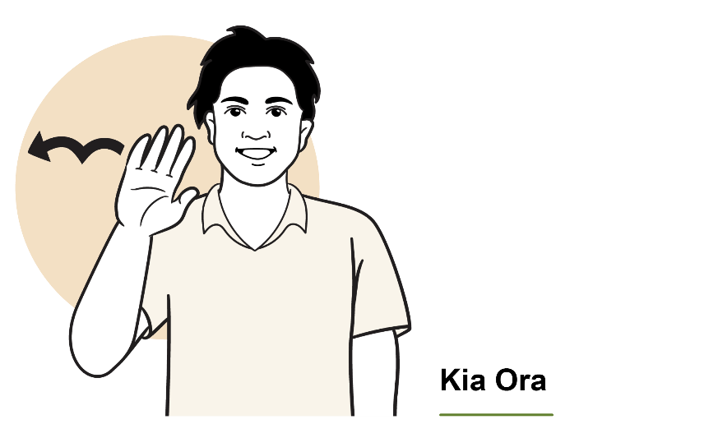


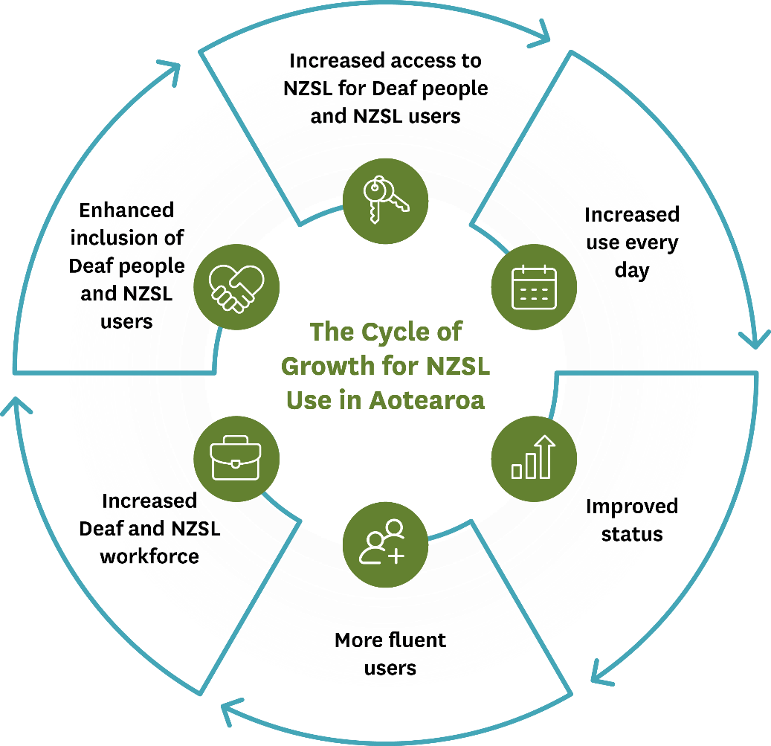

Building NZSL use will improve outcomes for all New Zealanders
The more NZSL is used and integrated into society and societal norms, the more the status of NZSL will be lifted. Increasing everyday use and fluency in NZSL will improve access to services and lead to better outcomes for Deaf people and NZSL users.
Increasing NZSL use will help build the Deaf and NZSL workforce, including Deaf tutors and teachers, and NZSL interpreters (including trilingual and tactile interpreters). This benefits everyone by increasing access to NZSL tutors, teachers, and interpreters, while promoting a more inclusive society and reducing communication barriers for Deaf people.

Everyone has a role to play to achieve real change
This strategy, and the priorities and actions outlined in it, are ambitious. Many actions will stretch well beyond the timeframe of this strategy.
While progress has been made, more is needed if real change is going to happen. Improving the responsiveness of agencies and service providers to Deaf people and NZSL users will result in better outcomes for Deaf people and NZSL users. It is also about challenging agencies, service providers, organisations and businesses to really look at what they are doing to improve the lives of Deaf people and NZSL users.
This strategy is for everyone in New Zealand. Everyone can play a part in making NZSL a strong, vibrant, living language recognised and embraced by all.


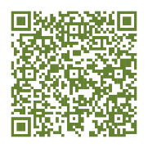

This strategy is about NZSL
and the people who use NZSL

NZSL is a dynamic, visual language
NZSL is a dynamic, visual-gestural language which uses the hands, body, and facial expressions to communicate. While sign languages have distinct linguistic families and lineages, NZSL is unique to New Zealand.
NZSL is not a signed form of a spoken language. Like other languages, it has its own grammar and sentence structure. There are also regional differences which are known as variations. Like all languages, NZSL is a living language continually evolving.

NZSL access, use and human rights
The New Zealand Sign Language Act 2006 declared NZSL to be an official
language of New Zealand. The Act also provided for the use of NZSL in legal proceedings and set out principles to guide government departments in the promotion and use of NZSL.
In addition, the right to use sign languages is also covered by international conventions, such as the United Nations Convention on the Rights of Persons with Disabilities (UNCRPD), which promotes and protects the human rights and freedoms of disabled people, and respect for dignity. The UNCRPD recognises sign languages as equal to spoken languages. Under the UNCRPD, people are entitled to have their cultural and linguistic identity recognised, including sign languages and Deaf culture.
The protections under the Treaty of Waitangi / Te Tiriti o Waitangi would also
involve protecting the rights of Turi Māori (Māori Deaf) to use NZSL to access te ao Māori concepts.

Why is NZSL essential?
There is often an assumption that everyone understands written English. However, this is not always the case for Deaf and hard of hearing people. Without access to NZSL, many Deaf people miss out on important information and interactions within the community and within the workplace.
NZSL is important because it is the preferred (and sometimes only) language
used by Deaf and hard of hearing people to communicate, to connect, and to be included in society.

Deafhood and Deaf culture
The term ‘deaf’ is an umbrella term used to refer to audiological deafness. It includes people who are born deaf or hard of hearing and people who become deaf later in life. People who are prelingually deaf were born deaf or become deaf prior to acquisition of a spoken language. Children who are prelingually deaf need to acquire NZSL in a way comparable to their hearing peers’ acquisition of a spoken language. They will then have a foundation language to learn other languages, such as English or te reo Māori.
The term ‘Deaf’ (with a Capital D) is used when referring to Deaf culture and the
Deaf community. Deaf culture reflects the beliefs, attitudes, history, norms, values, traditions, and art associated with Deafhood, including the shared common language and similar life experiences. Deafhood reflects the journey undertaken to understand and identify as a Deaf person, celebrating both the language (NZSL) and Deaf culture. NZSL is an integral part of Deaf culture.
This strategy uses ‘Deaf’ to refer to Deaf and hard of hearing people, while ‘deaf’ will normally be used to refer to deaf and hard of hearing children, who are still on their identity journey.

Deaf identities and intersectionality
The Deaf community is diverse including Māori (Turi Māori), Pacific people, ethnic communities, rainbow communities, and Deaf Plus / Deaf+ people (Deaf people with additional disabilities). Recognising diverse identities and the intersectionality helps to understand different experiences and barriers Deaf people have when accessing and using NZSL.
Technologies such as cochlear implants and / or hearing aids are useful tools in accessing environmental sounds. People with cochlear implants may want to develop fluency in NZSL and their Deaf identity. Involvement in the Deaf world will be important to them.

Turi Māori navigate through both the Māori and Deaf worlds
The NZSL Board (the Board) acknowledges Turi Māori as tāngata whenua of New Zealand. Turi Māori identify as Māori and as members of the Deaf community. This means Turi Māori have a dual identity – both as Māori and as Deaf. For Turi Māori, it is important to be able to navigate in the worlds of both identities.
Turi Māori face barriers accessing te ao Māori. NZSL does not always reflect Māori concepts, and there is a low number of NZSL interpreters who can confidently interpret in te reo Māori setting.
The Board recognises the Crown has obligations under the Treaty of Waitangi /
Te Tiriti o Waitangi to actively protect the interests of Māori, which includes the interests of Turi Māori.

Outcomes for Deaf people in New Zealand
The first three years of a child’s life are key for language learning. Deaf children (0–5 years) may receive support through an early years NZSL acquisition programme. However, not all deaf children will receive early support or exposure to NZSL. The
lack of access to quality education at an early age, and the resulting social isolation negatively impacts on the outcomes of deaf children and results in language deprivation. International research indicates that language deprivation can cause significant long-term harms to deaf children, including poorer health, mental health, and overall life outcomes.
Deaf students in New Zealand achieve NCEA Level 2 at a lower rate than the New Zealand average. Deaf people also have lower rates of tertiary qualification, with Turi Māori having lower qualification rates than non-Māori Deaf.
Overall, the available research indicates Deaf people have poorer life outcomes than non-Deaf people. Turi Māori are likely to have poorer outcomes than other Deaf people. Turi Māori tend to have lower levels of educational achievement, lower incomes, poorer health and mental health outcomes, with higher rates of welfare and social housing support.
The Royal Commission of Inquiry into Abuse in Care
Deaf people suffered significant abuse – physically, mentally, sexually, racially, and culturally (including the denial and lack of access to te ao Māori, and te
reo Māori) – in institutions and places that should have been caring for them, including Deaf institutions, and schools.
Deaf children / tamariki were denied the right to use and learn NZSL and
were punished for doing so. This resulted in generations of Deaf people in
New Zealand who have suffered significant and lifelong negative outcomes due to not being allowed to learn NZSL. It also had, and continues to have, impacts for their family members, including parents, siblings, partners, and children.

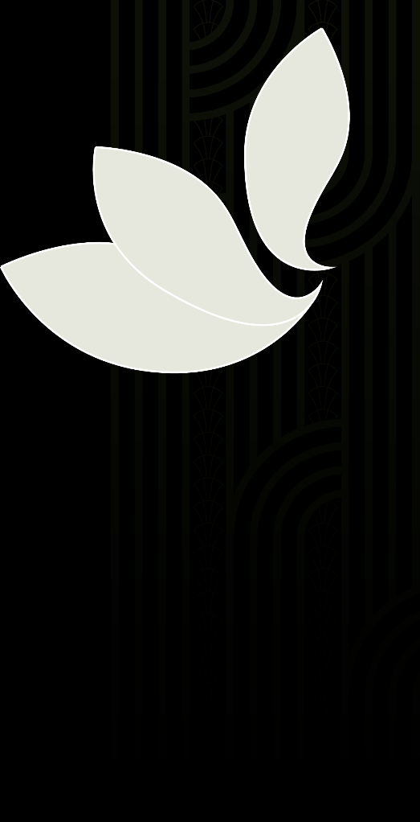

NZSL is also used by other people in New Zealand
In addition to the Deaf community, other people also use NZSL to communicate.
These include:
- the deafblind community: Many deafblind people use NZSL or tactile signing to communicate. This can include fingerspelling (using NZSL to spell words directly onto the palm of a hand), and hand over hand signing (where the deafblind
person places hands over those of the person using NZSL, to follow what is being communicated through touch and movement). Deafblind people face significant barriers when accessing services or supports including education and health, and in being able to fully participate in society.
- Child of Deaf Adult (CODA): NZSL is the first language for some CODA, and Deaf culture can be an important part of CODA identity. CODA and other hearing family members can help bridge the gap between Deaf and hearing people. However,
this can also lead to an expectation from some people (including family members) and service providers that CODA will communicate for Deaf family – even when a young child. Using CODA in this way is not appropriate.
- non-speaking people and people who have difficulty communicating: It
is estimated that up to 10 percent of the population has some form of difficulty communicating. Teaching NZSL to non-speaking children ensures children learn a language during the key language learning years, providing a way to communicate.

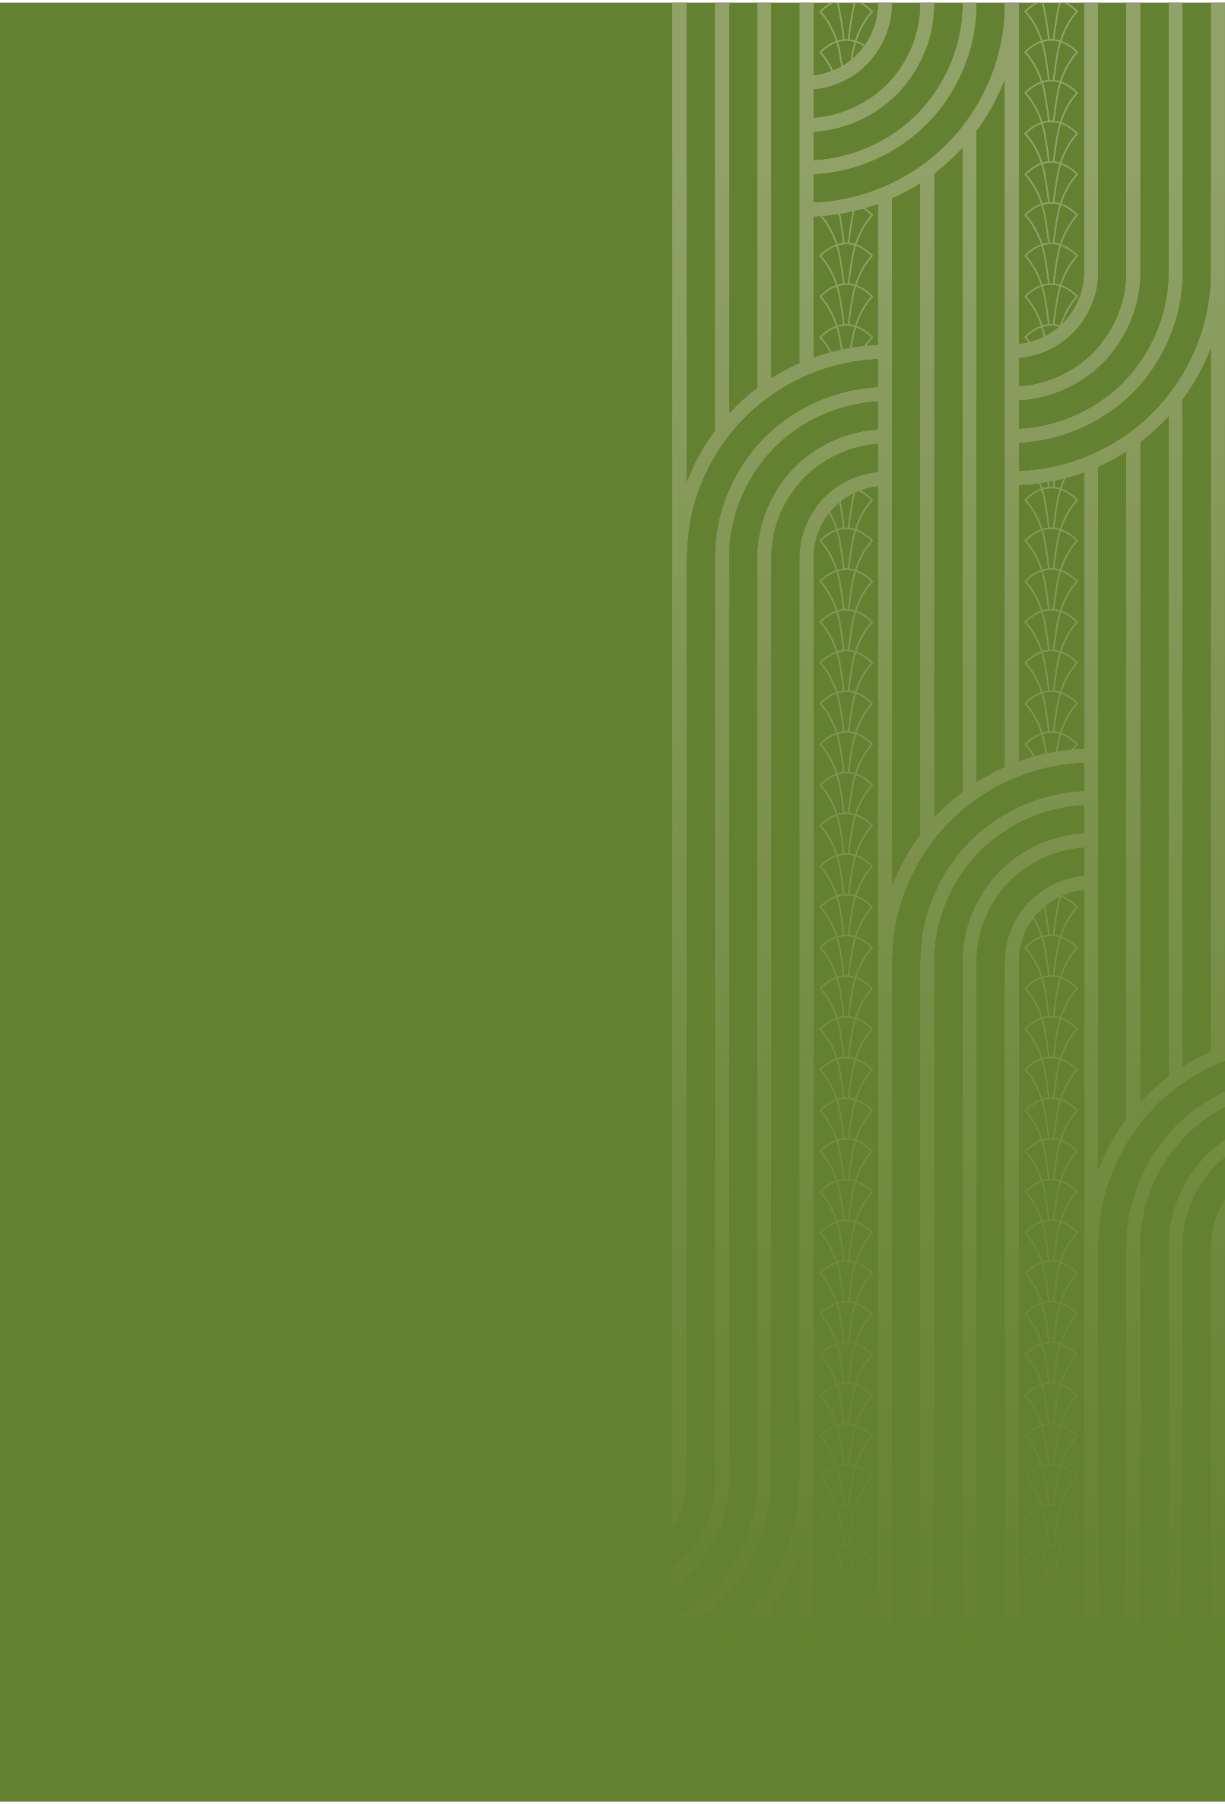

Refreshing the NZSL Strategy

The first NZSL strategy responded to concerns NZSL was a language at risk – and it is still at risk
Research in 2017 indicated that while NZSL was becoming more recognised and accepted, the percentage of the Deaf population that were learning and using the language had remained the same. This put the language at risk.
Evidence suggests the situation has not changed. While the number of NZSL users has increased over the 2013, 2018 and 2023 censuses, the number of users still amount to only about 0.5 percent of the population. This means that the percentage of the population using NZSL has stayed the same.

NZSL users cannot always access services and information using NZSL
Deaf people and NZSL users often lack access to NZSL in key areas such as education, healthcare, the justice system, and broader government services.
A 2022 community survey, as well as targeted Board engagements over 2024 indicated Deaf people, particularly children, and their families and whānau face challenges in learning NZSL and using NZSL in everyday interactions.
These challenges impact on the wider participation and well-being of the Deaf community Turi Māori face additional barriers in being fully able to use NZSL to access te ao Māori.
There is also a disconnect between the status of NZSL as an official language, and the actions, behaviours, and practices of government agencies in promoting and using NZSL. The Ministry of Disabled People – Whaikaha undertook a survey of 30 government agencies in 2024. While there were examples of good practice, the survey found NZSL was not well incorporated into many government work areas, and information and services were not always accessible in NZSL.

When NZSL or NZSL interpreters are unavailable, appointments are often cancelled
or postponed or Deaf people need to rely on methods like lip reading, writing, or using friends or family to communicate, which can lead to misunderstandings and serious implications, particularly in health and justice settings. Family members acting as interpreters can prevent Deaf people from sharing personal information.

Ensuring NZSL is recognised and embraced by all
New Zealanders
The use of NZSL interpreters during significant events, such as the Christchurch earthquakes, the Christchurch terror attack, the Whakaari / White Island eruption, and COVID-19, has built awareness and recognition of NZSL in the hearing community. Initiatives, such as NZSL Week, have also resulted in increased interest and awareness of NZSL. It has also highlighted to the hearing community the important role NZSL plays in the lives of Deaf people and NZSL users.
This strategy’s vision – New Zealand Sign Language – everyone, everywhere, every day – reflects the aim that all people in New Zealand will be aware and accepting of NZSL. But importantly it also reflects the aim for all Deaf people and non-speaking people to be able to access and learn NZSL.
Building recognition and acceptance of NZSL will help NZSL to become embedded in New Zealand culture. This will support Deaf people and NZSL users, help build the Deaf and NZSL workforce, and reduce the barriers faced by Deaf people / NZSL users in workplace, and when seeking information and services in NZSL. It will also support and enable Turi Māori to fully navigate in te ao Māori.
Improving the interpreter system will also support people to train and work as NZSL interpreters, as well as growing the number of trilingual interpreters (interpreters
who can confidently interpret in te reo Māori settings), and tactile interpreters in
New Zealand. It will also support the growth of interpreters who can confidently interpret in a range of cultural and linguistic settings, such as in and across Pacific settings and communities.
NZSL becoming more acknowledged, recognised, and valued will also mean that more information and services become available in NZSL, and lead to improved NZSL education opportunities for all children / tamariki needing to use NZSL, particularly the Deaf community.
This change cannot be implemented by the Board or the Deaf community alone. For this vision to succeed, change is needed at all levels - across central government and local authorities, across iwi and hapū, and across all of New Zealand.



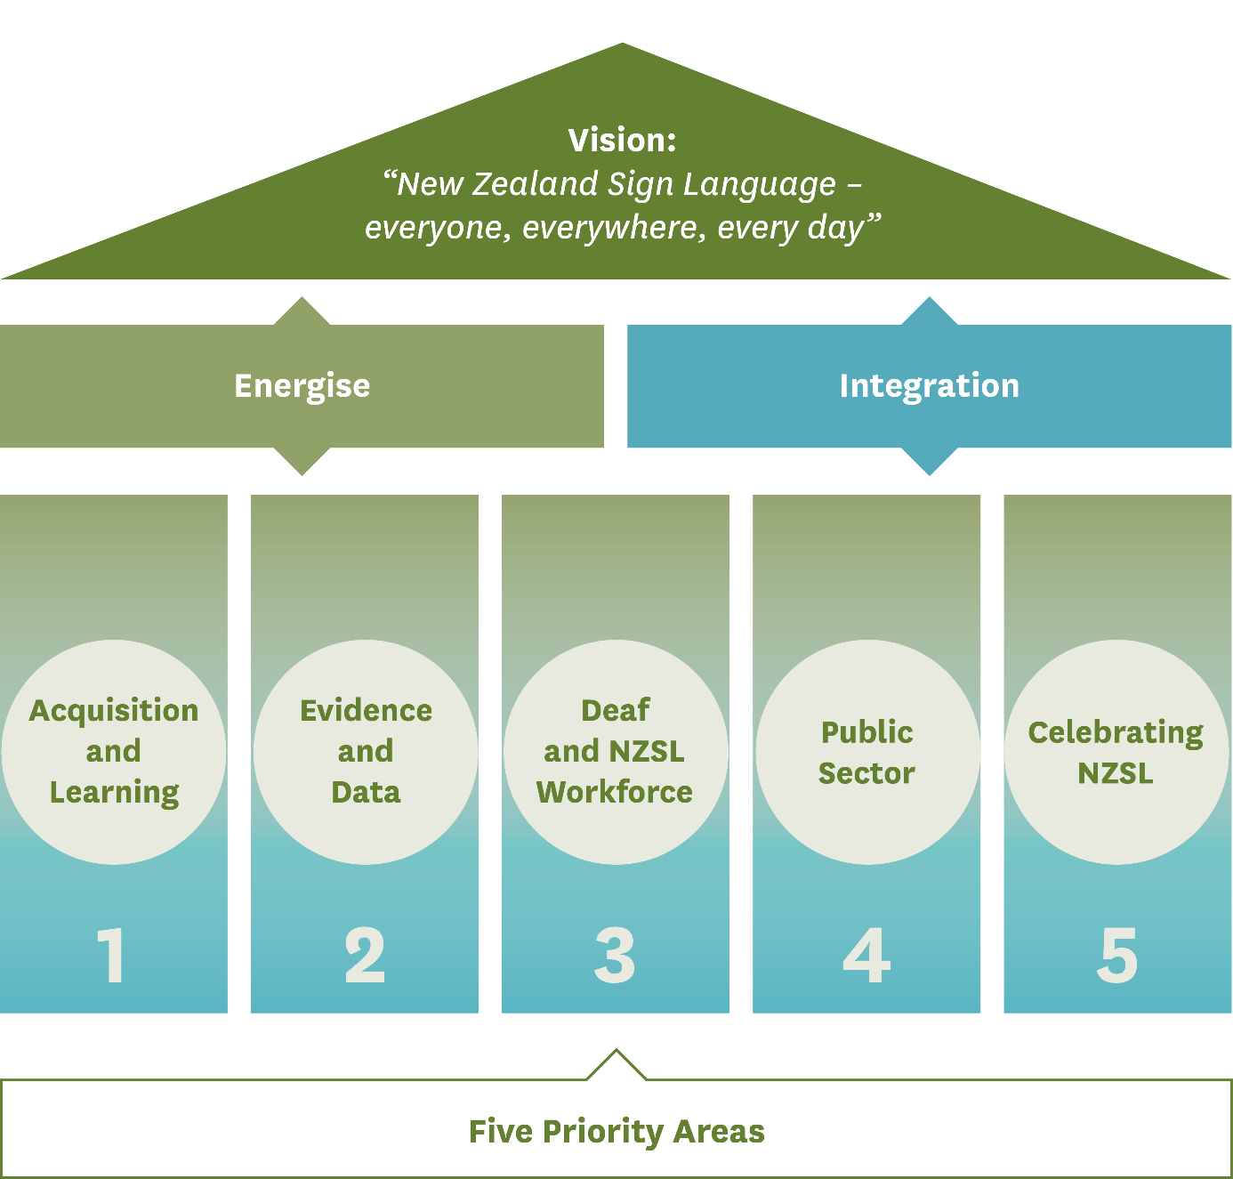
The NZSL Strategy


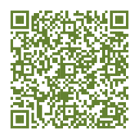

The NZSL Strategy is based around two strategic approaches
This strategy was influenced by research into the experiences of NZSL users in
New Zealand, as well as lessons from the work to strengthen te reo Māori.
There is a need to target actions towards people who use NZSL (particularly the Deaf community), and the wider community (the hearing community or non-NZSL users),
so that NZSL survives and thrives. This strategy calls these approaches ‘energise’
and ‘integration’:
Energise |  | Integration
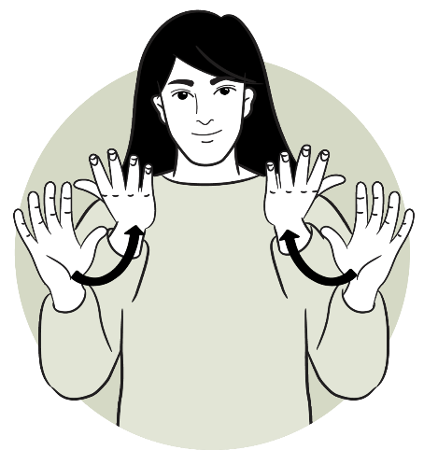 |  | 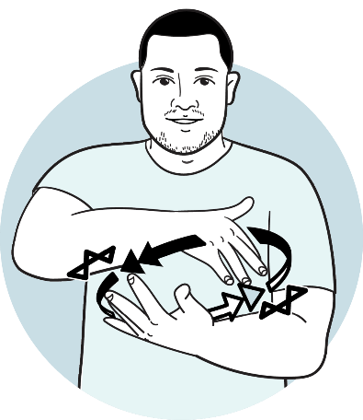
Energise is focused on Deaf  people and NZSL users, particularly children. It involves priorities and actions aimed at ensuring the survival of NZSL and ensuring early acquisition and use of NZSL by Deaf people and NZSL users. |  | Integration is focused on  people who do not use NZSL.  It involves priorities and actions aimed at ensuring NZSL thrives, and promoting the awareness, acceptance and everyday  use of NZSL.
It will be important that having two approaches does not impact on improving NZSL services to the Deaf community and other NZSL users. While the aim is for everyone to be aware of, using, and accepting of NZSL, this must not happen at the expense of Deaf people or NZSL users.
The Board, providers, and government must ensure that this work does not reroute limited resources away from deaf children or from children who need to acquire and access NZSL.
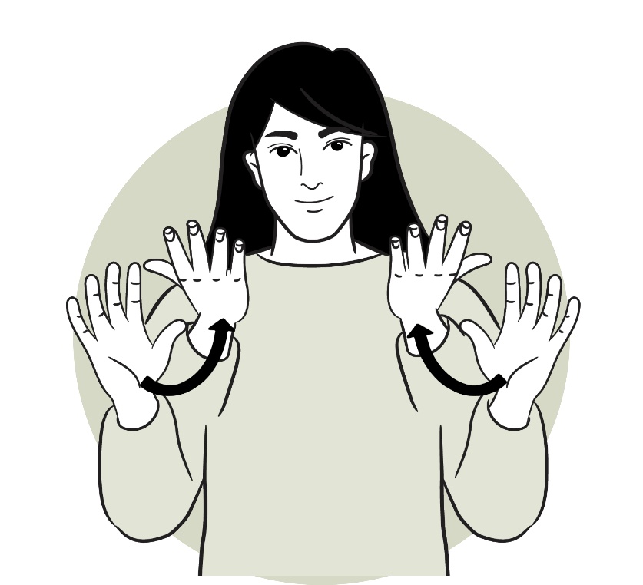

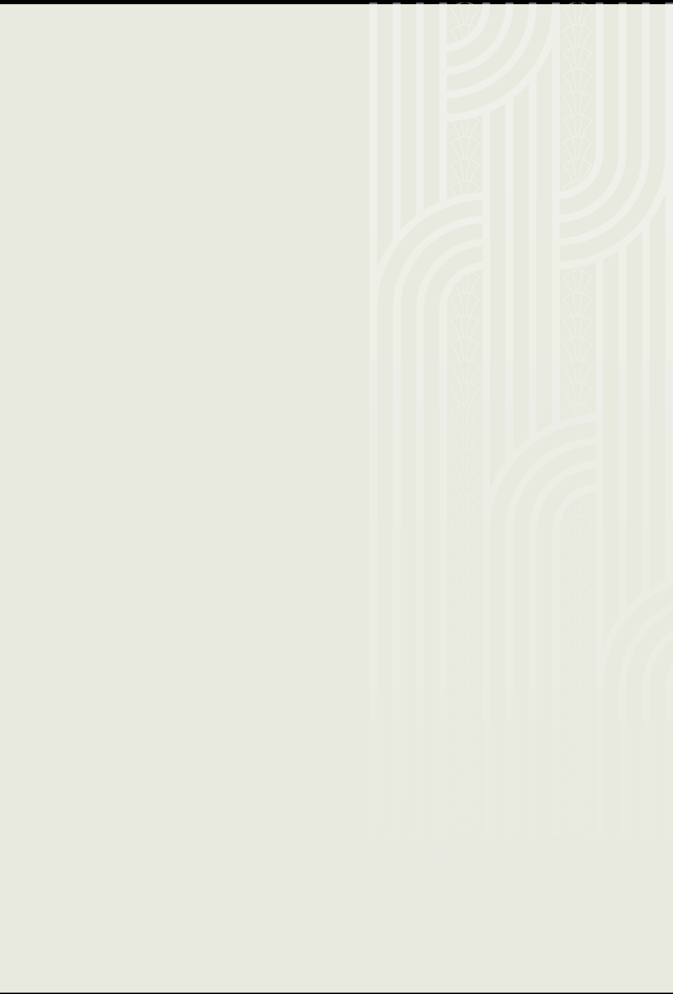
Energise
Energise is focused on Deaf people and NZSL users. It is about ensuring that Deaf people, and other NZSL users, particularly children can acquire and use NZSL across their lives.
Energise is about ensuring transmission of NZSL through family, whānau, communities, and education. Deaf people and NZSL users should be able to learn NZSL from an early age. Energise includes strengthening the use of NZSL in the home, recognising that most deaf children are born into hearing families and whānau.
Energise also involves building a strong language base for NZSL users, particularly children. Deaf people have the right to use and access information in NZSL as set
out in the New Zealand Sign Language Act 2006, while the UNCRPD also reflects the right to use and access information in sign language. The United Nations Convention on the Rights of the Child also sets out that children have the right to enjoy their own culture, and to use their own language.
Energising NZSL involves researching and documenting the language. It is also about ensuring that NZSL appropriately reflects te ao Māori, reflecting the obligations under the Treaty of Waitangi / Te Tiriti o Waitangi and the United Nations Declaration on the Rights of Indigenous Peoples.

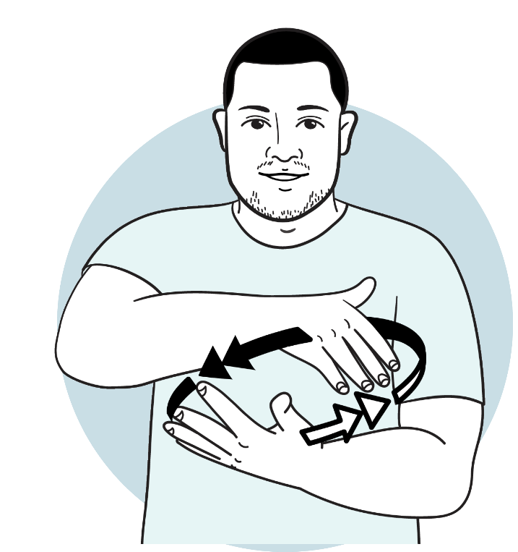


Integration
Integration is focused on people who do not use NZSL. It is aimed at ensuring non-NZSL users understand and accept the use of NZSL. It is also aimed at building New Zealand’s responsiveness to Deaf people and NZSL users.
Many barriers faced by NZSL users stem from the lack of awareness about NZSL,
and the lack of information and service available in NZSL. Integration is also about building awareness and understanding of the importance of NZSL, and the systems, policies, and practices needed to support Deaf people and NZSL users, such as reasonable accommodations in the workplace, and how to book and work with
NZSL interpreters.
The government and media as key drivers and influencers of change can support, facilitate, and enable wide-spread acceptance, understanding, acquisition and use of NZSL by the public.
Promoting understanding and recognition of the value of NZSL is important - especially given most deaf children are born into hearing families, will show the value of NZSL to all people’s lives. It is therefore important that everyone is aware of, understands, and values NZSL in New Zealand.

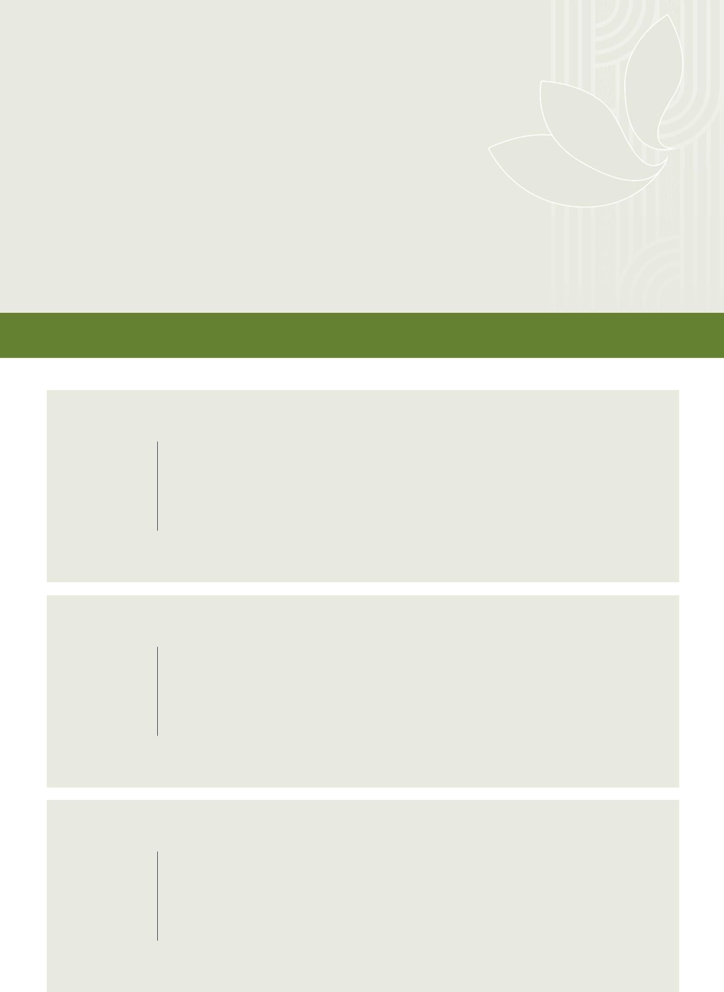
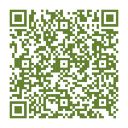

Five priority areas sit
under the two approaches
Five priority areas have been identified to support and enable the change needed:
1 | Acquisition and Learning  Enable deaf children / tamariki,  and children who use NZSL to communicate, and families and whānau to acquire and use NZSL. | 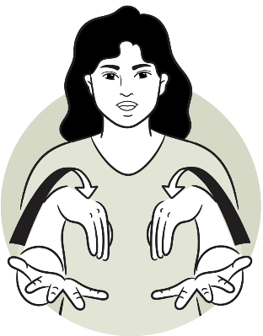
2 | Evidence and Data  Build an evidence-based profile of  Deaf people and NZSL users. | 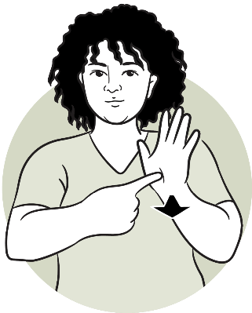
3 | Deaf and NZSL workforce  Ensure there is a workforce to support the acquisition and use of NZSL. | 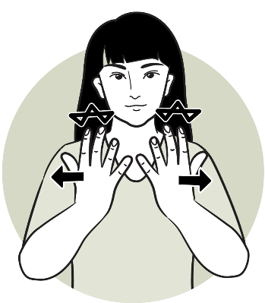

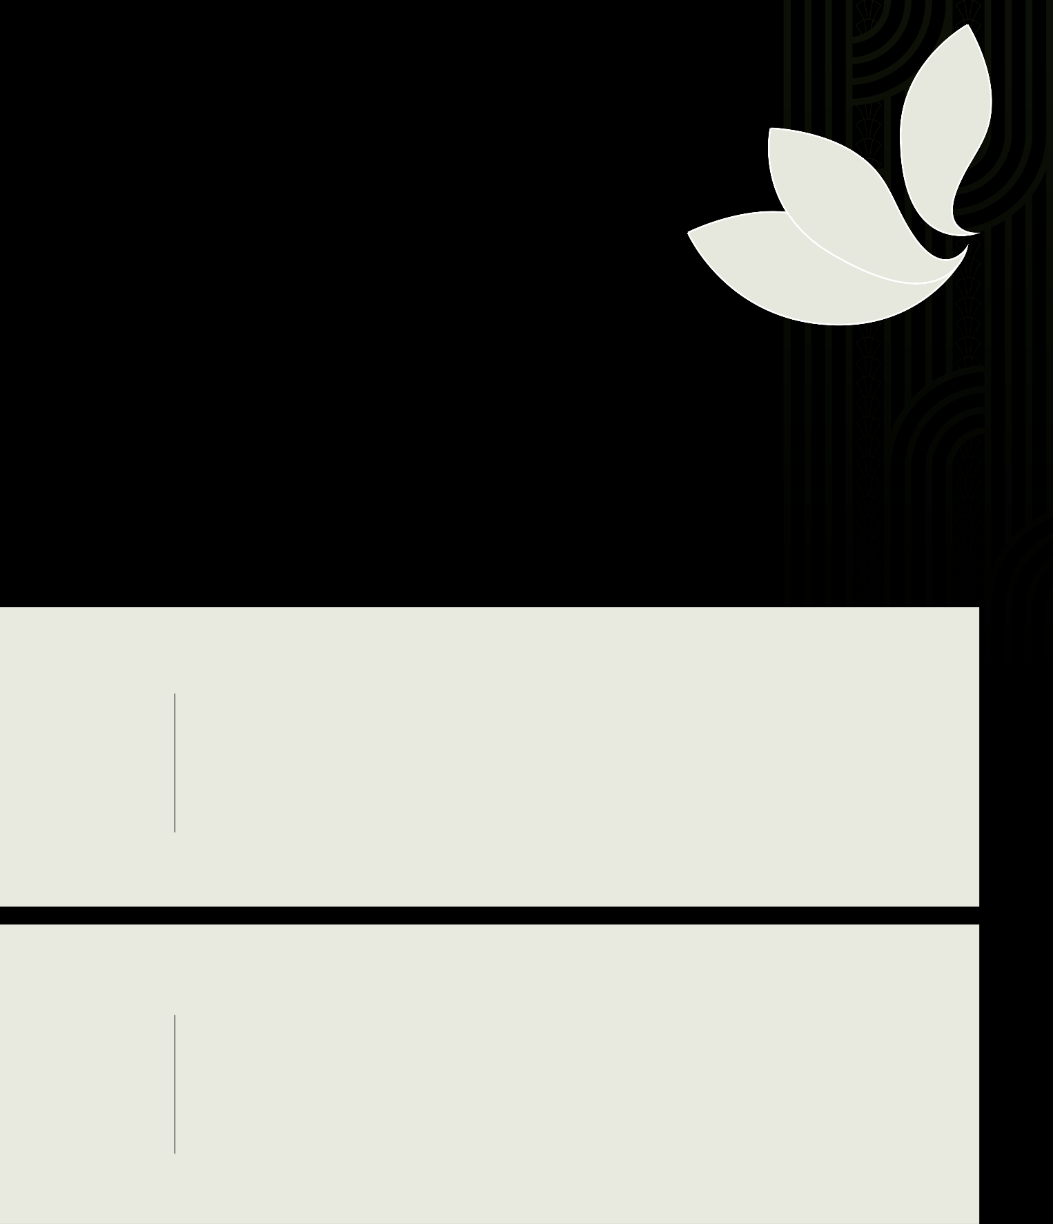

4 | Public Sector  Improve attitude, acquisition, and use  of NZSL across the public sector. | 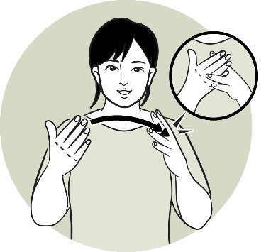
5 | Celebrating NZSL  Enhance the status of NZSL in  New Zealand and celebrate NZSL  across society and cultures. | 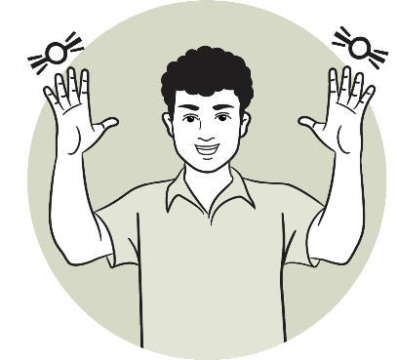
These five priority areas reflect the five language learning priorities in the first NZSL Strategy, and builds on them to:
- ensure appropriate opportunities for NZSL users, particularly deaf children, to learn and use NZSL
- build an evidence-based picture of the experiences of NZSL users, including developing measures (indicators) to show change or progress
- raise awareness and knowledge of NZSL and Deaf culture in New Zealand, and
- embed NZSL into New Zealand society and culture.


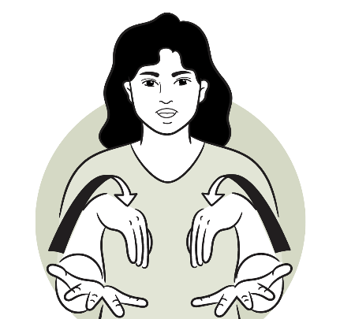
1


Acquisition and Learning
This priority is aimed at ensuring early access to NZSL. It is about ensuring deaf children / tamariki, and children who use NZSL to communicate, and families and whānau acquire, learn, and use NZSL.
NZSL learning opportunities must be available throughout childhood and adulthood. Many deaf children do not receive early access to NZSL and learn NZSL later in life. Late learning (or not learning) NZSL can result in language deprivation, and may result in poorer life-long education, employment, health, and mental health outcomes. Having learning opportunities throughout childhood would also reflect the right in the United Nations Convention on the Rights of the Child for children to use their own language.
In addition, most deaf children / tamariki are born into hearing families in
New Zealand. Many hearing parents will have had little or no exposure to NZSL or the Deaf community, so they should have the opportunity to learn NZSL alongside their child / tamaiti.
It is also important that children who are non-speaking or have difficulty communicating have opportunities to learn NZSL, and that their families and whānau are also provided with opportunities to learn NZSL.
Actions proposed for this priority area
- Ensure deaf children / tamariki, and children / tamariki who use NZSL to communicate, and families and whānau to learn NZSL together no matter the age of the child / tamaiti
- Assess and improve adequacy of information, resources, and supports for parents of deaf babies / pēpē, and children / tamariki
- Ensure learning pathways for deaf children / tamariki, and children / tamariki who use NZSL to communicate are fit for purpose
- Ensure learning pathways for Deaf adults and NZSL users to learn NZSL are fit for purpose
- Ensure data is collected on how many children are learning NZSL (including information about deaf status / non-speaking status), and how many are deaf or non-speaking children are not learning NZSL
- Elevate the role and perspectives of Deaf teachers and NZSL users as ‘kaitiaki’ of NZSL and as qualified educators
- Explore options to digitise learning modules in a way that is appropriate and acceptable to Deaf people and NZSL users

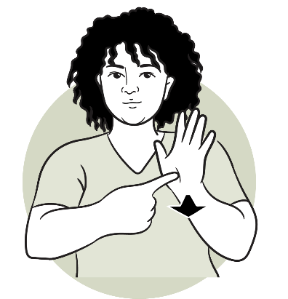
2


Evidence and Data
This priority is about developing and building an evidence-based profile
of Deaf people and NZSL users so resources can be more effectively targeted at opportunities and challenges for Deaf people and NZSL users.
It is important there is good information on NZSL and the experiences of NZSL users. This will help support and enable better outcomes for Deaf people and NZSL users, and ensure NZSL remains a strong, vibrant, living language.
There is minimal data about the experiences and outcomes of Deaf people and NZSL users available, which makes it difficult to ensure resources are targeted at the right issues, and that the experiences, barriers, and challenges faced by Deaf people
and NZSL users are well understood. It also makes it difficult to understand how experiences and barriers differ amongst diverse groups of NZSL users, including Turi Māori, Deaf Pacific people, ethnic communities, rainbow, Deaf+, deafblind people, and non-speaking people.
This priority area also involves the development of an indicator framework to monitor and measure this strategy’s progress and outcomes for NZSL and NZSL users. Data from individuals, communities, families and whānau will need to be gathered in a mana enhancing way and acknowledging that NZSL users, communities and stakeholders possess invaluable insights into strengths, challenges, and needs. Having good data and information on NZSL usage and need will also be important for government agencies when developing policy.
Actions proposed for this priority area
- Develop an indicator framework / dashboard for measuring and reporting on progress on outcomes for NZSL and NZSL users, with a focus on measures that record quantity (for instance, number of Deaf people and NZSL users in
New Zealand), as well as quality (such as quality of access), and disaggregate
data where possible and appropriate
- Map Deaf peoples’ and NZSL users’ touchpoints across the public service (including education and health services) to identify gaps, challenges, and unmet needs
- Improve NZSL documentation as part of understanding NZSL user journeys and experiences, and encourage agencies, organisations and businesses to develop NZSL guidelines that reflect their particular operating environment
- Explore opportunities presented by technology in an ethical and appropriate way, including identifying barriers or concerns that would need to be addressed, and develop guidelines relating its use

3


Deaf and NZSL workforce
This priority is about ensuring there is a workforce to support the acquisition and use of NZSL for Deaf people and NZSL users. It also involves strengthening the overall Deaf and NZSL workforce.
Energising and integrating NZSL means ensuring more people, particularly children, have opportunities to learn NZSL. It is also about enabling NZSL users to be able
to use NZSL more broadly within the wider community, promoting participation and overall social well-being. This includes recognising NZSL as a strength, not a barrier.
To support the wider energising and integration of NZSL, the Deaf and NZSL workforce also needs to grow. This includes Deaf tutors and teachers, as well a NZSL interpreters, including trilingual and tactile interpreters. While the primary focus for trilingual interpreters is for interpreters who can confidently interpret in te reo Māori settings), it is recognised there is also a need to support the growth of interpreters
who can confidently interpret in a range of cultural and linguistic settings, including Pacific settings.
The interpreter needs of NZSL communities need to be considered, while the interpreter system (such as interpreter standards) also needs to be fit for purpose.
The considerations of the support required for Deaf employees and NZSL users and their employee rights is also important here, including (but not limited to) reasonable accommodations and funding for interpreter support.
People should not have to rely on family members (especially children) or friends to interpret for them at medical appointments or key social and cultural occasions. Nor should they have to have appointments postponed due to interpreter availability.
Actions proposed for this priority area
- Identify capacity and capability gaps (including sectors and geographical) in the Deaf and NZSL workforce (such as Deaf / Turi Māori teachers and tutors, and NZSL interpreters and translators)
- Develop approaches to address those gaps (such as improving Deaf teacher pathways, building pathways for trilingual and tactile interpreters and NZSL interpreters for other cultural groups, and improving the interpreter funding model)
- Develop national standards for interpretation / NZSL interpreters
- Develop learning pathways for the public to learn NZSL (including opportunities for hearing children to learn NZSL)

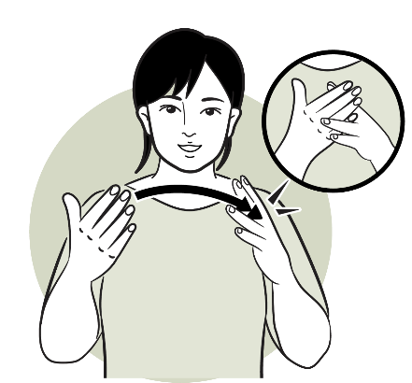
4


Public Sector
This priority is about improving the attitude, acquisition, and use of
NZSL across the public sector. It is also about the broader public sector role-modelling responsiveness to the NZSL community.
Deaf people and NZSL users pay taxes and rates, however, often struggle to access information and services that non-Deaf (hearing) people / non-NZSL users can. Currently, information and services are not always accessible to NZSL users and NZSL is not well incorporated into many government work areas. This creates barriers for Deaf people and NZSL users when seeking support or information.
The New Zealand public sector includes a broad range of government agencies including departments, Crown entities, state-owned enterprises, and a range of other government agencies.

Supporting departments to act in accordance with the principles of the New Zealand Sign Language Act 2006
The New Zealand Sign Language Act 2006 sets out that government departments should be guided by the following principles (so far as reasonably practicable) when exercising their powers and functions:
- NZSL should be used in the promotion of government services, and in the provision of information, to the public
- Government services and information should be made accessible to the Deaf community using appropriate means, such as NZSL.
To support government departments to be more responsive to Deaf people and NZSL users in line with these principles, government departments would be required to develop NZSL capability plans. These plans would involve government departments identifying how to increase their responsiveness to the Deaf community and NZSL users. This could include actions such as providing more information and services
in NZSL, or providing staff with opportunities to learn about NZSL and Deaf culture. Departments would also be expected to monitor and track progress on these plans.

4

Public Sector Cont...
Departmental NZSL capability plans would likely change over time as departments’ NZSL capability and responsiveness improved. In developing their initial capability plan, departments would need to consider their organisational starting points, what their priorities could be, and how activity could be sequenced to ensure improved responsiveness within current resources. How this would look would likely differ for each department.
To support government departments (and the wider public sector), the Board will update the guiding principles to support action, including guidance on the New Zealand Sign Language Act 2006, and rights to use NZSL.

Wider public sector organisations
Although the principles under the New Zealand Sign Language Act 2006 only relate
to government departments, all government agencies (and local authorities) are encouraged to improve NZSL access and information and offer staff opportunities to learn about NZSL and Deaf culture.
Separately, there is an expectation that all government agencies would report on NZSL use and NZSL service availability as part of their annual reports.
Actions proposed for this priority area
- Require government departments to develop NZSL capability plans, and to monitor and track progress to build NZSL capability
- Develop a toolkit to support departments in developing their NZSL capability plans
- Normalise government departments, government agencies, and local authorities providing information and services in NZSL and ensure information is available in NZSL during emergencies
- Require government agencies (including departments) to report on NZSL use and NZSL service availability as part of their annual reports
- Encourage government departments, government agencies, and local authorities
to provide staff with opportunities to learn / refresh knowledge about NZSL and
Deaf culture
- Increase employment opportunities for Deaf people and NZSL users in government departments
- Improve guidance for government departments, government agencies and local authorities on NZSL, such as guidance on the New Zealand Sign Language Act 2006, and rights to use NZSL
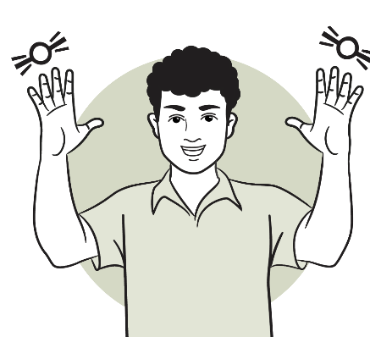

5

Celebrating NZSL

This priority is about raising the profile and celebrating NZSL
across society. This would include identifying NZSL role-models and celebrating significant anniversaries including the making of NZSL an official language of New Zealand.
This priority area is about promoting awareness, understanding and celebration of NZSL and NZSL users. It is also a call for action and change. This will be important to address any lack of information (or misinformation) about the value of NZSL to all
New Zealanders.
It is important that NZSL is celebrated in New Zealand. Events such as NZSL Week have increased awareness and interest in NZSL, as have nationally significant events, such as the COVID-19 pandemic. More is still needed to support NZSL to be a vibrant, thriving language, and to provide role-models for NZSL users that reflect them. This includes identifying and profiling role-models from Turi Māori, Deaf Pacific people, ethnic communities, rainbow, Deaf+, deafblind communities, and non-speaking NZSL users.
The year 2026 marks the 20th anniversary since NZSL was made an official language
of New Zealand. The 25th and 30th year anniversaries are also within the life of
this strategy.
Actions proposed for this priority area
- Work with the Deaf / NZSL community to increase visibility of role-models for different NZSL communities, and to identify and create opportunities for Deaf leadership / NZSL user leadership
- Profile stories by and with NZSL users about NZSL
- Create opportunities to raise public understanding and acknowledgement of the role of NZSL in the lives of Deaf people and NZSL users
- Create opportunities for NZSL users, families / whānau and groups to come together to enhance use of NZSL (such as NZSL spaces, Deaf spaces)
- Showcase activities that promote NZSL and work with media to get NZSL-related stories into mainstream and Māori-specific media
- Develop events to raise the profile of NZSL, and to celebrate significant anniversaries of the formal recognition of NZSL as an official language of New Zealand
- Grow documentation of NZSL, and NZSL resources, including te ao Māori resources / kete kōrero, and resources for different Deaf cultural communities, including
Pacific communities

Implementing the refreshed NZSL Strategy

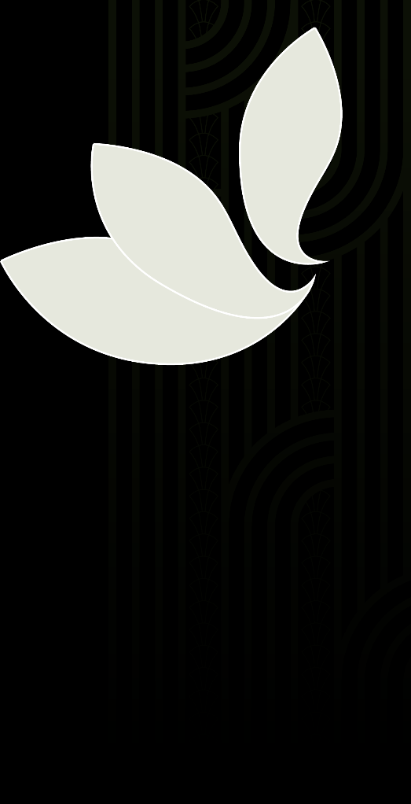

Developing action plans to deliver on the strategy
The Board, Te Rōpū Kaitiaki (the Board’s Turi Māori advisory group), and officials from the Ministry of Disabled People - Whaikaha will take the actions set out in this strategy and turn them into action plans. This will involve working with government agencies and key stakeholders to identify clear accountabilities for action.
This will also involve sequencing these actions to:
- identify the short-term practical changes that could happen now, while also planning for progress on longer-term actions
- manage the progression of actions against work programme priorities for government agencies and community organisations
- factor in the availability of funding to support initiatives.
The actions in this strategy are ambitious. Many will stretch well beyond the timeframe of this strategy. However, work to start delivering these actions will lay the foundations for change. This work needs to start if the change needed is going to be achieved.
The Board recognises the importance of engaging directly with the Deaf community, Turi Māori and NZSL users, as well as from the Deaf and NZSL workforce, from Deaf and NZSL organisations (including Deaf clubs), from businesses, from iwi and hapū, and from the wider public.
The Board must also maintain its strong relationship and consult with Deaf Aotearoa as the recognised disabled persons organisation for Deaf people in New Zealand.

Reporting on progress
The Board reports annually to the Minister for Disability Issues on its work. Ministry of Disabled People - Whaikaha officials will also support the Minister to report regularly to Cabinet on progress on delivering the NZSL Strategy. This will need to include regular reviewing and monitoring, collaborating with government departments, and with key NZSL stakeholders.
Regular reporting from government departments would also ensure departments are focusing on NZSL, and acting in accordance with the principles of the New Zealand Sign Language Act 2006. The Board and the Ministry of Disabled People - Whaikaha will work with government agencies on the requirement for them to report on NZSL use and service availability within their annual reports.


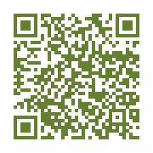

Measuring change

Knowing whether the strategy is making a difference
This strategy aims to ensure NZSL survives and thrives. The priority areas are aimed at increasing access to and learning of NZSL for Deaf people and NZSL users, increasing the understanding, acceptance and use of NZSL for non-NZSL users, increasing and strengthening the Deaf and NZSL workforce, and improving overall health and social outcomes for Deaf people and NZSL users.
Currently, there is limited evidence and indicators in relation to NZSL or outcomes
for those who use NZSL. Without appropriate evidence and indicators, progress on actions in this strategy will not be able to be monitored and reported on. This will also make it difficult to monitor and report on the wellbeing of NZSL as a language, or overall outcomes for those who use NZSL, such as Deaf people and Turi Māori.
The Board and the Ministry of Disabled People - Whaikaha will work with government agencies to identify the data and information that currently exists or can be sourced, and what indicators and targets can be developed.

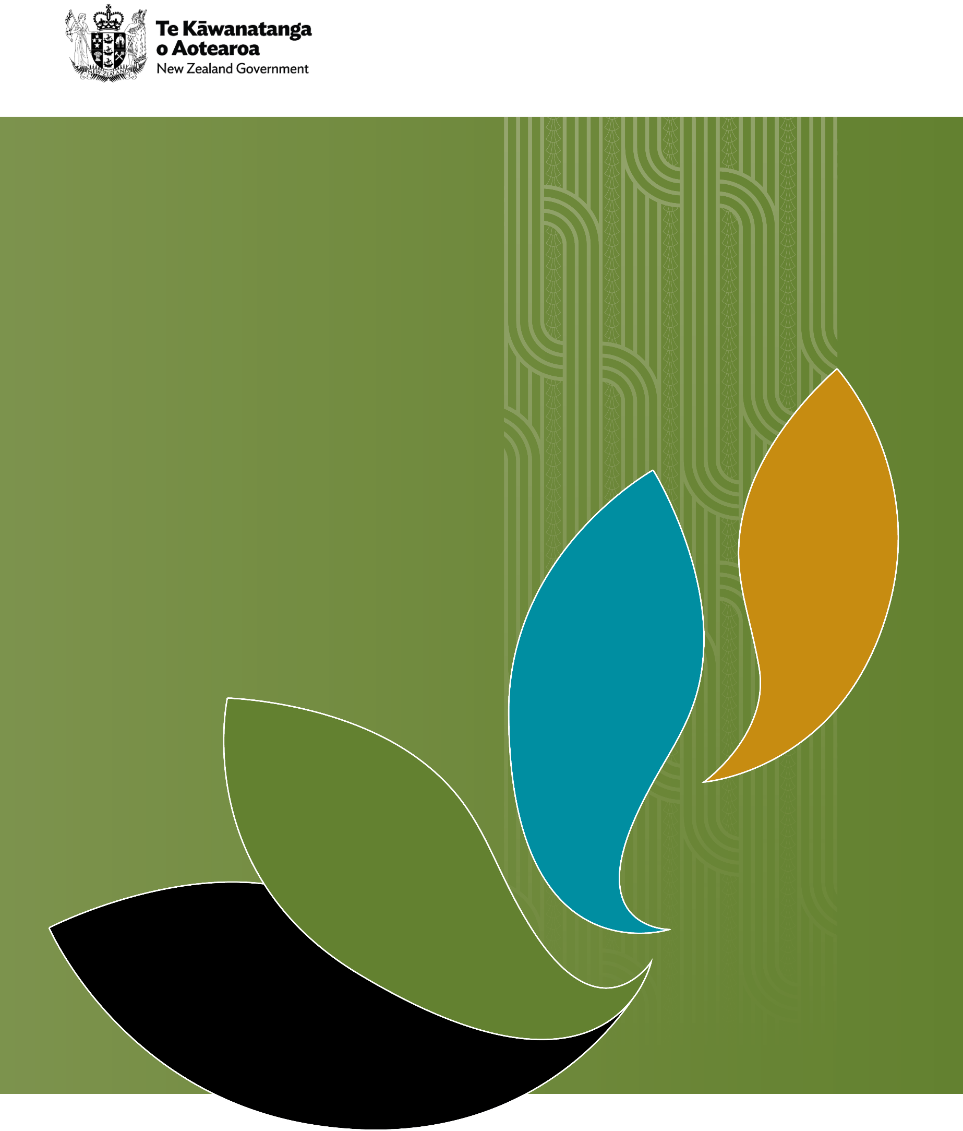

The term Deafhood was created by Paddy Ladd, see Ladd, P. (2003). Understanding Deaf culture: In search of Deafhood.
See Hall, W. C. (2017). What You Don’t Know Can Hurt You: The Risk of Language Deprivation by Impairing Sign Language Development in Deaf Children. Matern Child Health J. May, 21(5):961-965. doi: 10.1007/s10995-017-2287-y; Grote, K., Stenzel, M., Wegner, S. and Karar, E. (2024). The devastating effects of language deprivation and misguided diagnosis in deaf children with cognitive language disorders in medical centres, special needs and educational settings. Journal of MindDeaf & DeafDidactics, 1(1), 1-22
See NZQA. (2025, 19 March). Finalised 2024 NCEA and University Entrance attainment data now available. Retrieved https://www2.nzqa.govt.nz/about-us/news/finalised-2024-ncea-and-university-entrance-attainment-data-now-available/; Ko Taku Reo. (2025). Annual Implementation Plan. Retrieved https://www.kotakureo.school.nz/assets/pdfs/8291588_-Annual-Implementation-Plan-2025-Document.pdf.
Smiler, K., Bowde, N., Gibb, S., and Kokaua, J. (2023). Kei Aaku Ringa: te Mana Motuhake o Ngaati Turi: An independent report commissioned for the Taangata Turi Waitangi Tribunal claim (WAI 2143)
Royal Commission of Inquiry into Abuse in Care. (2024). Our hands were tied; Royal Commission of Inquiry into Abuse in Care. (2024). Deaf survivors’ experiences of abuse and neglect in care
See Walton, W. (2006). Sign language as a first language: Some experiences of a hearing child of Deaf parents. SITES, 3(1), 168 -182
New Zealand Speech-language Therapists’ Association (2023). Communication and swallowing disabilities in New Zealand data fact sheet. Retrieved https://speechtherapy.org.nz/assets/Uploads/SLT-Business-Case-2024/Communication-and-Swallowing-Disabilities-in-New-Zealand-Data-Fact-Sheet.pdf?vid=4
McKee, R. (2017). Assessing the vitality of New Zealand Sign Language. Sign Language Studies, 17(3), 322-362
The 2013 census indicated 20,235 people used sign language or approximately 0.5 percent of respondents. The 2018 census indicated this has increased to 22,986 people, which amounted to only 0.5 percent of respondents. In 2023, the number using sign language had increased to 24,678 people which this still amounted to approximately 0.5 percent of respondents.
McKee, R., and Vale, M. (2014) The vitality of New Zealand Sign Language project: Report on a survey of the Deaf / NZSL community. Victoria University of Wellington
See Witko, J., Boyles, P., Smiler, K., and McKee, R. (2017). Deaf New Zealand sign language users’ access to healthcare. New Zealand Medical Journal, 130(1466), 53-61
Martin, G., Foley, S., and Lovelock, K. (2021). New Zealand Sign Language Week: Impact Evaluation Summary Report. Ministry of Social Development
A broad definition of the public sector is provided in the Cabinet manual, which can be viewed at https://www.dpmc.govt.nz/our-business-units/cabinet-office/supporting-work-cabinet/cabinet-manual.

