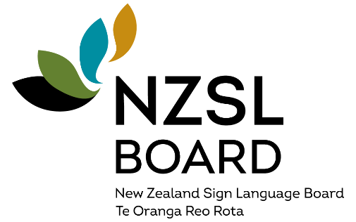
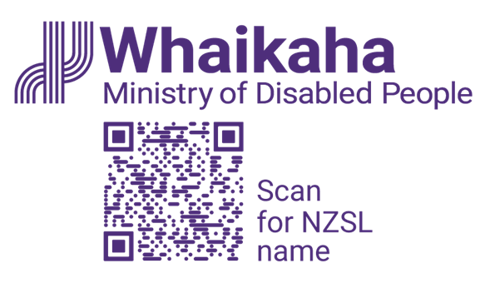
“New Zealand Sign Language everyone, everywhere, every day”

Summary of the
New Zealand Sign Language Strategy 2026-2036

Vision
The vision of the strategy is “New Zealand Sign Language - everyone, everywhere, every day”.

Why is New Zealand Sign Language (NZSL) important?
New Zealand Sign Language (NZSL) is an official language of New Zealand. However, NZSL is more than just an official language – it is vital for communication, for connection, and for inclusion.
NZSL is the language used by many Deaf and hard of hearing people. It is also used by many non-speaking people, people who have difficulty communicating using a spoken language, the deafblind community, and children of Deaf Adults (CODA).
For some people, NZSL will be their only language.
NZSL is also important to support Turi Māori (Māori Deaf) to access and engage in te ao Māori.

The role of the NZSL Board
The NZSL Board’s role is to maintain and promote NZSL.
In developing this strategy, the Board, along with its Turi Māori (Māori Deaf) advisory group, Te Rōpū Kaitiaki, aim to improve inclusion and equity for Deaf people and NZSL users by lifting the use, understanding, and acceptance of NZSL in New Zealand.
Everyone can play a part in making NZSL a strong, vibrant, living language.

The NZSL Strategy
The below image sets out the strategy in house form. The roof of the house refers to the vision: New Zealand Sign Language everyone, everywhere, every day. The house has five pillars, reflecting the strategy's five priority area: acquisition and learning, evidence and data, Deaf and NZSL workforce, Public Sector, and Celebrating NZSL. Underneath the house are the foundation in two parts, depicting the two approaches energise and integration. To try and show the importance of energise and integration across the five priority areas, the five priority areas are divided into two, on a diagonal across all five pillars, with the top half slightly bigger and lighter to reflect energise, and the bottom half slightly smaller and darker to reflect integration. This reflects the importance of having a strong base for Deaf people and NZSL users in NZSL, whereas integration is more important for the later pillars or priority areas.
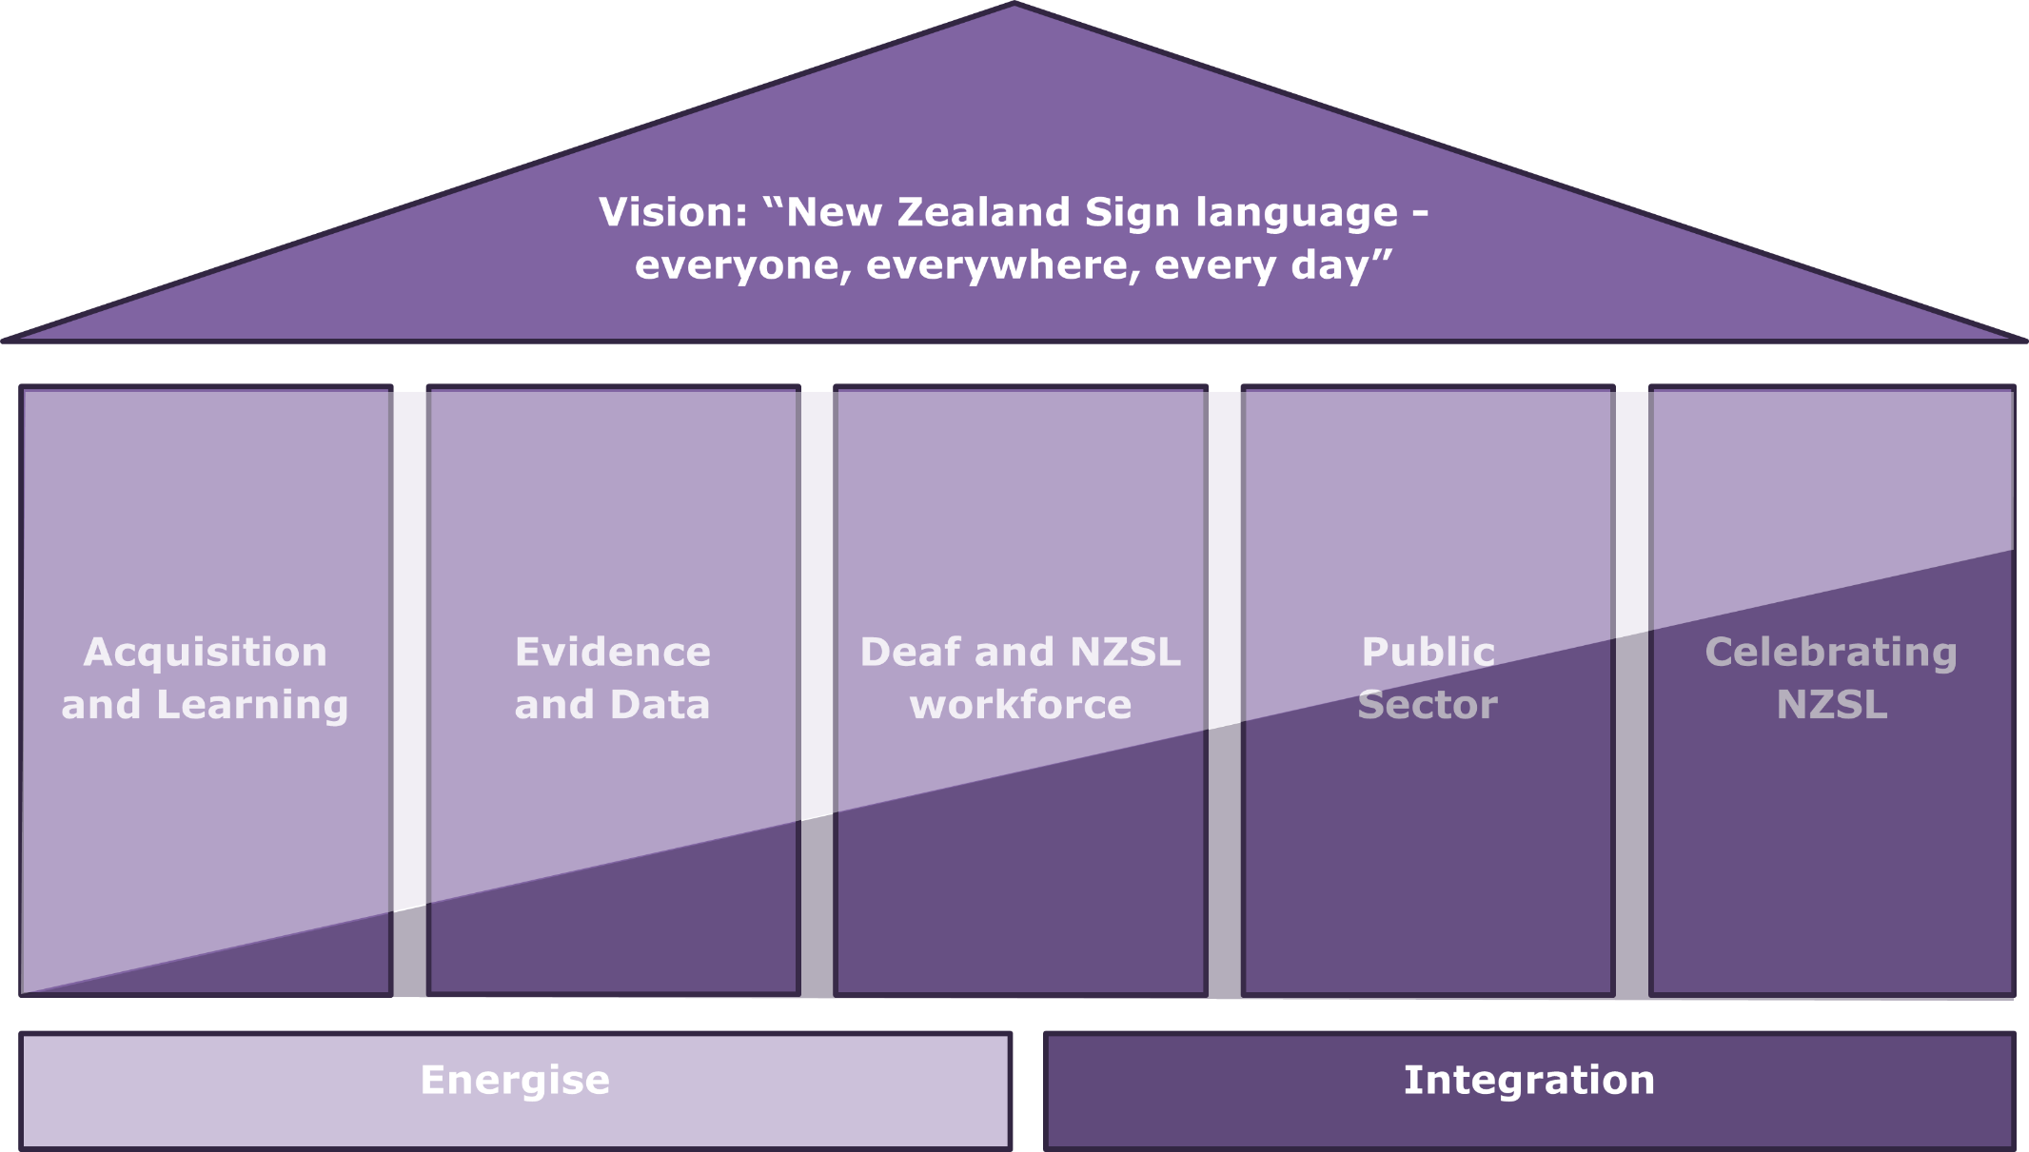

Refreshing the NZSL Strategy

The NZSL Strategy is based around two approaches
- Energise is focused on Deaf people and NZSL users, particularly children, and aimed at ensuring the survival of NZSL and ensuring early acquisition and use of NZSL by Deaf people and NZSL users.
- Integration is focused on people who do not use NZSL and aimed at ensuring NZSL thrives, and promoting the awareness, acceptance and everyday use of NZSL.

Five key priority areas sit under the two approaches
- Acquisition and Learning: Enable deaf children / tamariki, and children who use NZSL to communicate, and families and whānau to acquire and use NZSL.
- Evidence and Data: Build an evidence-based profile of Deaf people and NZSL users.
- Deaf and NZSL workforce: Ensure there is a workforce to support the acquisition and use of NZSL.
- Public sector: Improve attitude, acquisition, and use of NZSL across the public sector.
- Celebrating NZSL: Enhance the status of NZSL in New Zealand and celebrate NZSL across society and cultures.

Implementing the NZSL Strategy
Action plans will be developed by the NZSL Board, Te Rōpū Kaitiaki and the Ministry of Disabled People – Whaikaha, working with other agencies.
The NZSL Board will report annually to the Minister for Disability Issues on actions and progress.
Indicators will be developed to track progress and impact.

Acknowledgments
The New Zealand Sign Language Board and the Ministry of Disabled People - Whaikaha acknowledge and thank everyone who provided input to develop the New Zealand Sign Language Strategy 2026-2036.

Information about this summary document
This document is a summary of the New Zealand Sign Language Strategy 2026-2036.
You can access the full strategy at www.nzsl.govt.nz/nzsl-strategy-2026-2036
You can also the NZSL version and alternate formats of this summary at that same website.

Creative Commons Attribution 4.0
This work is licensed under the Creative Commons Attribution 4.0.
In essence, you are free to copy, distribute and adapt the work, as long as you attribute the work to the Crown and abide by the other licence terms. To view a copy of this licence, visit: CC BY 4.0 Legal Code | Attribution 4.0 International | Creative Commons.
Please note that no departmental or governmental emblem, logo or Coat of Arms may be used in any way which infringes any provision of the Flags, Emblems, and Names Protection Act 1981. Attribution to the Crown should be in written form and not by reproduction of any such emblem, logo, or Coat of Arms.
Published November 2025
ISSN (Print) 978-1-991429-02-5
ISSN (Online) 978-1-991429-03-2

End of: Summary of the New Zealand Sign Language Strategy 2026-2036 | “New Zealand Sign Language everyone, everywhere, every day”
This Large Print document is adapted by Blind Citizens NZ from the standard document provided by Whaikaha | Ministry of Disabled People



