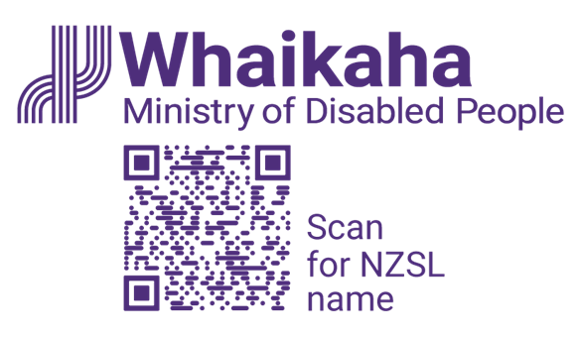
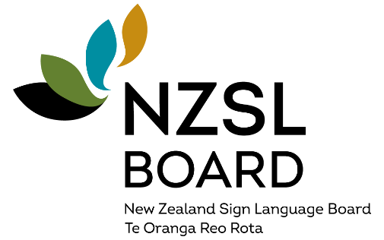
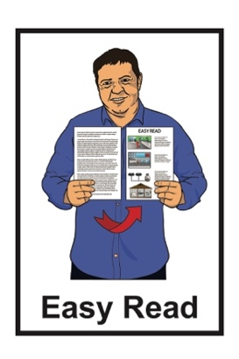

Summary of the

New Zealand Sign Language Strategy 2026 to 2036
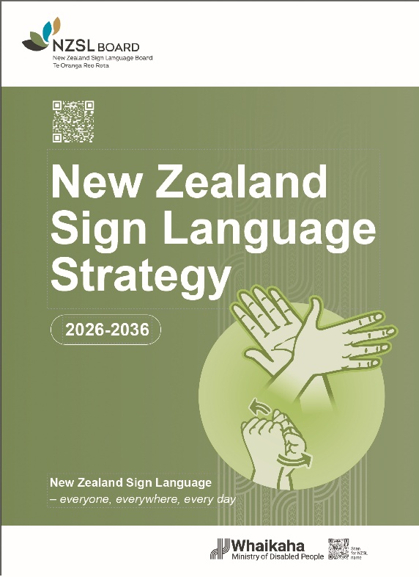

Published: November 2025

What is in this document


Page number:

About this document 2
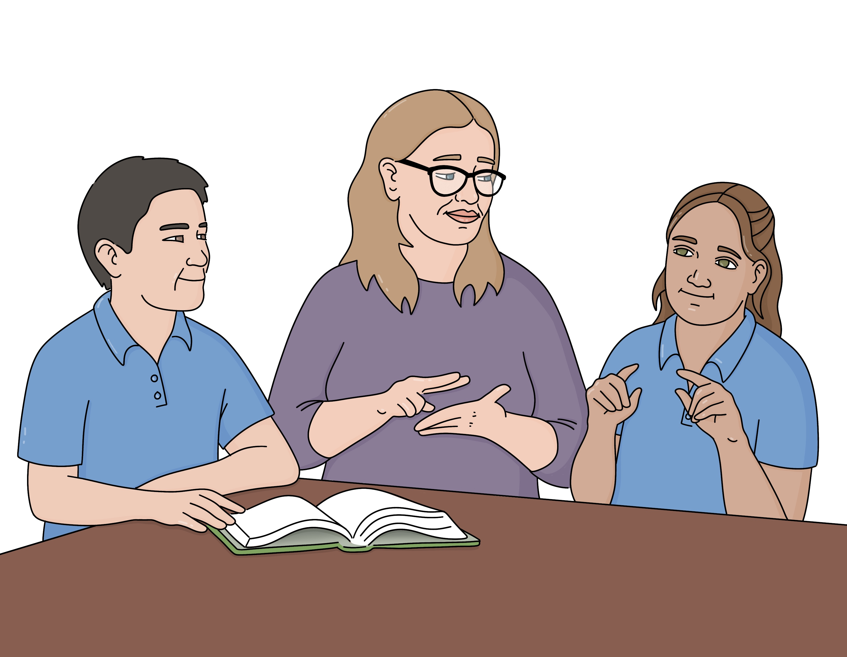
Why is NZSL important? 4
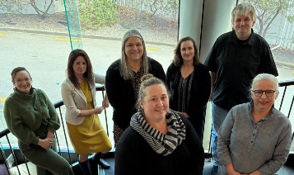
The role of the NZSL Board 6

The NZSL Strategy 9

What will happen with
the Strategy 19
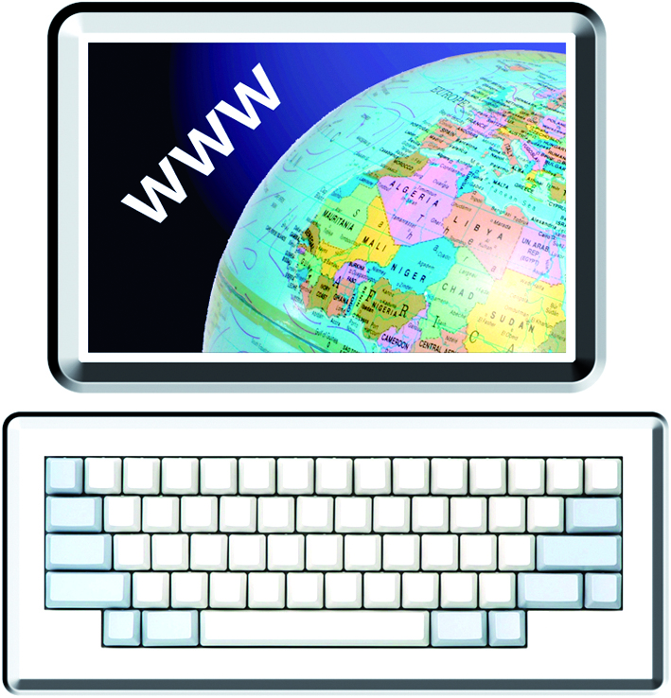
Where to find more information 21

About this document

This Easy Read document is a summary of the New Zealand Sign Language Strategy 2026 to 2036.
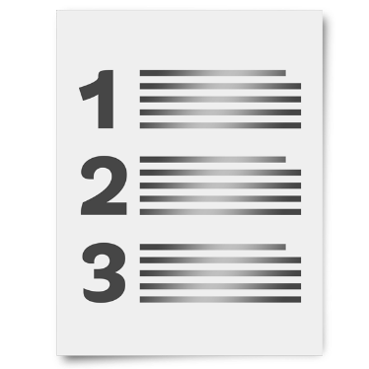

A summary is a shorter version of a document that tells you the main points.
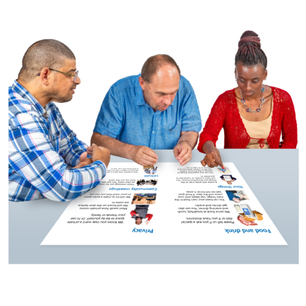

A strategy is a plan on how to do something.

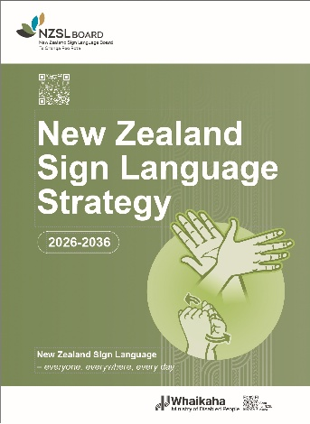
The New Zealand Sign Language Strategy is the plan the New Zealand Government has for things to do with New Zealand Sign Language.
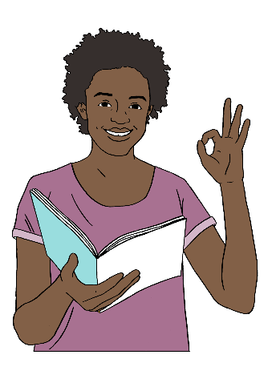
In this document the New Zealand Sign Language Strategy will be called the Strategy.

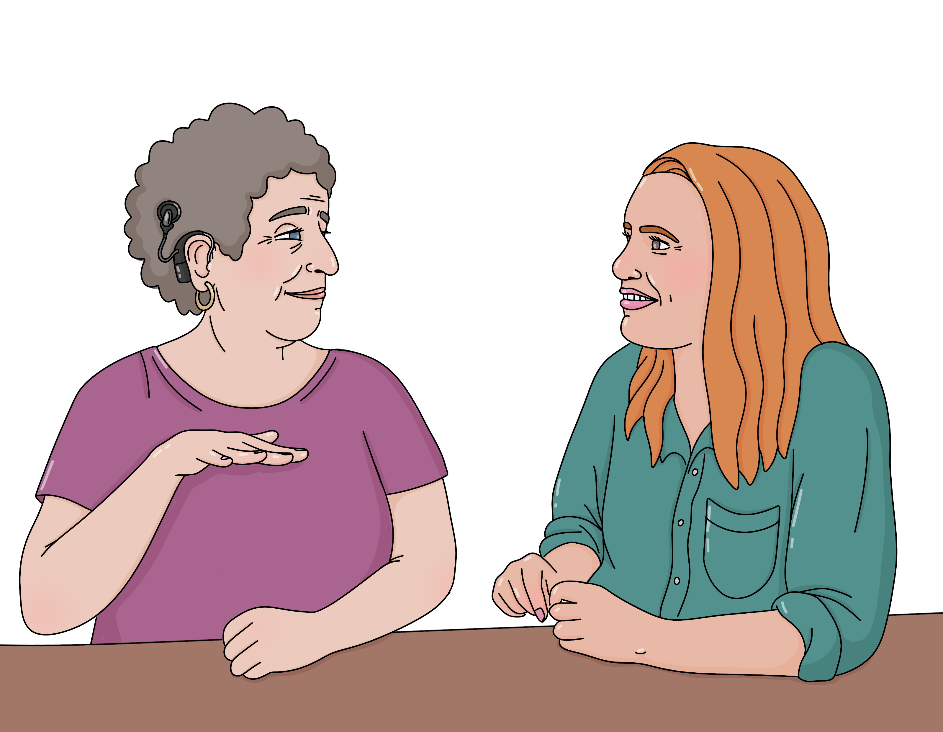
New Zealand Sign Language is also called NZSL.

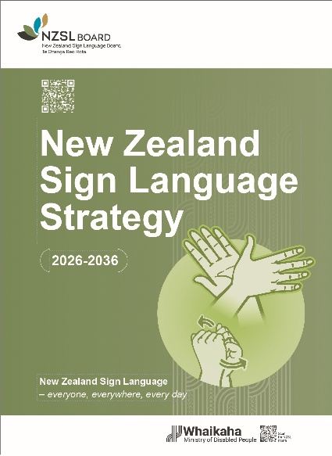
You can find the full Strategy at:

https://bit.ly/NZSL2636

The full Strategy is not in Easy Read.

Why is NZSL important?

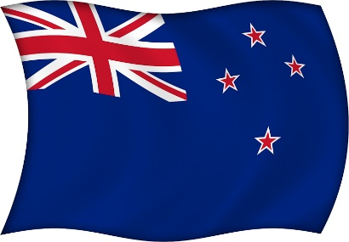
NZSL is an official language of New Zealand.

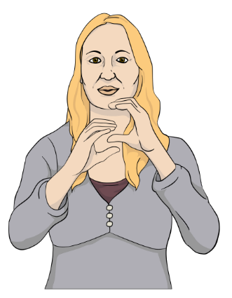
An official language is a language that has special rights in a country.

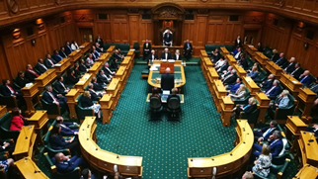
Official languages are used:
in government communication
in courts of law
in schools.

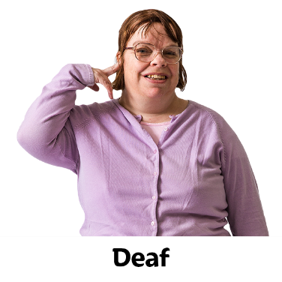
NZSL is the language used by many:
Deaf people
people who are hard of hearing
non-speaking people
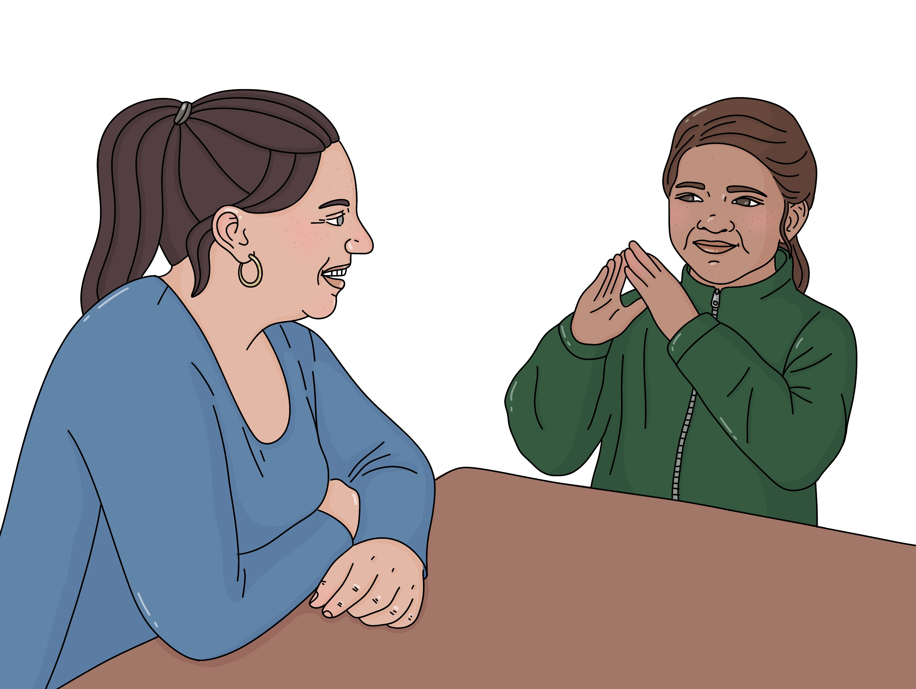
people who find spoken language hard
deafblind people
Children of Deaf Adults / CODA.
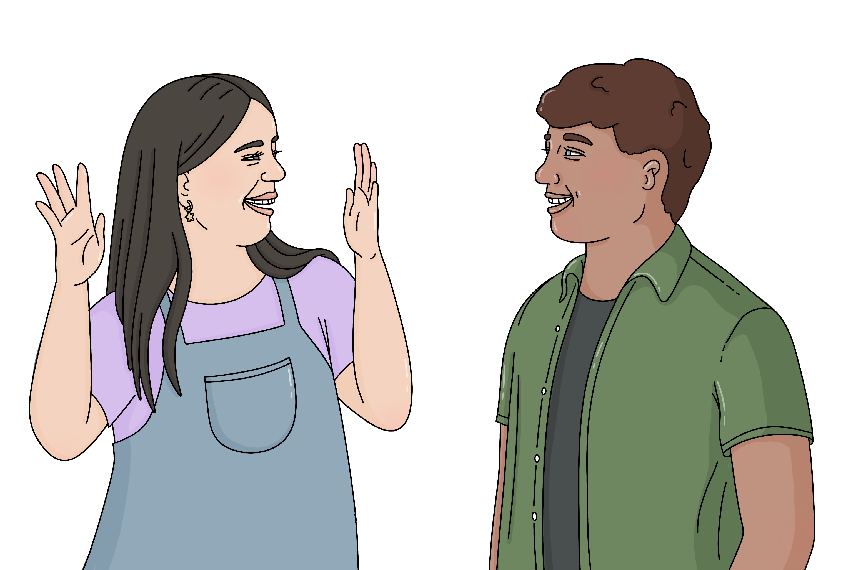

Some people only use NZSL as their language.

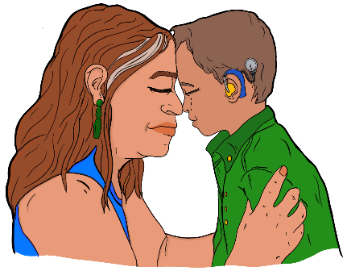
NZSL is also important to support Turi Māori / Māori Deaf to be part of te ao Māori / the Māori way of understanding the world.

The role of the NZSL Board

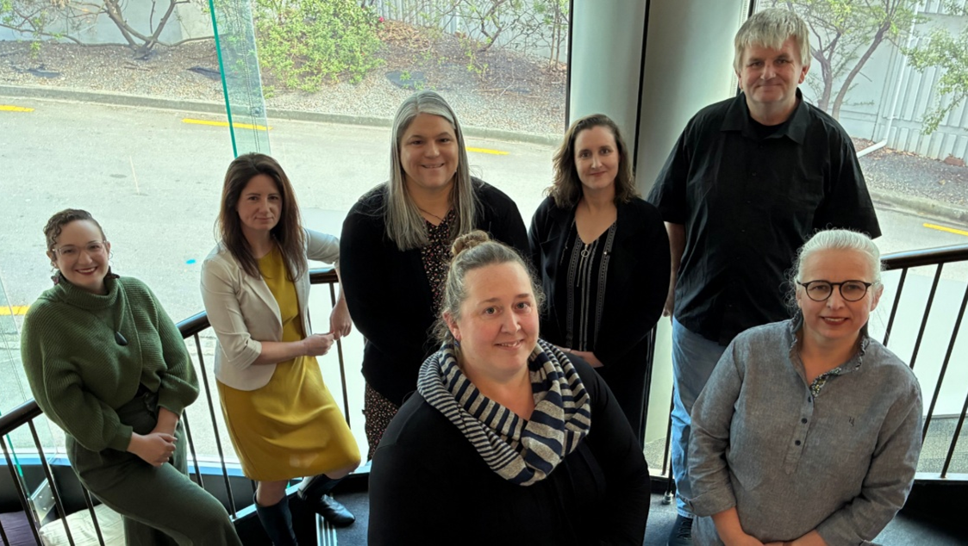
The New Zealand Sign Language Board is a group of people who:
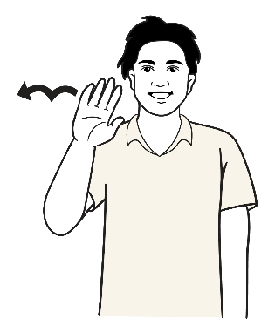
have lived experience of using NZSL
know a lot about NZSL
give advice about NZSL to the:
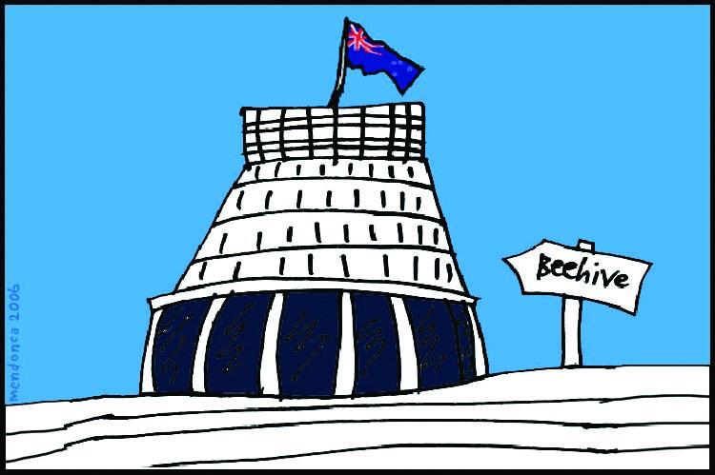
- Government
- community.

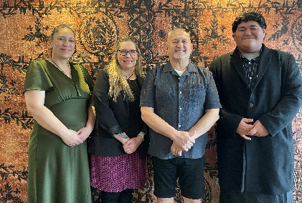
There is also a Turi Māori / Māori Deaf advisory group called Te Rōpū Kaitiaki.

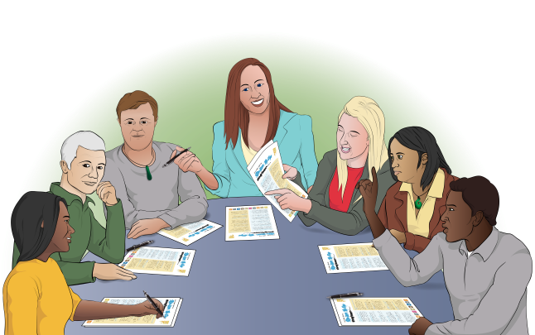
Both these groups are developing the Strategy with the goal of Deaf people and NZSL users:

being included
having their needs met.
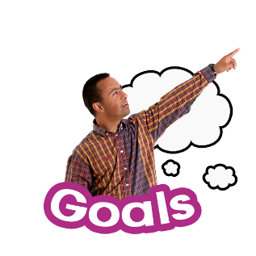

A goal is something we want to
make happen.

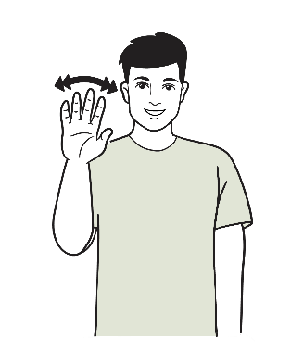
The 2 groups plan to meet this goal by:
making sure NZSL is used more
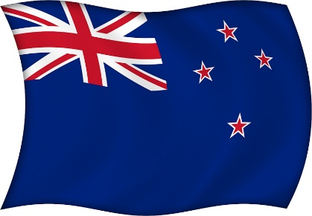
teaching people about NZSL
making sure NZSL is more accepted in New Zealand.


Everyone can play a part in making NZSL a language that is:
strong
wonderful
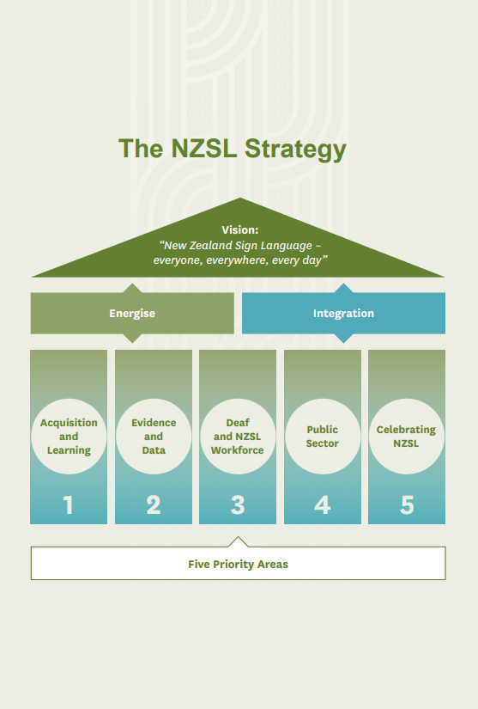
well used.

We have made a house image to explain the Strategy.

It is explained in the next few pages.

The NZSL Strategy

We have created a picture of a house to show how the Strategy will work.

This house picture shows:
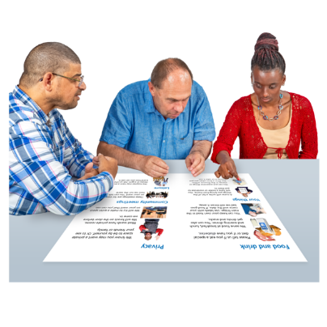
the vision for the Strategy
the 2 approaches to the Strategy
the 5 key priority areas for the Strategy as things that support the vision.


We will explain what these mean in the next parts of this Easy Read.


The vision

Here a vision is what we hope will happen with NZSL in the future.

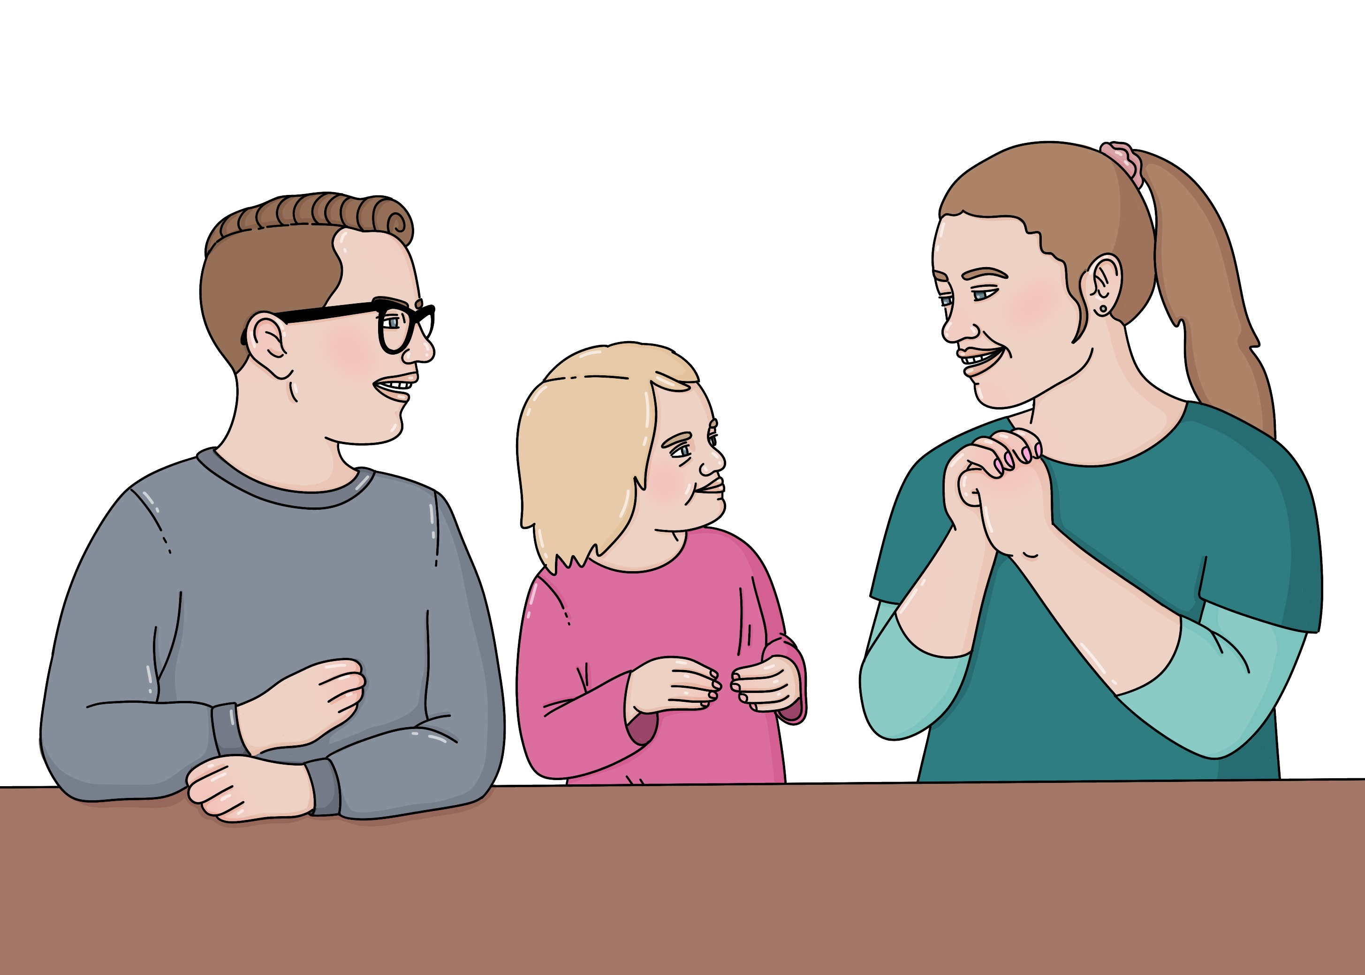
The vision for the Strategy is:

New Zealand Sign language – everyone, everywhere, every day.

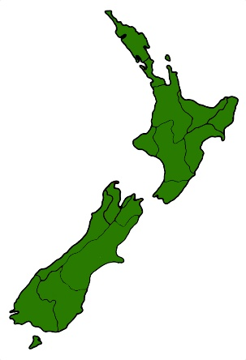
This means we want to see NZSL being used a lot more across New Zealand.

The 2 approaches
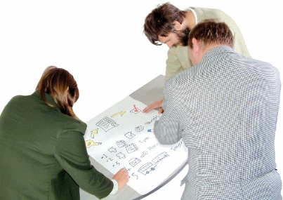
An approach is how we will do something to reach our goals for NZSL.

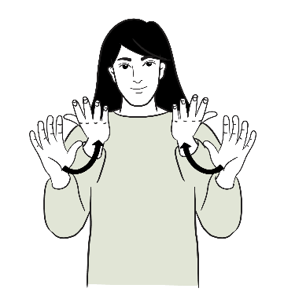
- The first approach is Energise.

This is the NZSL sign for energise.

Energise is about bringing together:
Deaf people
NZSL users
children who:
- are Deaf

- use NZSL.
Energise is also on making sure:

NZSL keeps being used as a language in New Zealand

people can learn NZSL earlier.

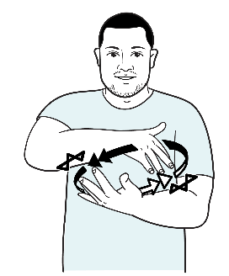
- The second approach is Integration.

This is the NZSL sign for integration.

Integration is about people who do not use NZSL.

It looks at making sure NZSL is:


a well known language

used a lot

known about by people who are not NZSL users.


5 key priority areas

A key priority area is an important area we will work on.

In the house picture each key priority area shows both approaches working together.

There are 5 key priority areas for the Strategy:

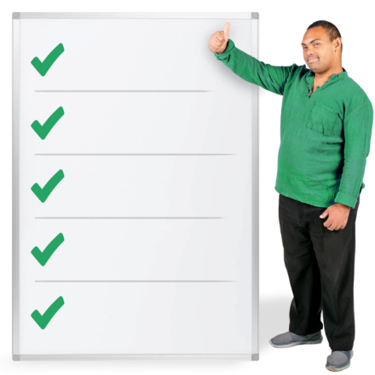
- Acquisition and Learning

- Evidence and Data

- Deaf and NZSL Workforce

- Public Sector

- Celebrating NZSL.

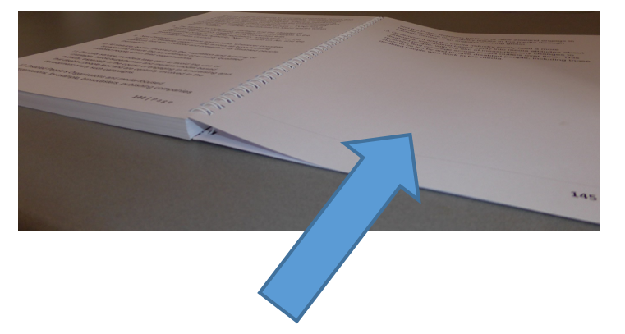
We will look at what these all mean on pages 15 to 18.
- Acquisition and Learning is about supporting people to learn / use NZSL like:
            - Deaf tamariki / children
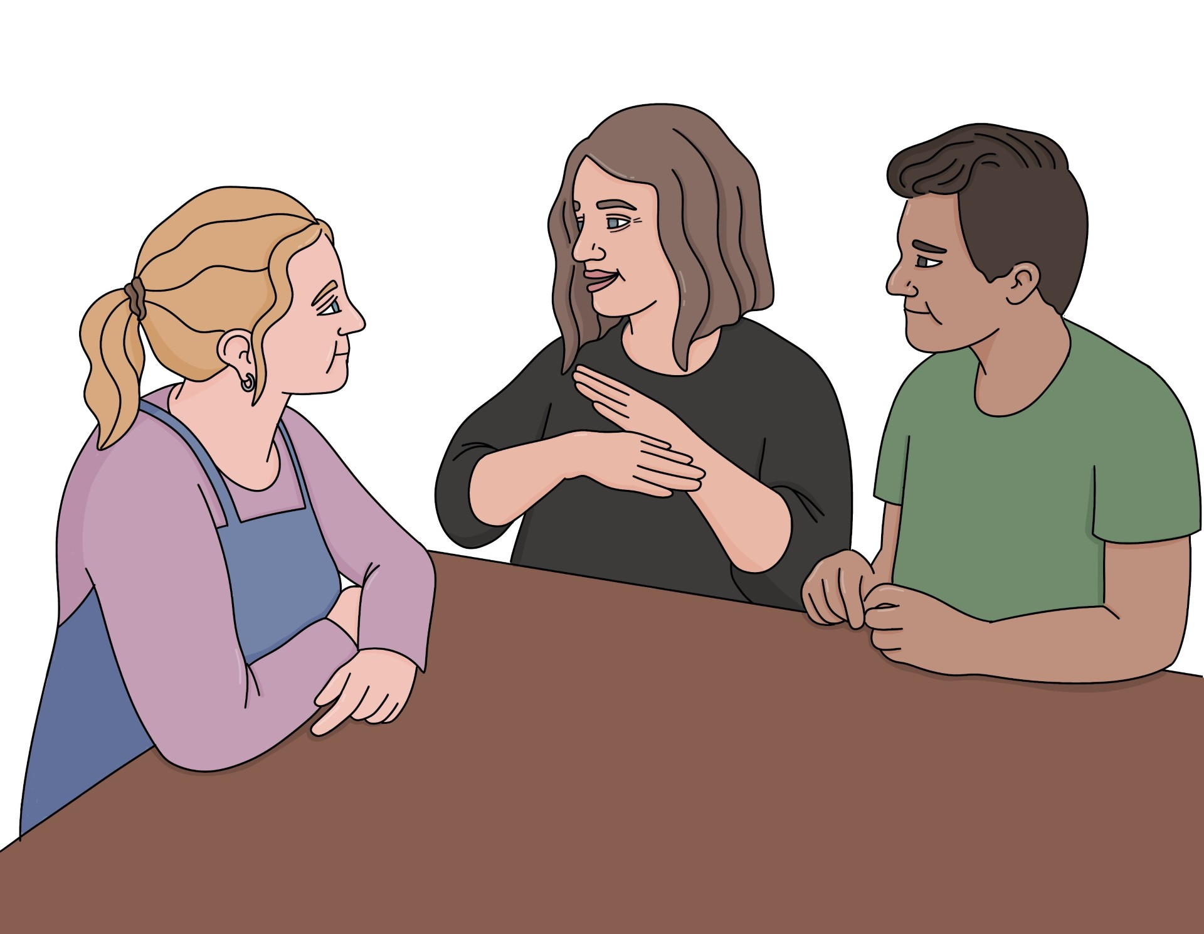
            - tamariki / children who use NZSL to communicate
            - whānau / families of Deaf children / children who use NZSL.
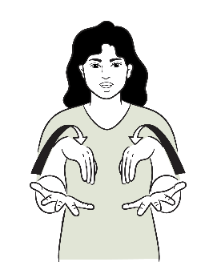

This is the NZSL sign for acquisition.


- Evidence and Data is about collecting information from:

Deaf people

NZSL users.

This will assist with understanding of how NZSL is used in New Zealand.
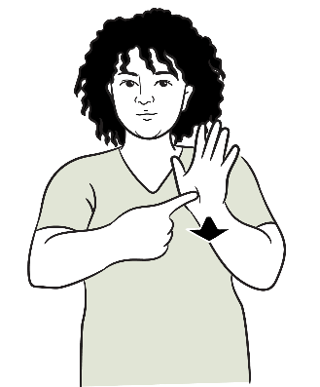

This is the NZSL sign for evidence.
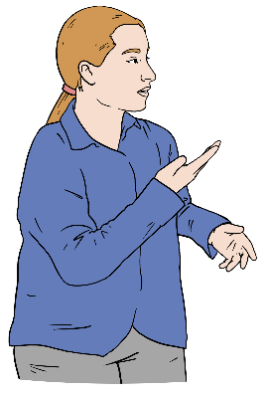
- Deaf and NZSL Workforce is about making sure that there are people working who can support:
people learning NZSL
use of NZSL.
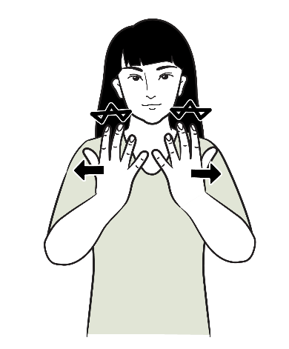

This is the NZSL sign for workforce.


- Public Sector is about making sure people who work for the Government:
think good things about NZSL
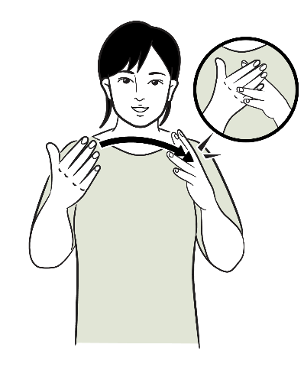
can learn to use NZSL
use NZSL in their work.

This is the NZSL sign for public sector.

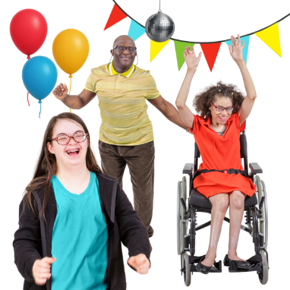
- Celebrating NZSL is about making NZSL more important in New Zealand

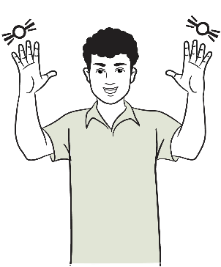
This is the NZSL sign for celebrate.

What will happen with the Strategy

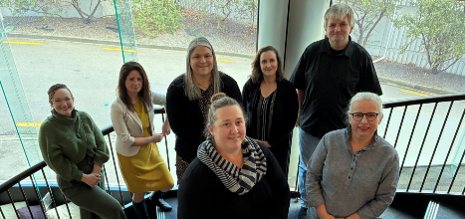
There will be action plans for the Strategy will be created by:
the NZSL Board
Te Rōpū Kaitiaki

the Ministry of Disabled People – Whaikaha.

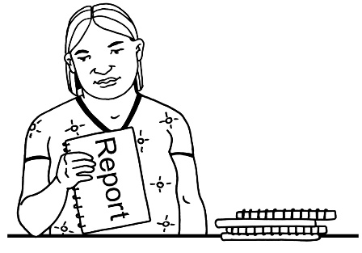
Each year the NZSL Board will report to the Minister for Disability Issues about:
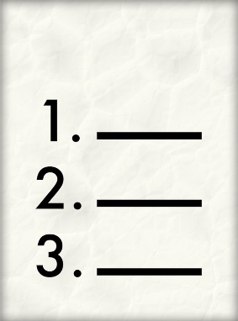
actions that have been taken
the progress that has been made on the Strategy.


We will make ways to check:
the progress being made
how the Strategy is affecting New Zealand.

Where to find more information
You can find the full Strategy at:

https://bit.ly/NZSL2636

The full Strategy is not in Easy Read.

You can also find the Strategy in NZSL at the same website link above.

This information has been written the Ministry of Disabled People – Whaikaha.

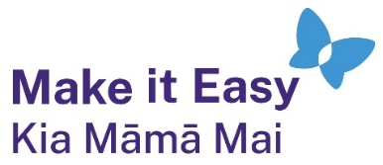
It has been translated into Easy Read by the Make it Easy Kia Māmā Mai service of People First New Zealand Ngā Tāngata Tuatahi.
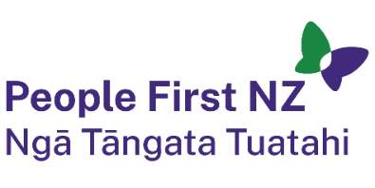
The ideas in this document are not the ideas of People First New Zealand Ngā Tāngata Tuatahi.

All images used in this Easy Read document are subject to copyright rules and cannot be used without permission.


Make it Easy uses images from:

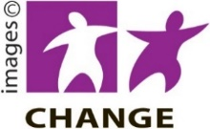
- Photosymbols

- Change Images


- Huriana Kopeke-Te Aho
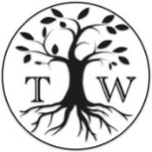
- SGC Image Works

- T Wood

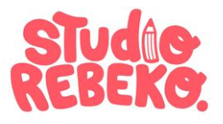
- Studio Rebeko

- Inga Kramer.

Some NZSL images have been provided by Ministry of Disabled People – Whaikaha and are also subject to copyright.

