This is the logo for the NZSL Board. It depicts four colorful leaves. 
 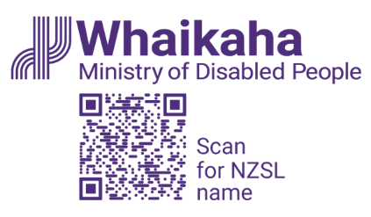

“New Zealand Sign Language everywhere, every day”

New Zealand Sign Language Strategy 2025-2030

SUMMARY OF STRATEGY

DRAFT FOR CONSULTATION

22 April – 2 June 2025

# Executive summary

## We want everyone to be aware of, using, and accepting NZSL – everywhere, and every day

* We want NZSL to be recognised and embraced by New Zealanders as an official language
* We want Deaf and hard of hearing people to be able to fully participate in society, in their communities and in their cultures
* We want Turi Māori to be able to successfully navigate te ao Māori

## Why a NZSL Strategy is important

* The role of the NZSL Board is to maintain and promote NZSL
* Having a NZSL strategy helps to support the role of the Board
* The Strategy will guide the work priorities for the Board for the next five years
* The Board also makes decisions about what to fund, including Community Grants and contracts, based on whether it matches the NZSL Strategy

## The Board seeks your feedback on this draft strategy

* Your feedback on this draft strategy is important
* At the back of this document, are questions you can use
* You can provide your feedback through an online form, via email, or via New Zealand Sign Language
* More information about the consultation process and how to make your submission - can also be found on [www.nzsl.govt.nz](http://www.nzsl.govt.nz).

# Focus and Language

* NZSL is an integral part of Deaf culture and is the preferred language of Deaf people. NZSL is not just a signed form of a spoken language.
* The term ‘deaf’ is an umbrella term used to refer to audiological deafness. The term ‘Deaf’ is used when referring to Deaf culture and the Deaf community.
* The Deaf community is a distinct linguistic and cultural group of people who are deaf and who use NZSL as their preferred, and first, language.
* As with the hearing community, there are a range of identities in the Deaf community, including Māori (Turi Māori), Pasifika, rainbow communities, and Deaf+ (Deaf people with an additional disability)
* There is also the deafblind community, people who navigate through dual sensory loss.
* The Board acknowledges Turi Māori, as tangata whenua of Aotearoa New Zealand.
* Turi Māori identify as members of the Deaf community, and as Māori. This means they have a dual identity – both as Māori and as Deaf. For Turi Māori, it is important to be able to walk in the worlds of both identities.

# Introduction

## The Deaf community in New Zealand is diverse

* The Deaf community in Aotearoa New Zealand is diverse and made up of people across all ages, ethnicities, and degrees of hearing impairment.
* Deaf people also make up parts of the rainbow community and the disabled community, along with many other communities.
* Hearing family members and NZSL interpreters, while not part of the Deaf community, participate in, and provide a bridge between the Deaf and hearing communities.
* The ability to bridge between Deaf and hearing communities is important because most deaf children and tamariki born in Aotearoa New Zealand are born into hearing families.

## There are gaps in knowledge about Deaf people and their experiences and outcomes

* There is little system level information on outcomes for deaf and hard of hearing New Zealanders
* Research indicates that deaf and hard of hearing people have worse life outcomes than hearing people
* Overseas research indicates early acquisition of sign language is important for preventing poor health and quality of life outcomes

## Deaf people face barriers in accessing services using NZSL

* Deaf people and their families and whānau face barriers in learning and using NZSL in everyday situations
* This includes when accessing services and supports from central and local government
* There are also barriers accessing good quality, suitable NZSL-based education services
* These barriers impact on the wider participation and well-being of Deaf people
* Turi Māori (Deaf Māori) face additional barriers in being fully able to use NZSL to engage in (and with) te ao Māori

## NZSL is an official language of New Zealand and is the preferred language of the Deaf community

* The New Zealand Sign Language Act 2006 declared NZSL to be an official language
* NZSL is the preferred language of the Deaf community, and is an important part of Deaf culture
* However, only 0.5 percent of the population use NZSL, meaning the language is at risk
* Without buy-in and support from the wider public (the hearing community), from iwi and hapū, and from families and whanau, NZSL cannot flourish

# Refreshing the NZSL Strategy

## The proposed NZSL strategy reflects two approaches: Revitalisation and Integration

**Revitalisation**

FIRST LANGUAGE USERS

Priorities and actions aimed at ensuring the survival of the language and the equitable development and use of the language by Deaf people

**Integration**

SECOND LANGUAGE USERS

Priorities and actions aimed at ensuring the language is used in everyday contexts by the non-NZSL user community

## Five strategic priority areas sit under the two approaches

**Revitalisation**

* Support and enable deaf and hard of hearing children / tamariki and their families and whānau to acquire and use NZSL
* Build an evidence-based profile of the experiences of NZSL users (including Turi Māori)

**Revitalisation and Integration**

* Enhance the status, capability, and capacity of NZSL learning and use in New Zealand

**Integration**

* Improve attitude, acquisition, and use of NZSL across public service
* Enhance the status of Turi / Deafhood and celebrate NZSL across society and cultures

# The NZSL Strategy

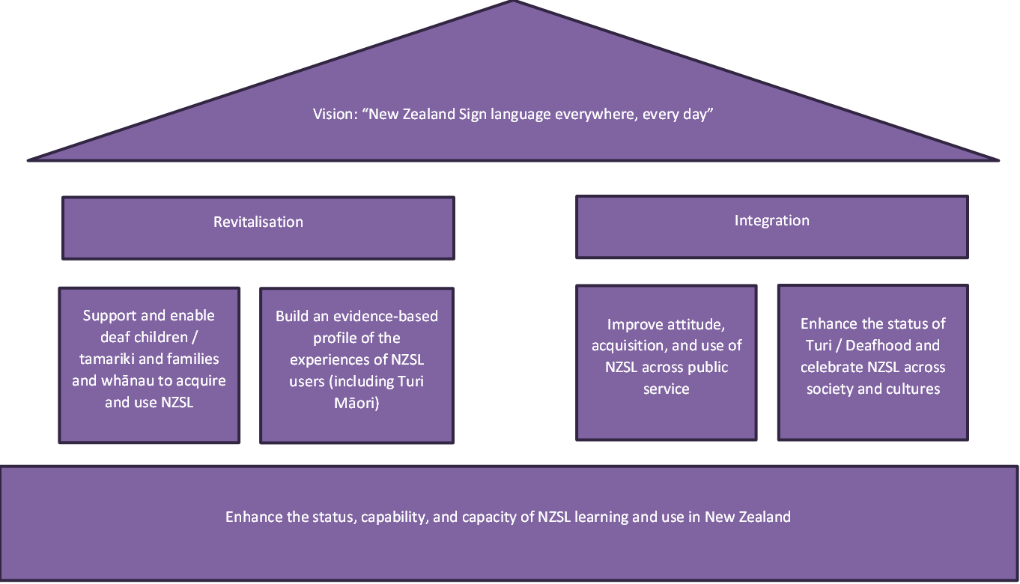

## Priority Area: Support and enable deaf and hard of hearing children / tamariki and their families and whānau to acquire and use NZSL

This priority is about ensuring community driven Deaf spaces and language ‘nests’ for NZSL learning and intergenerational transmission (especially, but not exclusively, in the crucial early development years).

Action proposed for this priority area:

* Create more opportunities for deaf and hard of hearing children / tamariki and families and whānau to learn together
* Assess adequacy of information, resources, and supports for parents of deaf babies / pēpē and children / tamariki
* Improve Deaf education opportunities for deaf and hard of hearing children / tamariki, and ensure access to NZSL
* Explore additional resources and learning pathways, (for example, for Turi Māori to learn in a te ao Māori context – which will help Turi Māori build their identity both as Turi, and Māori)
* Explore options to digitise learning modules
* Identify Deaf leadership opportunities for Deaf people, including Turi Māori

## Priority Area: Build an evidence-based profile of the experiences of NZSL users (including Turi Māori)

This priority is about developing and building a data rich research and evidence base so resources can be more effectively targeted at opportunities and challenges for Deaf people.

Action proposed for this priority area:

* Map Deaf NZSL users’ touchpoints across the public service (including education and health services) to identify gaps, challenges, and unmet needs, particularly for Turi Māori
* Develop an indicator framework for measuring and reporting on progress on outcomes for Deaf people and NZSL, with a focus on measures that record both quantity (for instance, number of NZSL users), but also quality (such as quality of access)

## Priority Area: Enhance the status, capability, and capacity of NZSL learning and use in New Zealand

This priority is about ensuring there is a workforce to support the acquisition and use of NZSL, to provide for opportunities for Deaf people, and to raise awareness and understanding among the hearing population.

Action proposed for this priority area

* Identify capacity and capability gaps (including sectors and geographical) in the Deaf and NZSL workforce (such as Deaf / Turi Māori teachers, and NZSL interpreters, tutors, translators, and teachers)
* Develop approaches to addressing those gaps (such as pathways for trilingual interpreters, growing NZSL interpreter workforce, interpreter standards)
* Explore and develop learning pathways for the public and communities to learn NZSL (this would also include opportunities for hearing children to learn NZSL)
* Explore language dissemination opportunities presented by technology

## Priority Area: Improve attitude, acquisition, and use of NZSL across public service

This priority is about expecting more from the public sector in role-modelling responsiveness to the NZSL community, including better meeting obligations under the New Zealand Sign Language Act 2006 to provide information and services in NZSL.

Action proposed for this priority area

* Provide and facilitate provision of public facing information and services in NZSL, including support to Deaf / Turi communities in emergencies
* Increase government’s responsiveness to Deaf people by requiring government agencies to develop NZSL capability development plans, and ensuring actions are monitored and progress tracked
* Increase employment and other opportunities for Deaf people and fluent NZSL users in the government agencies
* Provide opportunities for all staff to learn (and refresh knowledge) about Deaf communities
* Drive improvements to interpreter funding models (based on EGL principles, ensuring appropriate for Deaf people and different Deaf / Turi communities)
* Develop guidance for government agencies on use of interpreters

,

## Priority Area: Enhance the status of Turi / Deafhood and celebrate NZSL across society and cultures

This priority is about using the 20-year anniversary mark for the New Zealand Sign Language Act 2006 to profile, raise awareness, and celebrate NZSL and Deaf culture, and build role-models for the Deaf and Turi communities.

Action proposed for this priority area

* Identify and profile stories by and with Deaf people about Deaf culture and NZSL – and use these to help build knowledge overall, and to build role-models for the Deaf and Turi communities
* Showcase activities, promotion, and delivery of NZSL by the Deaf community
* Collaborate with media to get stories into mainstream and Māori-specific media
* Develop events for 2026 to raise NZSL profile, and the 20-year anniversary of the New Zealand Sign Language Act 2006
* Grow NZSL documentation and resources, including te ao Māori resources / kete kōrero

# Implementing the refreshed NZSL Strategy

## Action plans will be developed to deliver on the strategy

* These actions are ambitious, and many will stretch beyond the timeframe of this strategy
* However, work on delivering these actions, on setting the foundations for change, need to start if the change needed is going to be achieved
* Support to deliver these actions will be needed from across Aotearoa New Zealand – from local and central government, from the Deaf community, from Turi Māori, from deafblind people, from the NZSL workforce, from businesses, and the wider public

## Reporting on progress

* The Board reports annually to the Minister for Disability Issues on its work, which will include progress on delivering the NZSL Strategy
* Regular reporting from government agencies would also ensure agencies are focusing on NZSL, and meeting obligations under the New Zealand Sign Language Act 2006
* The Board will also work with the Minister and government agencies on requiring government agencies to report on NZSL use and service availability as part of their annual report

# Measuring change

* Currently, there is limited evidence and indicators in relation to NZSL or outcomes for Deaf people
* Without evidence and indicators, it will not be possible to monitor and report on progress on actions in this strategy
* The Board and Whaikaha-Ministry of Disabled People officials will work with other government agencies to identify what data and information currently exists or can be sourced, and what indicators and targets can be developed.

# Have your say

Your feedback on this draft strategy is important.

It will help shape the final strategy and support the NZSL Board to maintain and promote NZSL.

Thank you for taking the time to provide your feedback.

Questions to guide feedback:

1. Do you agree with the proposed vision and approach of the draft NZSL Strategy? How could these be improved? Please include the reasons for your answer.
2. Do you agree with the five strategic priority areas? How could these five strategic priority areas be improved? Please include the reasons for your answer.
3. Do you agree with the high-level actions set out under each of the strategic priority areas? Why / Why not?
4. What other actions do you think could be included? Please include the reasons for your suggestions.
5. What do government agencies need to consider when considering the draft NZSL Strategy to ensure what is delivered meets the needs of communities? Please include the reasons for your suggestions.
6. Some actions will need to be led by communities – for instance, ensuring that Deaf people are included in community events. What do communities, in particular Deaf and Turi Māori communities, need to consider when implementing actions? Please include the reasons for your suggestions.
7. What are the key barriers that you have experiences in accessing NZSL?
8. What do you see as the most important areas that need the most urgent improvements?
9. Finally, how will we know if the strategy has been successful?

## How to provide your feedback

The closing date for submissions is 2 June 2025

You can provide feedback by attending:

* in-person consolation sessions
* virtual consultation sessions

For more information, see the NZSL Board website: <https://www.nzsl.govt.nz/>

You can also provide feedback in NZSL or in writing:

* by email – [nzsl_strategy@whaikaha.govt.nz](mailto:nzsl_strategy@whaikaha.govt.nz)
* by completing an online form on <https://www.nzsl.govt.nz/>

For more information about the consultation process, please contact the NZSL Team at [nzsl_strategy@whaikaha.govt.nz](mailto:nzsl_strategy@whaikaha.govt.nz)

Note: under the Official Information Act 1982, anyone can request feedback from this consultation. If this happens, we would normally redact personal information and then release your feedback to the person who asked for it. If you feel there are good reasons to withhold your submission in its entirety, please indicate these in your feedback.

