This is the logo for the New Zealand Sign Language Board, also known as the NZSL Board. It depicts four colorful leaves, along with the Board's name. 
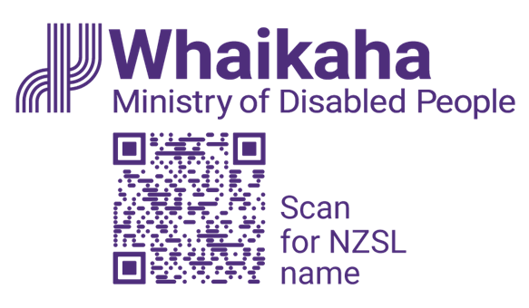

**“New Zealand Sign Language everywhere, every day”**

**New Zealand Sign Language Strategy 2025-2030**

**Draft for Consultation**

**22 April – 2 June 2025**

# Contents page

Contents page 1

Minister’s foreword 4

Board chair foreword 6

Te Rōpū Kaitiaki kupu whakataki / foreword 9

Executive summary 12

The aim is that everyone is aware of, using and accepting NZSL - everywhere, every day 12

The Board seeks your feedback on this draft strategy 15

Focus and Language 17

This strategy is about NZSL and people who use NZSL 17

New Zealand Sign Language (NZSL) 19

Introduction 22

The Deaf community in New Zealand is diverse – but there is limited data available on its size or make-up 22

Overall, there is not good information on outcomes and experiences of Deaf people in New Zealand 25

Deaf people are not always able to use New Zealand Sign Language when needed 28

The first NZSL strategy responded to concerns NZSL was a language at risk – and it is still a language at risk 31

What is known about NZSL users 32

Refreshing the NZSL Strategy 40

This strategy aims at ensuring NZSL is recognised and embraced as an official language of New Zealand 40

The NZSL Strategy is based around two strategic approaches 42

Five key priority areas sit under the two approaches 47

The NZSL Strategy 49

Priority Area: Support and enable deaf and hard of hearing children / tamariki and their families and whānau to acquire and use NZSL 50

Priority Area: Build an evidence-based profile of the experiences of NZSL users (including Turi Māori) 53

Priority Area: Enhance the status, capability, and capacity of NZSL learning and use in New Zealand 55

Priority Area: Improve attitude, acquisition, and use of NZSL across public service 58

Priority Area: Enhance the status of Turi / Deafhood and celebrate NZSL across society and cultures 61

Implementing the refreshed NZSL Strategy 63

Developing action plans to deliver on the strategy 63

Reporting on progress 64

Measuring change 66

Knowing whether the strategy is making a difference 66

Have your say 67

How to provide your feedback 67

Official Information Act requirements 68

Questions to help guide your feedback 69

Appendix: Submission form 71

Background information about you 71

Questions 75

# Minister’s foreword

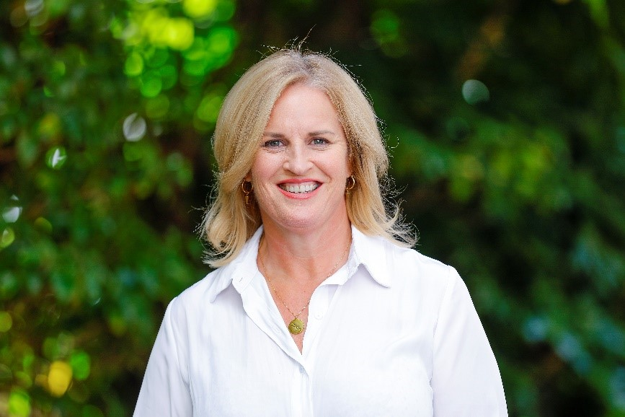

I am very pleased to release the draft New Zealand Sign Language (NZSL) Strategy 2025-2030 for consultation. This strategy takes a refreshed look at what needs to be done to ensure New Zealand – and New Zealanders – value NZSL.

I would like to acknowledge the work of the NZSL Board for its continued advocacy of NZSL, and its work on this strategy. The Board has a vital role to ensure that NZSL is, and continues to be, a strong, vibrant language that is recognised and embraced by New Zealanders.

I also want to acknowledge the wider Deaf community, and particularly Turi Māori, the Deaf Māori community. None of this work can occur without you. We need you to continue to be involved. Work to improve outcomes for the Deaf community cannot occur without the input and support of the Deaf community.

NZSL is an official language of New Zealand and has been for almost 20 years. As we approach this 20-year anniversary, it is time to stop and celebrate – not just progress over the last 20 years but progress before that. NZSL has gone from a language banned from use in schools to an official language. How fantastic is that? It is time for us to reflect, as a nation, on what has been achieved. But – it is also time to acknowledge that there is still a long way to go.

Finally, I want to celebrate that I have been gifted a sign name. The name reflects my lovely (and colourful) jackets / blazers. Thank you. I feel honoured. I can honestly say that it is something I value.

I look forward to seeing your feedback on the draft strategy.

Hon Louise Upston  
Minister for Disability Issues

# Board chair foreword

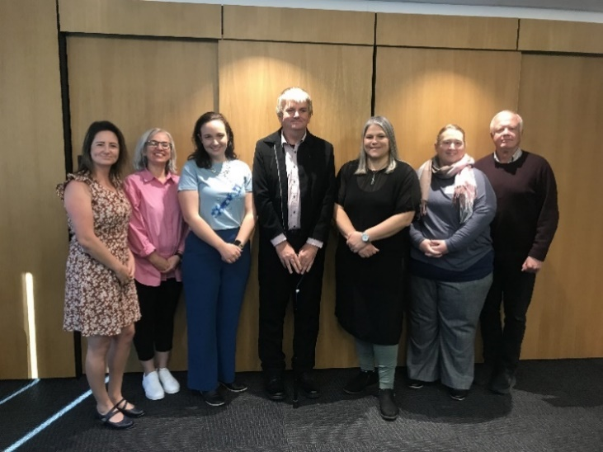

**Photo above**: Members of the NZSL Board from left to right: Jaime Brown (Deputy Chair), Monica Leach, Erica Dawson, Kim Robinson, Catherine Greenwood (Chair), Joanne Becker (Deputy Chair) and David McKee.

It gives me great pleasure, as the Chair of the NZSL Board, to present you with this draft NZSL Strategy. This draft strategy reflects the Board’s high ambitions for NZSL as a language. We want it to be a language that can be – and is – used every day, in every context, by all New Zealanders.

I want to acknowledge the members of the Board for their time, energy, and passion in developing this draft strategy. I also want to acknowledge the talented group of Turi Māori supporting the Board. Te Rōpū Kaitiaki provides advice to the Board on how to improve outcomes for Turi Māori.   
The support of Te Rōpū Kaitiaki will be key to ensure the Board remains connected with, and is supporting, the Turi Māori community.

This strategy is a cumulation of research and information that has been collected through engagement with the Deaf community over recent years, including a survey of NZSL users in 2022, and targeted engagement in 2024. I want to acknowledge the generosity of Te Taura Whiri i te Reo Māori – the Māori Language Commission – in sharing its experiences over what has worked to contribute to the growth in the use of te reo Māori. These insights helped to shape this draft strategy.

This strategy builds on the first NZSL Strategy. The five language planning priorities (acquisition, use / access, attitude, documentation, and status) of that strategy continue to be important and can be seen integrated throughout the five priority areas set out in this strategy.

While I am pleased with the draft strategy, I look forward to seeing your views on the it and how it can be improved.

With your support, we can lift the understanding, acceptance, and value of NZSL in New Zealand so that it is valued as one of New Zealand’s official languages – and as the taonga that it is.

Catherine Greenwood  
Chair, NZSL Board

# Te Rōpū Kaitiaki kupu whakataki / foreword

This photo sets out members of Te Rōpū Kaitiaki with NZSL Board, July 2024. There are two rows of people - with seven people standing in the back row and five people sitting in the front row.
In the back row are Eric Matthews (TRK), Kim Robinson, Jaime Brown, David McKee, Joanne Becker, Erica Dawson, Monica Leach
Sitting in the front row are Haamiora Samuel Te Maari (TRK), Stevie Aiono (TRK), Rāhera Turner (TRK), Catherine Greenwood, Mita Moses TRK)

**Photo above**: Members of Te Rōpū Kaitiaki with NZSL Board, July 2024  
Back row: Eric Matthews (TRK), Kim Robinson, Jaime Brown, David McKee, Joanne Becker, Erica Dawson, Monica Leach  
Front row: Haamiora Samuel Te Maari (TRK), Stevie Aiono (TRK), Rāhera Turner (TRK), Catherine Greenwood, Mita Moses (TRK)

**Mihimihi / Welcome**

**E ngā mana, e ngā reo rotarota, e ngā Turi Māori me ō koutou whānau whānui, tēnā koutou katoa! E ngā mate kua whetūrangitia, haere, haere, haere atu rā.**

We acknowledge all Turi Māori across Aotearoa. We honour those who have passed away and now live in the stars. We farewell you. Tihei Mauriora! Your memory lives on as we continue your good work.

**Kupu whakataki / Foreword**

Te Rōpū Kaitiaki, the Māori Advisory Group to the NZSL Board, provides Turi Māori advice. We use Māori cultural values to support how we work and lead together with the Board. This approach is called Mahi Rangatira – Leading Together.

Our thinking uses the mokopuna based decision making model – we are thinking long term for our mokopuna and that means improving access to education, health, and most importantly, access to te ao Māori, which includes increasing the number of trilingual interpreters in Aotearoa.

It is important that our community has access to te ao Māori through NZSL, especially for our rangatahi and mokopuna. The strategy shows the need for Turi Māori leadership to provide role models for rangatahi, so they develop a strong identity as Turi Māori.

We are excited that the draft strategy includes the aspirations of Turi Māori, and we look forward to achieving better outcomes together with the NZSL Board in kotahitanga (as one). We look forward to your feedback on the strategy.

**Ka mutu, kia whai ora, kia whai hua, kia whai kaha - Haumi ē, hui ē, tāiki ē!**

We will embrace and grow these qualities to live well, thrive and find strength. United we are stronger.

# Executive summary

## The aim is that everyone is aware of, using and accepting NZSL - everywhere, every day

NZSL is an official language of Aotearoa New Zealand, alongside te reo Māori. It is the first language for many Deaf people living in New Zealand – and for a significant proportion of Deaf people, NZSL is their only language. Being able to learn, access, and use NZSL is essential for Deaf people to achieve access to health, education, employment, and society.

This draft strategy sets out the change needed across government – and across the public – to support and enable the Deaf community to be able to fully participate in society using NZSL. The Deaf community experience barriers in using NZSL to access services. These barriers are heightened for Turi Māori in accessing te ao Māori. There are also barriers for many Deaf communities in using NZSL to access services, including Deaf Pasifika, rainbow, and Deaf+ (Deaf with an additional disability) and the deafblind community.

As part of our vision **“New Zealand Sign Language everywhere, every day”**, the Board wants New Zealanders to be able to incorporate a few NZSL phrases into their everyday - everyday signs such as ‘good morning’ and ‘good afternoon’, in the same way many New Zealanders have adopted ‘mōrena’ and ‘kia ora’ into everyday language.

It is the aim of this strategy that through everyday use, the attitude towards, and status of, NZSL will lift, leading to more people going further and becoming fluent NZSL users.

**Note:** The diagram below reflects what we hope will happen as a result of increased use of New Zealand Sign Language every day. In a circle, there are six text boxes. The first says 'increased access to NZSL for Deaf people'. This has an arrow leading to the second box, which says 'increased use every day'. This has an arrow leading to 'improved status', which has an arrow leading to 'more fluent users'. This has an arrow leading to 'increased NZSL workforce' with an arrow leading to the final box, 'enhanced inclusion of Deaf people', which then has an arrow leading to with an arrow leading back to the first box 'increased access to NZSL for Deaf people'.

An increase in the value and visibility of NZSL will in turn mean more people will choose a career within the NZSL workforce – interpreters, educators, researchers, enhancing the inclusion of Deaf people into everyday society. While this has obvious benefits for the Deaf community, it also benefits society in general by promoting a more inclusive society. There are also benefits for hearing people who would learn new skills, potentially opening up additional job opportunities, and who may become more valued employees due to their ability to communicate with the Deaf community.

The proposed priorities and actions include initiatives that community organisations, the private sector, and government agencies would need to deliver. Most initiatives will require a collaborative approach between the Deaf community, government, and other agencies.

This approach is a way for everyone - for Deaf, Turi Māori, deafblind, hard of hearing, and hearing people – to identify how they can contribute to making NZSL is a strong, vibrant, living language recognised and embraced by all, and improving outcomes for the Deaf communities.

This strategy, and the priorities and actions outlined in it, is ambitious. Many actions will stretch well beyond the timeframe of this strategy. But, for change to happen, work on delivering these actions needs to begin now.

## The Board seeks your feedback on this draft strategy

This document provides a refreshed NZSL Strategy. Refreshing the NZSL Strategy will support the Board by guiding its work priorities over the next five years. It also guides the Board’s decisions on what to fund, including Community Grants and contracts, based on whether the initiative aligns with the NZSL Strategy.

Your feedback on this draft strategy is important. At the back of this document, are questions and a submission form you can use. You can provide your feedback through an online form, via email, or via NZSL.

More information about the consultation process – and how to make your submission - can also be found on [www.nzsl.govt.nz](http://www.nzsl.govt.nz).

**A note on data:** Data relating to the 2023 Census is still being released. This means that updated data in many areas is not available. Where possible, the draft strategy will be updated as data becomes available. However, there are gaps in the data. These data gaps are something aimed to be addressed through the actions under this strategy.

# Focus and Language

## This strategy is about NZSL and people who use NZSL

NZSL is an integral part of Deaf culture and is the preferred language of Deaf people. Many Deaf people in Aotearoa New Zealand only use NZSL.

### Deafhood and Deaf culture

The term ‘deaf’ is an umbrella term used to refer to audiological deafness. It includes people who are born deaf and people who acquire a (usually severe) hearing impairment during their life. Many deaf people are prelingually deaf – that is, they were born deaf, or lost their hearing early in childhood. This means that many deaf people may not be able to access written forms of languages (including English and te reo Māori, without additional support).

The term ‘Deaf’ is used when referring to Deaf culture and the Deaf community. The Deaf community is a distinct linguistic and cultural group of people who are deaf and who use NZSL as their preferred, and first, language. Hearing people, on the other hand, tend to use spoken and written languages, and tend to rely on auditory cues for communication.

Like any group of people who share a common language and similar life experiences, Deaf people have their own culture. This includes beliefs, attitudes, history, norms, values, traditions, and art. Deaf culture is fundamentally about valuing and celebrating Deafhood.

### Deaf identities

As with the hearing community, there are a range of identities in the Deaf community, including Māori (Turi Māori), Pasifika, rainbow communities, and Deaf+.

There is also the deafblind community, people who navigate through dual sensory loss. Deafblindness is a third sensory impairment, separate to deafness and blindness. Like the Deaf community, deafblind people face significant barriers when seeking to access services or supports (including education and health), and in being fully able to participate in their communities. Many deafblind people use NZSL as their first language, or learn it later in life.

### Turi Māori walk in both the Deaf and Māori worlds

The Board acknowledges Turi Māori as tāngata whenua of Aotearoa New Zealand. Turi Māori identify as members of the Deaf community, and as Māori. This means they have a dual identity – both as Māori and as Deaf. For Turi Māori, it is important to be able to walk in the worlds of both identities.

Many Turi Māori use NZSL as their first language. However, Turi Māori face barriers accessing te ao Māori. NZSL does not always reflect Māori concepts (for instance, to enable Turi Māori to deliver their pepeha in NZSL), and other barriers include a lack of interpreters fluent in both te reo Māori and NZSL, and NZSL not always being available in te ao Māori settings.

The Board recognises that the Crown has obligations under the Treaty of Waitangi / Te Tiriti o Waitangi to actively protect the interests of Māori, which includes the interests of Turi Māori.

## New Zealand Sign Language (NZSL)

NZSL is a dynamic, visual language of Aotearoa New Zealand used by the Deaf and hard of hearing community. It includes facial expressions and body movement as well as hand signing.

While NZSL shares similarities with some other sign languages (such as British Sign Language or Auslan – Australian Sign Language), it is unique to Aotearoa New Zealand. It has distinct grammar, sentence structures, and vocabulary. Like all languages, it is a living language that continually evolves. There are also regional differences or dialects (similar to English and te reo Māori).

NZSL is not just a signed form of a spoken language. NZSL is not a literal translation of English or te reo Māori; rather it has its own grammar and sentence structure – in a similar way that grammar and sentence structures often differ between spoken languages (for instance, between English and French). As signs do not always match exactly to words and phrases used in English or te reo Māori, interpreters and translators often interpret based on context as well as the words used.

### NZSL use / access and human rights

The New Zealand Sign Language Act 2006 declared NZSL to be an official language of Aotearoa New Zealand. The Act also provided for the use of NZSL in legal proceedings and set out principles to guide government departments in the promotion and use of NZSL.

The United Nations Convention on the Rights of Persons with Disabilities (UNCRPD) promotes and protects the human rights and freedoms of disabled people, and respect for dignity. The UNCRPD recognised sign languages as languages equal with spoken languages. Under the UNCRPD, people are entitled to have their cultural and linguistic identity recognised, including sign languages and Deaf culture.

# Introduction

## The Deaf community in New Zealand is diverse – but there is limited data available on its size or make-up

The Deaf community in Aotearoa New Zealand is diverse and made up of people across all ages, ethnicities, and degrees of hearing impairment. Deaf people also make up parts of the rainbow community and the disabled community, along with many other communities.

In addition, hearing family members and NZSL interpreters, while not part of the Deaf community, participate in, and provide a bridge between the Deaf and hearing communities. The ability to bridge between Deaf and hearing communities is important because most deaf children and tamariki born in Aotearoa New Zealand are born into hearing families.

There is limited data available about deaf and hard of hearing people in Aotearoa New Zealand – and even less on deafblind people. Census 2023 indicates that that 5,736 people in Aotearoa New Zealand could not hear at all, while a further 62,640 people had a lot of difficulty hearing (even if using a hearing aid). The total of people who cannot hear at all or who have a lot of difficult hearing (even if using a hearing aid) amount to approximately 1.7 percent of New Zealanders.[1]

Additional information on these groups is likely to be released as part of future Census updates by Statistics NZ. However, previous research[2] suggests a higher prevalence of hearing loss among Māori than New Zealand Europeans / Pākehā; higher rates of hearing loss amongst males than females;[3] and higher levels of hearing loss amongst older populations than younger populations.[4]

The Deafness Notification Database includes information on children and young people identified with hearing loss. Between 2010 to 2022, 2,556 children and young people (aged under 19) had a hearing loss diagnosis.[5] Approximately a quarter (23 percent) of these children and young people either had, or were suspected of having, another disability or condition.

A slightly higher proportion of the notifications related to male children and young people (55 percent), while Māori tamariki and rangatahi were overrepresented in notifications (Māori tamariki and rangatahi made up 34 percent of notifications but only make up 26 percent of the general population under age 20).[6]

The first three years of a child’s life are key for language learning. Children (aged 0 – 5 years) who are diagnosed with hearing loss may receive support through the First Signs programme. Over the first 10 years of this programme (launched in 2014), over 1,000 children and their families and whānau received support.[7] However, not all children diagnosed with hearing loss will receive early support or exposure to NZSL.

## Overall, there is not good information on outcomes and experiences of Deaf people in New Zealand

Overall, there is limited system level information on outcomes for Deaf and hard of hearing people in Aotearoa New Zealand. The limited available research indicates that, on average, Deaf and hard of hearing people have worse life outcomes than hearing people, and this is particularly the case for Turi Māori.[8] Overseas research indicates that the lack of access to language and information is causing harms to Deaf and hard of hearing people. These harms include language deprivation, poor mental health outcomes, and poorer quality of life outcomes.[9]

Many Deaf people in Aotearoa New Zealand learn NZSL late in their educational journey – for instance at secondary school or later.[10] The available information indicates that Deaf and hard of hearing people have lower rates of tertiary qualification than hearing people – with Turi Māori having lower qualification rates than non-Māori Deaf.[11] This is likely to result in lower employment outcomes and lower income outcomes for Deaf people, in particular Turi Māori.[12]

Overall, Turi Māori are likely to have worse outcomes than other Deaf people. Turi Māori tend to have lower levels of educational achievement, lower incomes, higher rates of welfare support, higher rates of social housing, and poorer health (and mental health) outcomes.[13]

**The Royal Commission of Inquiry into Abuse in Care**

It is very clear that Deaf and hard of hearing people suffered significant abuse – physically, mentally, sexually, racially, and culturally (including the denial and lack of access to te ao Māori, and te reo Māori) – in institutions and places that should have been caring for them, particularly deaf institutions, and schools.[14]

Deaf and hard of hearing children / tamariki were also denied the right to use and learn NZSL – and were punished if they attempted to do so. This has resulted in generations of deaf people in Aotearoa New Zealand not able to use their language, and who have suffered significant and lifelong negative outcomes as a result.

## Deaf people are not always able to use New Zealand Sign Language when needed

NZSL enables Deaf people, Turi Māori, and deafblind people to live their lives to the fullest of their potential. However, evidence suggests Deaf people are not provided with opportunities to use or access NZSL in situations where needed. This includes in education settings, health settings, interactions with the criminal justice system, and in other interactions with central or local government.[15]

A survey undertaken in 2022 by the NZSL Board, as well as targeted engagements over 2024, indicate that Deaf people and their families and whānau face challenges in learning NZSL and using NZSL in everyday interactions. These challenges impact on the wider participation and well-being of the Deaf community. Turi Māori (Deaf Māori) face additional barriers in being fully able to use NZSL to engage in (and with) te ao Māori.

There is a disconnect between the status of NZSL as an official language, and the actions, behaviours, and practices of government agencies in promoting and using NZSL. NZSL is not well incorporated into many government work areas. This means that general information and services are not always made accessible to the Deaf community.

Deaf and hard of hearing people in Aotearoa New Zealand also struggle to be able to use NZSL within the wider community, and this impacts on the Deaf community’s wider participation and well-being.[16] Turi Māori also face additional barriers in accessing te ao Māori and Māori culture.

In situations where NZSL and interpreters are not available, Deaf people often need to use other communication methods, such as writing, lip reading, or getting a friend or family member to interpret. This creates the risks of miscommunication and misunderstandings, particularly in high-stakes or high-risk interactions within the health and justice sectors. It may also result in Deaf people not being able to express themselves honestly in front of family members. Appointments may also be postponed until an interpreter is available.[17]

## The first NZSL strategy responded to concerns NZSL was a language at risk – and it is still a language at risk

Research in 2017 indicated that while NZSL was becoming more recognised and accepted, the percentage of the deaf population that were learning and using the language had remained the same. This put the language at risk.[18]

Evidence suggests the situation since 2018 has not changed. For instance, while the number of NZSL users has increased over the 2013, 2018 and 2023 censuses, the number of users still amount to only about 0.5 percent of the population.[19] This indicates that while the number of people using NZSL has increased, the percentage of the population using NZSL has stayed the same.

The use of NZSL interpreters during nationally significant events, such as the Christchurch terror attack, the Whakaari / White Island eruption and COVID-19, has built awareness and recognition of NZSL. Initiatives, such as New Zealand Sign Language Week have also resulted in increased interest in NZSL, as well as an increased interest in learning NZSL.[20]

## What is known about NZSL users

For many people in the Deaf community, NZSL is their first language, and may be their only language.[21] However, not all NZSL users will be Deaf or hard of hearing: many will be family members or friends, and some will also be hearing members of the NZSL workforce (such as interpreters).

The following graph sets out the use of NZSL across the recent censuses:

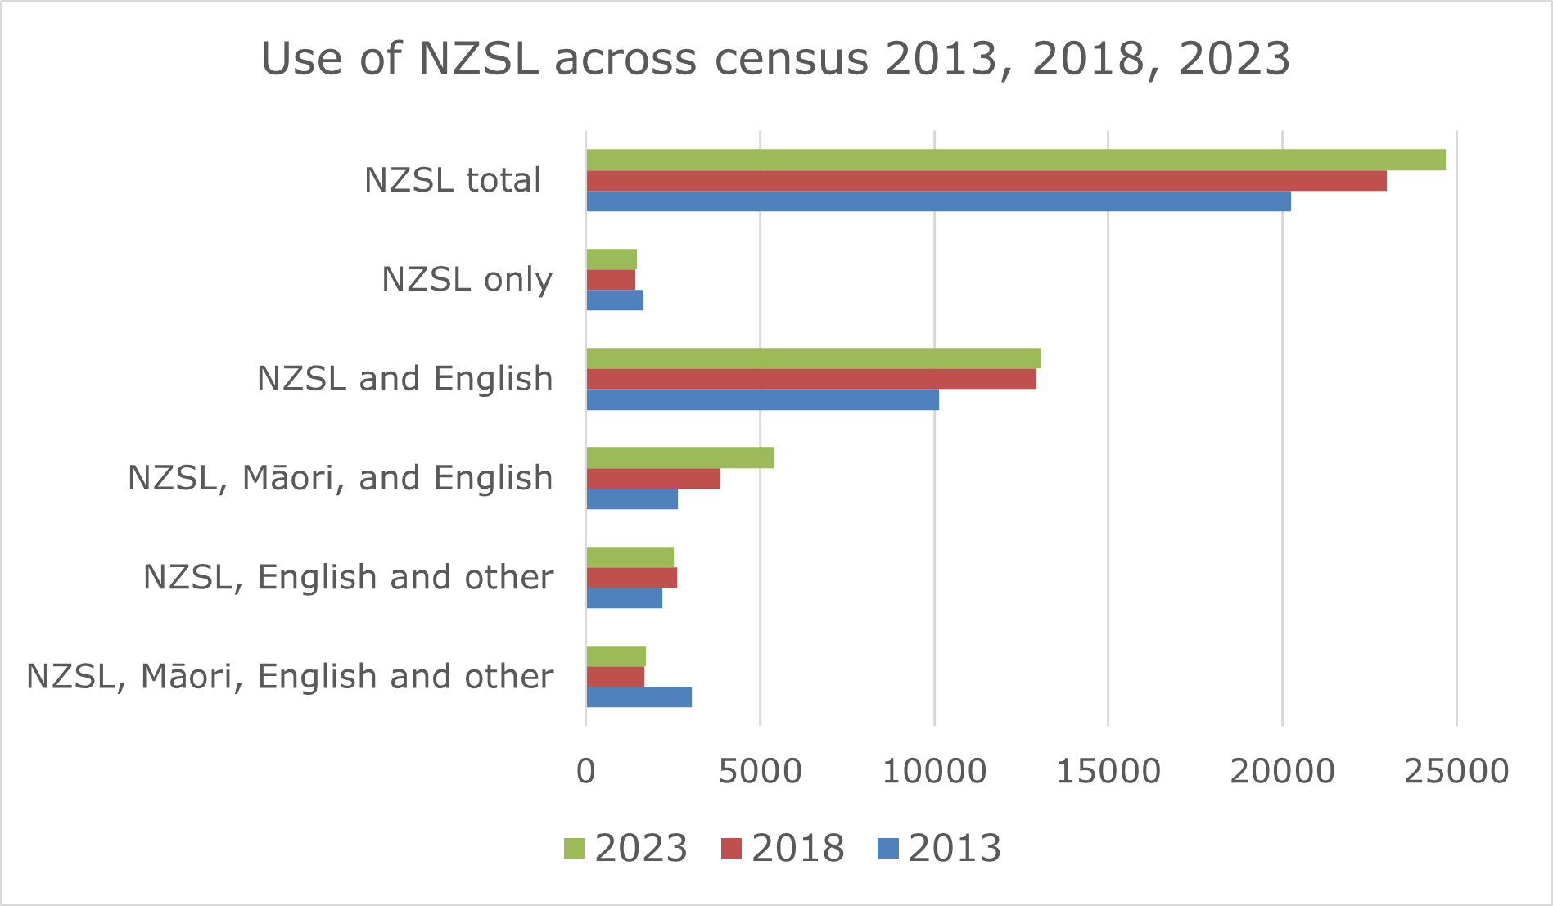

(data from Statistics New Zealand, Census 2013, 2018, and 2023 data)

Data for the above graph:

**Use of NZSL only**

* 2013: 1,644;
* 2018: 1,410;
* 2023: 1,467.

**Use of English and NZSL**

* 2013: 10,149
* 2018: 12,930
* 2023: 13,044

**Use of Māori, English and NZSL**

* 2013: 2,637
* 2018: 3,855
* 2023: 5,388

**Use of English, NZSL and other**

* 2013: 2,196
* 2018: 2,613
* 2023: 2,529

**Use of Māori, English, NZSL and other**

* 2013: 3,036
* 2018: 1,683
* 2023: 1,713

**Total number NZSL users**

* 2013: 20,235
* 2018: 22,986
* 2023: 24,678

Note, amounts do not add up to the total due to non-included result grouping that involves “other combination” involving NZSL, English or Māori as it is not stated how many were NZSL users.

**Breakdown by ethnicity**

While full information is not yet available from Census 2023, available data indicates that a higher percent of Māori (0.8 percent) can use NZSL than the average (0.5 percent).[22]

**Age breakdown**

The following graph provides information on the age breakdown of people who use NZSL:

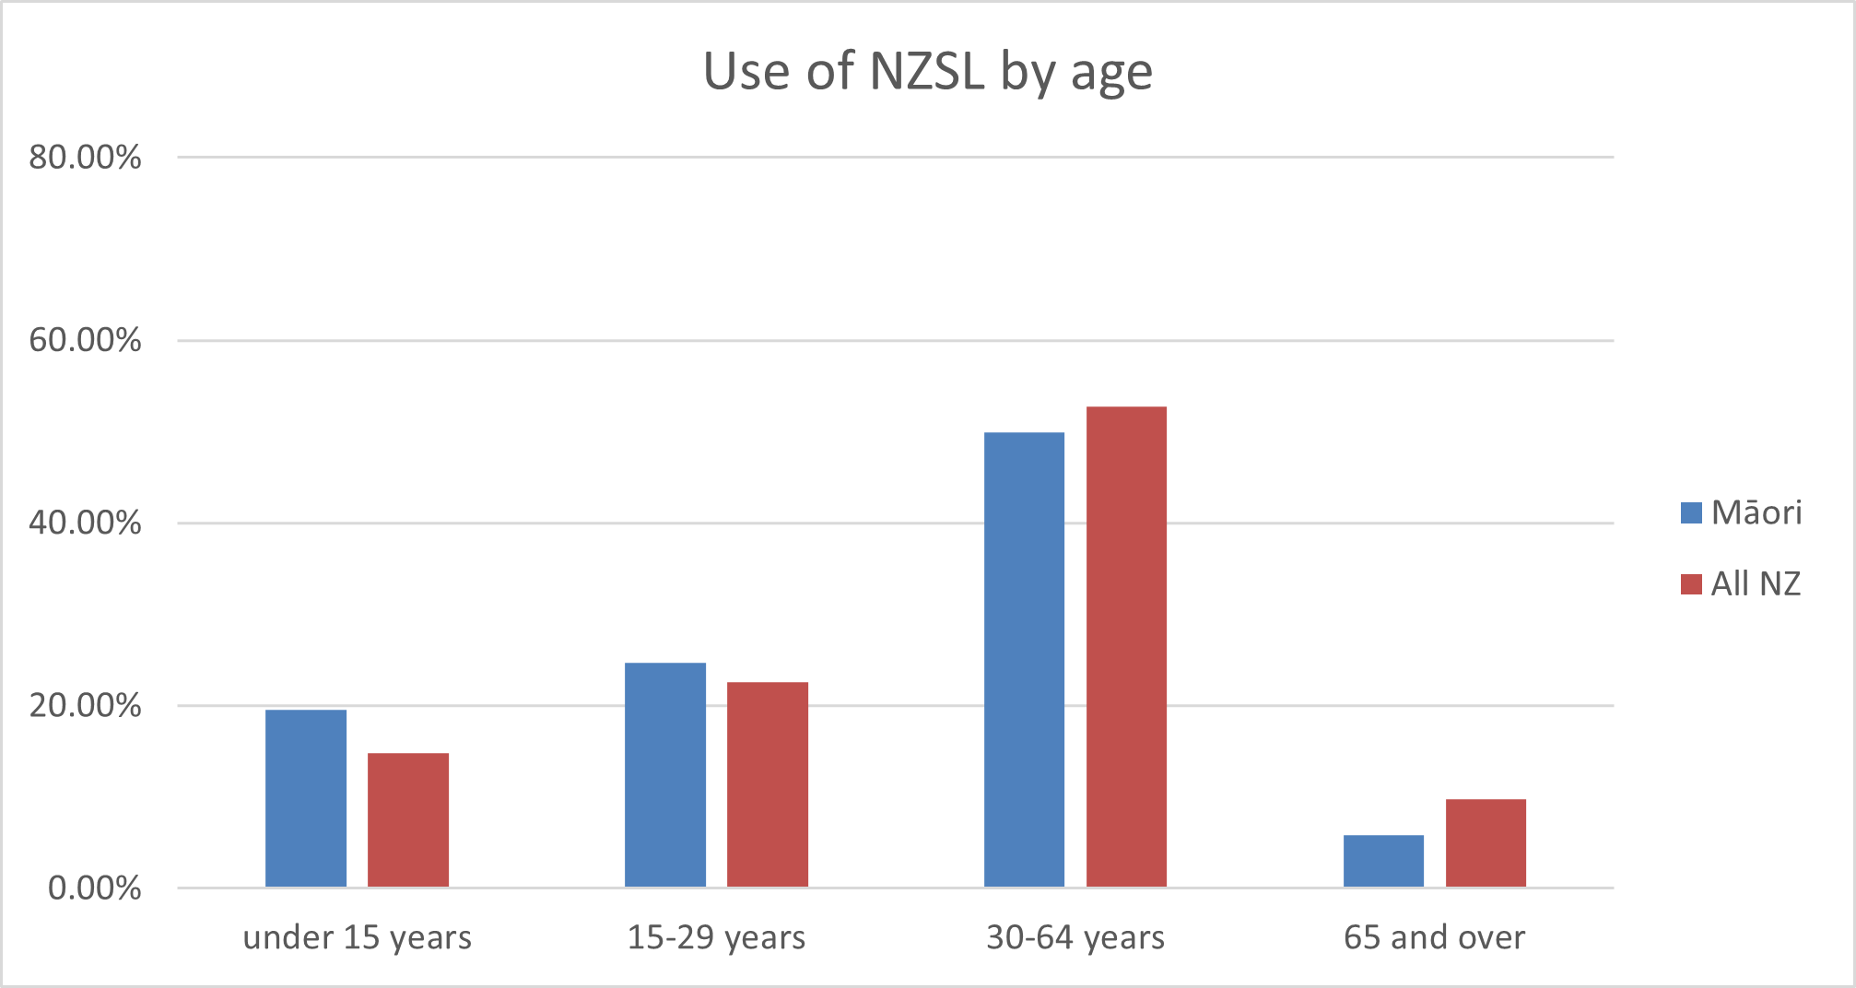

(Census 2023 data, sourced from tewhata.io)

Data for the graph on use of NZSL by age:

**Under 15 years:**

* Māori: 19.6 percent
* All New Zealand: 14.8 percent

**15-29 years:**

* Māori: 24.7 percent
* All New Zealand: 22.6 percent

**30-64 years:**

* Māori: 49.9 percent
* All New Zealand: 52.8 percent

**65 years and over:**

* Māori: 5.8 percent
* All New Zealand: 9.8 percent

**Breakdown by gender**

Most people who use NZSL are female (62 percent), as opposed to male (36 percent) or people of another gender (two percent).[23]

**Regional breakdown**

As noted earlier, the percentage of people in New Zealand who use NZSL is approximately 0.5 percent. However, the percentage of NZSL users varies across regions:

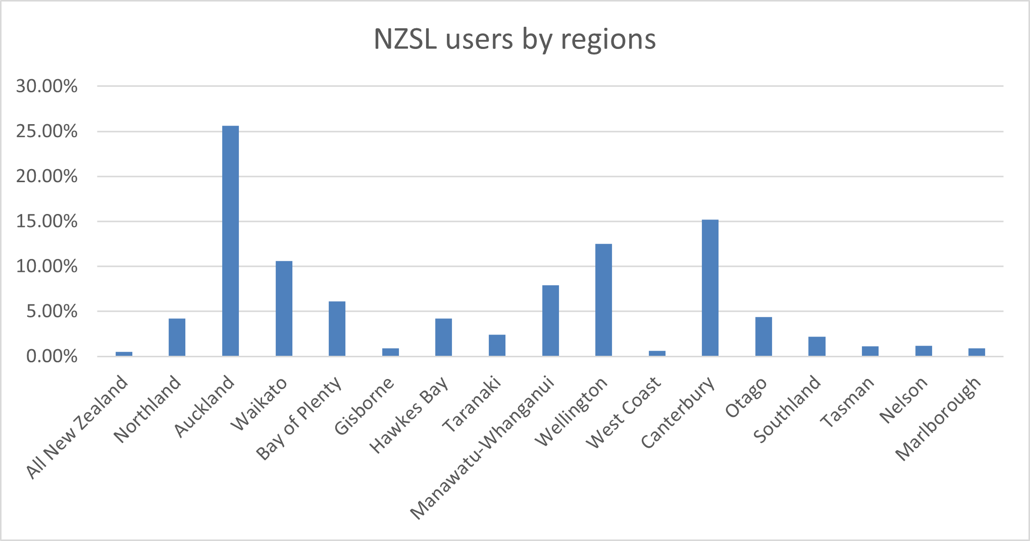

(Census 2023 data, sourced from tewhata.io)

Data for the graph showing percentages of NZSL users by region:

* All New Zealand:0.5 percent
* Northland: 4.2 percent
* Auckland: 25.6 percent
* Waikato: 10.6 percent
* Bay of Plenty: 6.1 percent
* Gisborne: 0.9 percent
* Hawkes Bay: 4.2 percent
* Taranaki: 2.4 percent
* Manawatu-Whanganui: 7.9 percent
* Wellington: 12.5 percent
* West Coast: 0.6 percent
* Canterbury: 15.2 percent
* Otago: 4.4 percent
* Southland: 2.2 percent
* Tasman: 1.1 percent
* Nelson: 1.2 percent
* Marlborough: 0.9 percent

# Refreshing the NZSL Strategy

## This strategy aims at ensuring NZSL is recognised and embraced as an official language of New Zealand

This strategy aims to create the change needed to support and enable Deaf, Turi Māori, and deafblind people to be able to fully participate in society, in their communities, and in their cultures. This includes supporting and enabling Turi Māori to successfully navigate te ao Māori.

The vision of this strategy – **New Zealand Sign Language everywhere, every day** – reflects the aim that all people in Aotearoa New Zealand will be aware of, use and accept NZSL. By starting simply – by helping to get NZSL out there, by learning a few words, and a few phases, NZSL will become more common, more accepted, more embedded as part of the culture. This will result in more people learning NZSL, which will result in more people becoming experts in NZSL. As more people become experts in NZSL, more people are likely to train to be NZSL interpreters. As the number of NZSL interpreters grow, the Deaf and hard of hearing community will be better supported, and better able to access services. There will also be growth in the number of interpreters trained (and comfortable) in using hand on hand and tactile NZSL interpretation. It will also support the growth of trilingual interpreters – that is, people skilled in te reo Māori, English and NZSL.

But this cannot be done by government alone. Change is needed at all levels - across central and local government, across iwi and hapū, and across the public and within communities, for this vision to succeed.

And all it takes is starting: just a few words, just a few phases, just the willingness to use **New Zealand Sign Language everywhere, every day**.

## The NZSL Strategy is based around two strategic approaches

In developing this strategy, the Board has been influenced by lessons learned from work to revitalise te reo Māori – in particular, the need to target actions towards both first language users (here, the Deaf community and NZSL users) and the wider community (the hearing community), so that the language to thrive.

This has resulted in the strategy being based around two strategic approaches: revitalisation and integration.

### Revitalisation

**First Language Users**

Priorities and actions aimed at ensuring the survival of the language and the equitable development and use of the language by Deaf people.

### Integration

**Second Language Users**

Priorities and actions aimed at ensuring the language is used in everyday contexts by the non-NZSL user community.

The Board acknowledges there may be concern that having two approaches may remove the focus of NZSL services from the Deaf community to hearing people. The Board is clear that while we want everyone to be aware of, using, and accepting NZSL, this must not happen at the expense of the Deaf community, who need NZSL to be able to access information and services, and who have the right to use NZSL.

The Board, providers, and government agencies will need to ensure that the targeting of actions towards both first language users and the wider community does not result in the taking of limited NZSL resources away from Deaf people, particularly children.

### Revitalisation

**Revitalisation is aimed at first language users (the Deaf community and Deaf NZSL users). It reflects the priorities and actions aimed at ensuring the survival of NZSL for Deaf people, and the equitable development, acquisition, and use of NZSL by Deaf people, including Turi Māori.**

Revitalisation is aimed at ensuring intergenerational transmission of NZSL and Deaf culture through family, whānau, and community centric approaches. A good start in life is vital, and language learning is key to later success. Deaf people should be able to learn NZSL from an early age – as should their families and whānau. Revitalisation therefore includes strengthening the use of NZSL in the home.

Everyone should have the chance to do well and enjoy life to the full. An inclusive community is a community where everyone has equal rights to services. Barriers preventing Deaf people from participating should be removed and Deaf people in Aotearoa New Zealand should be able to use their first or preferred language. More importantly, the right to use sign languages, and be able to access information in sign language is set out in the New Zealand Sign Language Act 2006, and the UNCRPD.

Revitalisation is also about language documentation and research, and building our knowledge about NZSL and ensuring the language stays alive. It is also about building Deaf leadership, employment opportunities, and identifying role models for the Deaf community.

### Integration

**Integration is aimed at second language users (hearing people). Integration refers to the priorities and actions aimed at ensuring acceptance, understanding, acquisition and use of NZSL by the non-Deaf / non-Turi community.**

Integration builds awareness and understanding of the importance of language as a key marker of identity. Integration helps to build a society that is inclusive, accepting, and respectful of a diverse range of people.

The government and media are key drivers of integration. Both government and the media reflect society as it is today and can be first movers in influencing change. The government and media can support, facilitate, and enable wide-spread acceptance, understanding, acquisition and use of NZSL by the public.

Some people in Aotearoa New Zealand may question the value of NZSL in their own lives. Promoting understanding and recognition of the value of NZSL is important - especially given that most deaf children are born into hearing families.

## Five key priority areas sit under the two approaches

Based on feedback from the Deaf community and NZSL users, and previous research, five key priority areas have been identified to support and enable the change needed:

### Revitalisation

* Support and enable deaf children / tamariki and their families and whānau to acquire and use NZSL.
* Build an evidence-based profile of the experiences of NZSL users (including Turi Māori).

### Revitalisation and Integration

* Enhance the status, capability, and capacity of NZSL learning and use in New Zealand.

### Integration

* Improve attitude, acquisition, and use of NZSL across public service.
* Enhance the status of Turi / Deafhood and celebrate NZSL across society and cultures.

These five priority areas reflect the five language learning priorities in the first NZSL Strategy, but build on them to:

* ensure appropriate opportunities for Deaf people, particularly Deaf children, to learn and use NZSL
* build an evidence-based picture of the experiences of Deaf NZSL users (particularly Turi Māori), including developing measures (indicators) to show change or progress
* raise awareness and knowledge of NZSL and Deaf culture in Aotearoa New Zealand, and
* embed NZSL into Aotearoa New Zealand society and culture.

# The NZSL Strategy

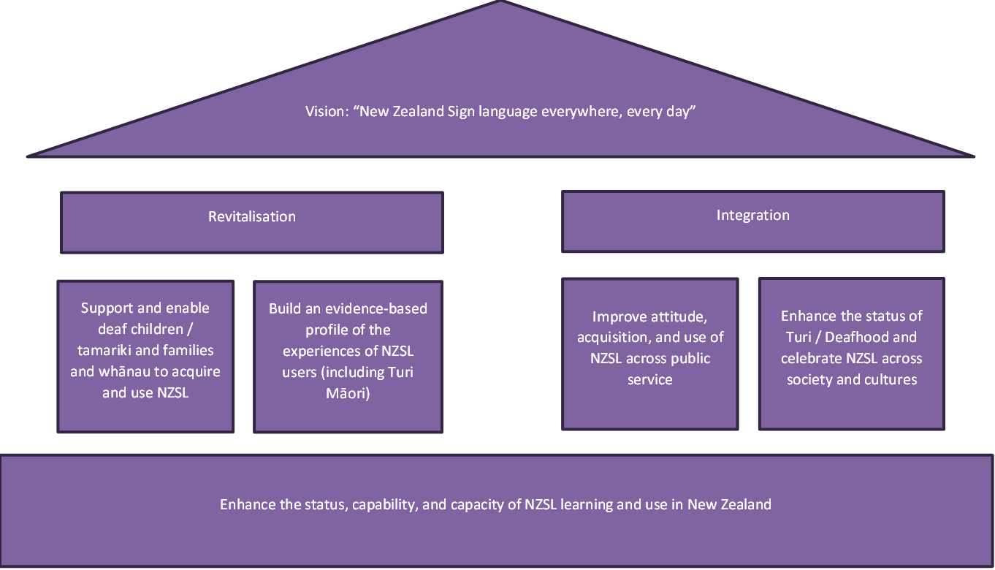

**Note:** The image above sets out the strategy in house form.

The roof of the house refers to the vision: **New Zealand Sign Language everywhere, every day**.

The house has two pillars, reflecting the strategy's two approaches of revitalisation and integration.

Under revitalisation are the two strategic priority areas relating to revitalisation: "support and enable deaf children, tamariki and families and whānau to acquire and use NZSL", and "build an evidence-based profile of the experiences of NZSL users (including Turi Māori)".

Under integration are the two priority areas relating to integration: "improve attitude, acquisition, and use of NZSL across public service" and "enhance the status of Turi / Deafhood and celebrate NZSL across society and cultures".

Underneath the two pillars is the fifth priority area "enhance the status, capability, and capacity of NZSL learning and use in New Zealand". This fifth priority area is akin to foundation given the importance of building everyone's ability to learn and use NZSL.

## Priority Area: Support and enable deaf and hard of hearing children / tamariki and their families and whānau to acquire and use NZSL

**This priority is about ensuring community driven Deaf spaces and language ‘nests’ for NZSL learning and intergenerational transmission (especially, but not exclusively, in the crucial early development years).**

It is important that deaf children / tamariki learn NZSL during their early development years. Given that most deaf children / tamariki born in Aotearoa New Zealand are born into hearing families, it is also important that the child’s family and whānau can also learn NZSL with them.

This priority is aimed at improving early access to NZSL, as well as broader educational and employment outcomes for all Deaf people, including (but not limited to) Turi Māori.

Most deaf children / tamariki are born to hearing parents, and many hearing parents will have had little or no exposure to NZSL or the Deaf community. Unfortunately, many deaf children / tamariki learn NZSL late in their educational journey. Late learning (or not learning) NZSL can result in language deprivation, and may result in poorer life-long education, employment, health, and mental health outcomes.

**Action proposed for this priority area**

* Create more opportunities for deaf and hard of hearing children / tamariki and families and whānau to learn together.
* Assess adequacy of information, resources, and supports for parents of deaf babies / pēpē and children / tamariki.
* Improve Deaf education opportunities for deaf and hard of hearing children / tamariki, and ensure access to NZSL.
* Explore additional resources and learning pathways, (for example, for Turi Māori to learn in a te ao Māori context – which will help Turi Māori build their identity both as Turi, and Māori).
* Explore options to digitise learning modules.
* Identify Deaf leadership opportunities for Deaf people, including Turi Māori.

## Priority Area: Build an evidence-based profile of the experiences of NZSL users (including Turi Māori)

**This priority is about developing and building a data-rich research and evidence base so resources can be more effectively targeted at opportunities and challenges for Deaf people**.

It is important that there is good information on NZSL and the experiences of NZSL users. This will help support and enable better outcomes for Deaf people, and ensure NZSL remains a strong, vibrant, living language.

However, there is currently a lack of good information about NZSL users, and about the experiences and outcomes of the Deaf community. This lack of information can make it difficult to ensure resources are targeted at the right issues, and that the experiences, barriers, and challenges faced by Deaf people and Turi Māori are understood. The Board, providers and government agencies need to understand the different experiences and barriers faced by different groups in the Deaf community (including, but not limited to, Pasifika, rainbow, Deaf+, and deafblind people).

This priority area also involves the development of an indicator framework to enable the monitoring and measuring of progress on this strategy, but also on outcomes for Deaf people and NZSL generally. However, data also needs to be gathered in a way that is mana enhancing and community-driven.

**Action proposed for this priority area**

* Map Deaf NZSL users’ touchpoints across the public service (including education and health services) to identify gaps, challenges, and unmet needs, particularly for Turi Māori.
* Develop an indicator framework for measuring and reporting on progress on outcomes for Deaf people and NZSL, with a focus on measures that record both quantity (for instance, number of NZSL users), but also quality (such as quality of access).

## Priority Area: Enhance the status, capability, and capacity of NZSL learning and use in New Zealand

**This priority is about ensuring there is a workforce to support the acquisition and use of NZSL, to provide for opportunities for Deaf people, and to raise awareness and understanding among the hearing population.**

It is important that Deaf people can access appropriately qualified NZSL interpreters when needed. At the same time, the NZSL and Deaf workforce also needs to grow so all New Zealanders can learn NZSL if they want to.

The vision for this strategy is **New Zealand Sign Language everywhere, every day**. Integrating NZSL into society means ensuring more people, particularly many more children, have opportunities to learn. This will also support and enable Deaf and hard of hearing people to be able to use NZSL more broadly within the community – which will also promote their wider participation and well-being.

At the same time, Deaf, Turi Māori, and deafblind communities need to be able to access NZSL interpreters, including trilingual interpreters. The interpreter needs of all Deaf communities in Aotearoa New Zealand, including Deaf Pasifika peoples, also need to be considered. In addition, the interpreter system, particularly the funding system, needs to be fit for service.

In many situations, Deaf people rely on friends and family to interpret for them or postpone appointments until an interpreter is available. Deaf people should not have to rely on family members (especially children) or friends to interpret for them at medical appointments or key social and cultural occasions.

**Action proposed for this priority area**

* Identify capacity and capability gaps (including sectors and geographical) in the Deaf and NZSL workforce (such as Deaf / Turi Māori teachers, and NZSL interpreters, tutors, translators, and teachers).
* Develop approaches to addressing those gaps (such as pathways for trilingual interpreters, growing NZSL interpreter workforce, interpreter standards).
* Explore and develop learning pathways for the public and communities to learn NZSL (this would also include opportunities for hearing children to learn NZSL).
* Explore language dissemination opportunities presented by technology.

## Priority Area: Improve attitude, acquisition, and use of NZSL across public service

**This priority is about expecting more from the public sector in role-modelling responsiveness to the NZSL community, including better meeting obligations under the New Zealand Sign Language Act 2006 to provide information and services in NZSL.**

The New Zealand Sign Language Act 2006 provides the following principles to guide government departments when exercising their functions and powers:

* the Deaf community should be consulted on matters relating to NZSL
* NZSL should be used in the promotion of government services, and in the provision of information, to the public
* Government services and information should be made accessible to the Deaf community using appropriate means, such as NZSL.

Currently, information and services are not always accessible to the Deaf community, and NZSL is not well incorporated into many government work areas. This creates barriers for the Deaf community when seeking support or information.

While the Act specifically refers to government departments, all government agencies and Crown entities (Crown agents, Autonomous Crown entities, and Independent Crown entities) that deliver services and supports need to meet these obligations as well.

This priority area also involves building the capability and accountability of the public sector to meet the needs of the Deaf community. This includes meeting the needs of Turi Māori, as well as Pasifika, rainbow, Deaf+, and the deafblind community.

Government agencies (including Crown entities) would be required to develop NZSL capability development plans. These would help government agencies to understand what they need to do to increase their responsiveness to the Deaf community, to identify how to provide more information and services in NZSL, and to provide staff with opportunities to learn about Deaf culture. Agencies would be expected to monitor and track progress on these plans.

**Action proposed for this priority area**

* Provide and facilitate provision of public facing information and services in NZSL, including support to Deaf / Turi communities in emergencies
* Increase government’s responsiveness to Deaf people by requiring government agencies to develop NZSL capability development plans, and ensuring actions are monitored and progress tracked
* Increase employment and other opportunities for Deaf people and fluent NZSL users in the government agencies
* Provide opportunities for all staff to learn (and refresh knowledge) about Deaf communities
* Drive improvements to interpreter funding models (based on EGL principles, ensuring appropriate for Deaf people and different Deaf / Turi communities)
* Develop guidance for government agencies on use of interpreters

## Priority Area: Enhance the status of Turi / Deafhood and celebrate NZSL across society and cultures

**This priority is about using the 20-year anniversary mark for the New Zealand Sign Language Act 2006 to profile, raise awareness, and celebrate NZSL and Deaf culture, and build role-models for the Deaf and Turi communities.**

It is important that NZSL and Deaf culture is celebrated in Aotearoa New Zealand. Events such as New Zealand Sign Language Week have increased awareness and interest in NZSL, as have nationally significant events (such as the COVID-19 pandemic). However, more is needed to support NZSL to be a vibrant, thriving language, and to provide role-models for the Deaf communities. This includes role-models from Turi Māori, and Deaf Pasifika, rainbow, Deaf+, and deafblind communities.

The year 2026 will be an important year for NZSL. It marks the 20th anniversary since the passing of the New Zealand Sign Language Act 2006, and the making of NZSL an official language of Aotearoa New Zealand.

This priority area is about celebrating this 20-year anniversary of the Act, and promoting awareness, understanding and celebration of the Act, of NZSL, of Deaf culture, and of Deaf communities, as well as a call for action and change. This will also be important to address any lack of information (or misinformation) about the value of NZSL to all New Zealanders.

**Action proposed for this priority area**

* Identify and profile stories by and with Deaf people about Deaf culture and NZSL – and use these to help build knowledge overall, and to build role-models for the Deaf and Turi communities
* Showcase activities, promotion, and delivery of NZSL by the Deaf community
* Collaborate with media to get stories into mainstream and Māori-specific media
* Develop events for 2026 to raise NZSL profile, and the 20-year anniversary of the New Zealand Sign Language Act 2006
* Grow NZSL documentation and resources, including te ao Māori resources / kete kōrero

# Implementing the refreshed NZSL Strategy

## Developing action plans to deliver on the strategy

The Board, along with members of Te Rōpū Kaitiaki (an advisory group to the Board made up of Turi Māori) and Whaikaha - Ministry of Disabled People officials will take the actions set out in this refreshed NZSL Strategy and turn them into action plans. These action plans will provide further information on how the actions in this strategy will be delivered.

This will also involve sequencing these actions to:

* identify the short-term practical changes that could happen now – while also planning for progress on longer-term actions
* manage the progression of actions against work programme priorities for government agencies and community organisations
* factor in the availability of funding to support initiatives
* raise the profile of NZSL (and the Board) in Aotearoa New Zealand.

The actions in this strategy are ambitious. Many will stretch well beyond the timeframe of this strategy. However, work on delivering these actions, on setting the foundations for change, need to start if the change needed is going to be achieved.

While clear accountabilities for action is important, the Board acknowledges it will not be able to deliver these actions by itself. We will need support from across Aotearoa New Zealand – from local and central government, from the Deaf community, from Turi Māori, from deafblind people, from the NZSL workforce, from businesses, and the wider public.

## Reporting on progress

The Board reports to the Minister for Disability Issues on an annual basis on its work. Whaikaha - Ministry of Disabled People officials will also support the Minister to report regularly to Cabinet on progress on delivering the NZSL Strategy. This will need to include regular reviewing and monitoring, collaborating with agencies, and with Deaf and Turi Māori communities.

Regular reporting from government agencies would also ensure agencies are focusing on NZSL, and meeting obligations under the New Zealand Sign Language Act 2006. The Board will work with the Minister and government agencies on requiring government agencies to report on NZSL use as part of their annual report. Agencies would also be expected to report on NZSL service availability as part of their annual reports.

# Measuring change

## Knowing whether the strategy is making a difference

Currently, there is limited evidence and indicators in relation to NZSL or outcomes for Deaf people overall, and even less for Turi Māori, deafblind people, and other groups within the Deaf community.

Without appropriate evidence and indicators, progress on actions in this strategy will not be able to be monitored and reported on. This will also make it difficult to monitor and report on the well-being of NZSL as a language, or overall outcomes for Deaf people and Turi Māori.

The Board and Whaikaha-Ministry of Disabled People officials will work with other government agencies to identify what data and information currently exists or can be sourced, and what indicators and targets can be developed. These indicators would also need to reflect a te ao Māori perspective. It is for this reason that a key priority area of the strategy relates to building an evidence profile of the experiences of NZSL users.

# Have your say

Your feedback on this draft strategy is important. You do not have to answer all of the questions. However, your feedback will help shape the final strategy, and support the NZSL Board to maintain and promote NZSL in Aotearoa New Zealand.

## How to provide your feedback

You can provide feedback by attending either an in person or virtual consultation session. Information about these sessions will be placed on the NZSL Board website: <https://www.nzsl.govt.nz/>

You can also provide feedback in NZSL or in written form:

* by email – you can email us at [nzsl_strategy@whaikaha.govt.nz](mailto:nzsl_strategy@whaikaha.govt.nz)
* by online survey, see <https://www.nzsl.govt.nz/>

For more information about the consultation process, please contact: [**nzsl_strategy@whaikaha.govt.nz**](mailto:nzsl_strategy@whaikaha.govt.nz)

**Submissions**

The closing date for submissions is 2 June 2025.

A submission form is attached to this draft strategy. You do not have to use this form to make a submission.

When making a submission, please include your name, contact details, and organisation (if applicable) in your submission.

## Official Information Act requirements

Note: Under the Official Information Act 1982, anyone can request feedback from this consultation. If this happens, Whaikaha-Ministry of Disabled People officials would normally redact personal information (for example, your name and any contact details) and then release your feedback to the person who asked for it. If you feel there are good reasons to withhold your submission in its entirety, please clearly indicate these in your feedback.

## Questions to help guide your feedback

**1.** Do you agree with the proposed vision and approach of the draft NZSL Strategy? How could these be improved? Please include the reasons for your answer.

**2.** Do you agree with the five strategic priority areas? How could these five strategic priority areas be improved? Please include the reasons for your answer.

**3.** Do you agree with the high-level actions set out under each of the strategic priority areas? Why / Why not?

**4.** What other actions do you think could be included? Please include the reasons for your suggestions.

**5.** What do government agencies need to consider when considering the draft NZSL Strategy to ensure what is delivered meets the needs of communities? Please include the reasons for your suggestions.

**6.** Some actions will need to be led by communities – for instance, ensuring that Deaf people are included in community events. What do communities, in particular Deaf and Turi Māori communities, need to consider when implementing actions? Please include the reasons for your suggestions.

**7.** What are the key barriers that you have experiences in accessing NZSL?

**8.** What do you see as the most important areas that need the most urgent improvements?

**9.** Finally, how will we know if the strategy has been successful?

# Appendix: Submission form

The closing date for submission is 2 June 2025.

## Background information about you

This submission was completed by:

**Name**: **Click or tap here to enter text.**

**Address**: **Click or tap here to enter text.**

**Email:** **Click or tap here to enter text.**

**Organisation** (if appropriate): **Click or tap here to enter text.**

**Position (if appropriate):** **Click or tap here to enter text.**

**Are you submitting this:** (circle or highlight the option that applies)

* as an individual?
* on behalf of a group or organisation?
* other? (please specify): **Click or tap here to enter text.**

**If completing as an individual, do you consider yourself to be:** (circle or highlight the option that applies)

* deaf / Deaf
* hard of hearing
* hearing
* other? (please specify): **Click or tap here to enter text.**

**If completing as an individual, do you work in any of the following capacities?** (circle or highlight as many as applicable)

* NZSL interpreter
* NZSL translator
* NZSL tutor or teacher
* Deaf tutor or teacher
* Other role that works primarily with deaf / Deaf or hard of hearing people (including Turi Māori)

**If completing as an individual, do you consider yourself to be:** (circle or highlight as many as applicable)

* New Zealand European / Pākehā
* New Zealand Māori
* Pacific / Pasifika
* Asian
* other? (please specify): **Click or tap here to enter text.**

**If completing as an individual, do you identify as:** (circle or highlight the option that applies)

* male
* female
* gender diverse

**If completing on behalf of an organisation, does your organisation work with or support either or both of the following groups:** (circle or highlight as many as applicable)

* deaf / Deaf or hard of hearing people generally
* Turi Māori specifically

**If completing on behalf of an organisation, does your organisation either work in or support the following roles?** (circle or highlight as many as applicable)

* NZSL interpreters
* NZSL translators
* NZSL tutors or teachers
* Deaf tutors or teachers
* Other role that works primarily with deaf / Deaf or hard of hearing people (including Turi Māori)

## Questions

**1.** Do you agree with the proposed vision and approach of the draft NZSL Strategy? How could these be improved? (circle or highlight Yes/No) Please include the reasons for your answer

* Yes
* No

Comment: Click or tap here to enter text.

**2.** Do you agree with the five strategic priority areas? How could these five strategic priority areas be improved? (circle or highlight Yes/No)   
Please include the reasons for your answer

* Yes
* No

Comment: Click or tap here to enter text.

**3.** Do you agree with the high-level actions set out under each of the strategic priority areas? (circle or highlight Yes/No)   
Why / Why not?

* Yes
* No

Comment: Click or tap here to enter text.

**4.** What other actions do you think could be included? Please include the reasons for your suggestions.

Comment: **Click or tap here to enter text.**

**5.** What do government agencies need to consider when considering the draft NZSL Strategy to ensure what is delivered meets the needs of communities? Please include the reasons for your suggestions.

Comment: **Click or tap here to enter text.**

**6.** Some actions will need to be led by communities – for instance, ensuring that Deaf people are included in community events. What do communities, in particular Deaf and Turi Māori communities, need to consider when implementing actions? Please include the reasons for your suggestions.

Comment: **Click or tap here to enter text.**

**7.** What are the key barriers that you have experiences in accessing NZSL?

Comment: **Click or tap here to enter text.**

**8.** What do you see as the most important areas that need the most urgent improvements?

Comment: **Click or tap here to enter text.**

**9.** Finally, how will we know if the strategy has been successful?

Comment: **Click or tap here to enter text.**

**End of information: New Zealand Sign Language Strategy 2025-2030 | Draft for Consultation**

This Large Print document is adapted by Blind Citizens NZ from the standard document provided by Whaikaha | Ministry of Disability People

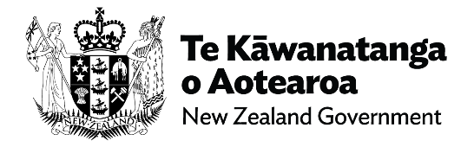

1. In addition to these groups were New Zealanders who had some difficulty with hearing. This group comprised of 494, 232 respondents or about 12 percent of the population. Overall, people with some form of hearing difficulty amounted to about 14 percent of the population.
2. Greville, K. A (2005). Hearing impaired and deaf people in New Zealand: an update on population numbers and characteristics. Greville Consulting. Retrieved from Oticon.org.nz
3. Some of this would likely reflect noise-induced hearing loss in adult males
4. This is largely likely to reflect the ageing process on hearing loss
5. Digby, J. E., Purdy, S. C., and Kelly, A. S. (2023) Deafness Notification Report (2022) Hearing loss (not remediable by grommets) in New Zealanders under the age of 19. Enable New Zealand. Auckland, New Zealand. To be included, the following criteria needed to be met: a permanent hearing loss in one or both ears, or an average loss of 26 dB HL or greater over four frequencies (0.5, 1.0, 2.0 & 4.0 kHz) for pure tone audiometry and 30 dB HL or greater over four frequencies for ABR (auditory brainstem response, which indicates how the inner ear, the cochlear, and brain pathways for hearing are work)
6. Pacific, Asian and MELAA (Middle Eastern, Latin American, and African) children and young people are notified to the Database in proportions approximately equivalent to their relative under 20 population size
7. Deaf Aotearoa. (2024). Annual Report 2023-2024.
8. Smiler, K., Bowde, N., Gibb, S., and Kokaua, J. (2023). Kei Aaku Ringa: te Mana Motuhake o Ngaati Turi: An independent report commissioned for the Taangata Turi Waitangi Tribunal claim (WAI 2143)
9. See for instance, Hall, W. C. (2017). What You Don't Know Can Hurt You: The Risk of Language Deprivation by Impairing Sign Language Development in Deaf Children. Matern Child Health J. May, 21(5):961-965. doi: 10.1007/s10995-017-2287-y; Grote, K., Stenzel, M., Wegner, S. and Karar, E. (2024). The devastating effects of language deprivation and misguided diagnosis in deaf children with cognitive language disorders in medical centres, special needs and educational settings. Journal of MindDeaf & DeafDidactics, 1(1), 1-22
10. Witko, T. (2020). An insight into the preferences and needs of the Deaf Youth community as NZSL users. Retrieved from https://www.nzsl.govt.nz/news/nzsl-youth-project
11. Smiler, K., Bowde, N., Gibb, S., and Kokaua, J. (2023). Kei Aaku Ringa: te Mana Motuhake o Ngaati Turi: An independent report commissioned for the Taangata Turi Waitangi Tribunal claim (WAI 2143)
12. Smiler, K., Bowde, N., Gibb, S., and Kokaua, J. (2023). Kei Aaku Ringa: te Mana Motuhake o Ngaati Turi: An independent report commissioned for the Taangata Turi Waitangi Tribunal claim (WAI 2143)
13. Smiler, K., Bowde, N., Gibb, S., and Kokaua, J. (2023). Kei Aaku Ringa: te Mana Motuhake o Ngaati Turi: An independent report commissioned for the Taangata Turi Waitangi Tribunal claim (WAI 2143)
14. Royal Commission of Inquiry into Abuse in Care. (2024). Our hands were tied; Royal Commission of Inquiry into Abuse in Care. (2024). Deaf survivors’ experiences of abuse and neglect in care
15. Cooage, R., Sainsbury, C., Bridman, G., and Goodwin, S. (2021). Interviews with twelve Deaf with mental illness. Coalition of Deaf Mental Health professionals; McKee, R., and Vale, M. (2014) The vitality of New Zealand Sign Language project: Report on a survey of the Deaf / NZSL community. Victoria University of Wellington; Witko, J., Boyles, P., Smiler, K., and McKee, R. (2017). Deaf New Zealand sign language users’ access to healthcare. New Zealand Medical Journal, 130(1466), 53-61; Roguski, M., Officer, T. N., Nazari Orakani, S., Good, G., Händler-Schuster, D., and McBride-Henry, K. (2022). Ableism, Human Rights, and the COVID-19 Pandemic: Healthcare-Related Barriers Experienced by Deaf People in Aotearoa New Zealand. International Journal of Environmental Research and Public Health, 19(24). https://doi.org/10.3390/ijerph192417007
16. McKee, R., and Vale, M. (2014) The vitality of New Zealand Sign Language project: Report on a survey of the Deaf / NZSL community. Victoria University of Wellington
17. McKee, R., and Vale, M. (2014) The vitality of New Zealand Sign Language project: Report on a survey of the Deaf / NZSL community. Victoria University of Wellington
18. McKee, R. (2017). Assessing the vitality of New Zealand Sign Language. Sign Language Studies, 17(3), 322-362
19. The 2013 census indicated 20,235 people used sign language or approximately 0.5 percent of respondents. The 2018 census indicated this has increased to 22,986 people, which amounted to only 0.5 percent of respondents. In 2023, the number using sign language had increased to 24,678 people which this still amounted to approximately 0.5 percent of respondents.
20. Martin, G., Foley, S., and Lovelock, K. (2021). New Zealand Sign Language Week: Impact Evaluation Summary Report. Ministry of Social Development
21. McKee, R., and Vale, M. (2014) The vitality of New Zealand Sign Language project: Report on a survey of the Deaf / NZSL community. Victoria University of Wellington
22. Census 2023 data, sourced from tewhata.io; this is also consistent with Census 2018 data
23. Census 2023 data, sourced from https://explore.data.stats.govt.nz